PROACTIVE NETWORK SECURITY

JERINA BEGUM.S1, BALAJI.V2, PRINCE.T3

Assistant Professor1, Department of Information Technology,

Jerusalem College of Engineering, Chennai-600100

Email:

Final Year Students2, 3, Department of Information Technology,

Jerusalem College of Engineering, Chennai-600100

Email: [balajivit2021@jerusalemengg.ac.in](mailto:balajivit2021@jerusalemengg.ac.in)

[princetit2021@jerusalemengg.ac.in](mailto:princetit2021@jerusalemengg.ac.in)

**ABSTRACT:** The increasing sophistication and frequency of network attacks pose a significant threat to organizations worldwide. Traditional security measures, such as firewalls and intrusion detection systems, are often reactive and insufficient to counter these evolving threats. This project explores the application of machine learning techniques for predicting network attacks, enabling proactive defense strategies. By leveraging historical network traffic data, this study develops and compares several machine learning models, including Decision Trees, Random Forests, and Support Vector Machines, to predict potential attacks before they occur.

The dataset used includes various attack types such as Distributed Denial of Service (DDoS), brute force, and malware injections. The models are trained and evaluated based on performance metrics such as accuracy, precision, recall, and F1-score. Our results demonstrate that machine learning can significantly improve the ability to detect and predict network intrusions with high accuracy, offering a promising approach for enhancing network security. The study also highlights the challenges in model optimization and data quality, providing insights for future research in real-time attack prediction systems.

.

Keywords: Network Security, Cyberattack Prediction, ML algorithm, Intrusion Detection, Network Traffic Analysis, Predictive Modeling, Cyber Threat Intelligence, Supervised Learning, Real-Time Monitoring.

# INTRODUCTION

# In today’s hyper connected world, network security has become a critical concern for organizations of all sizes. With the rise in sophistication and frequency of cyberattack securing networks against unauthorized access and malicious activities is more challenging than ever.

# Traditional security mechanisms, such as firewalls, antivirus software, and signature-based intrusion detection systems, are increasingly inadequate in dealing with novel and rapidly evolving threats. These traditional approaches are typically reactive, relying on known attack signatures or behavioral patterns, leaving systems vulnerable to new and unknown threats. To address these challenges, machine learning (ML) has emerged as a promising approach for enhancing network security.

# ML algorithms can analyze vast amounts of network traffic data, detect anomalies, and predict potential attacks in real time. By learning from historical data, machine learning models can identify patterns that may indicate malicious activities, enabling proactive measures to be taken before an attack occurs. This shift from reactive defense to predictive security has the potential to significantly reduce the impact of network attacks. This project explores the application of machine learning techniques for network attack prediction. The goal is to develop models that can accurately identify threats before they materialize, using publicly available datasets of network traffic.

# By evaluating various machine learning algorithms, this study aims to determine the most effective approach for predicting different types of network attacks, providing valuable insights into how such models can be integrated into modern security infrastructures to improve overall against cyber threats.

# LITERATURE REVIEW

**Automatic Evasion of Machine Learning Based Network Intrusion Detection Systems:**

Automatic evasion of machine learning-based network intrusion detection systems (NIDS) refers to the strategies employed by attackers to circumvent detection mechanisms that utilize machine learning algorithms. As organizations adopt these advanced systems to enhance cybersecurity, adversaries are increasingly developing sophisticated techniques to manipulate their attacks, making them appear benign and avoiding alerts.

**Unknown, Atypical and Polymorphic Network Intrusion Detection:**

Automatic evasion of machine learning-based network intrusion detection systems (NIDS) refers to the strategies employed by attackers to circumvent detection mechanisms that utilize machine learning algorithms. As organizations adopt these advanced systems to enhance cybersecurity, adversaries are increasingly developing sophisticated techniques to manipulate their attacks, making them appear benign and avoiding alerts. For instance, attackers may use adversarial machine learning, subtly altering their malicious traffic patterns to evade detection while maintaining the effectiveness of their attacks.

**Complex Dynamic Networks for Multiple Attacks:**

The study of complex dynamic networks for multiple attacks addresses the challenges posed by cyber threats in interconnected systems, where various components are susceptible to simultaneous attacks. An innovative approach in this field is the Jump-Like Event-Triggered Controller, which utilizes neural network models to enhance the resilience of dynamic networks during an attack. Unlike traditional monitoring systems

that require constant observation, this controller activates based on specific event triggers, allowing for more efficient resource utilization.

**A Network Security Situation Prediction Method Based On SSA- GResNest:**

The network security situation prediction method based on SSA-GResNeSt combine’s innovative neural network architecture with a robust optimization algorithm to enhance cybersecurity predictions. As network environments become more complex and face

Constant threats, the need for accurate and timely predictions of security situations is crucial for proactive defense strategies. This method integrates the Salp Swarm Algorithm (SSA),

a nature-inspired optimization technique, with the GResNeSt (Gated Residual Network with Nested Skip Connections) model.

1. **COMPONENTS REQUIRED:**

**Data Collection Infrastructure:**

Devices like Intrusion Detection Systems (IDS) and firewalls to capture network traffic and logs.

Integration with various data sources, including server logs, application logs, and external threat intelligence feeds.

**Data Storage Solutions:**

Scalable databases (e.g., SQL, NoSQL) to store and manage large volumes of historical data and real-time logs. For unstructured data storage, allowing for flexible data processing and analytics.

**Data Preprocessing Tools:**

Extract, Transform, Load (ETL) tools to preprocess and clean data, ensuring it is ready for analysis (e.g., Apache NiFi, Talend). Libraries such as pandas or scikit-learn in Python for creating relevant features from raw data.

**Machine Learning Frameworks**:

Tools for developing machine learning models, such as TensorFlow, Keras, PyTorch, and scikit-learn. Implementations of various algorithms like Decision Trees, Random Forests, Support Vector Machines, and Neural Networks.

**Training and Evaluation Environment:**

Access to powerful CPUs or GPUs for training machine learning models on large datasets.

Tools for model evaluation, including cross-validation techniques and performance metrics (e.g., confusion matrix, ROC curves).

**Real-Time Monitoring and Deployment:**

Containerization technologies (like Docker) or orchestration tools (like Kubernetes) to manage and deploy machine learning models in production environments. Visualization tools (like Grafana or Kibana) to provide real-time insights and alerts on network activity and model predictions.

**Compliance and Security Measures:**

Mechanisms to ensure compliance with data protection regulations (e.g., GDPR, HIPAA)

Implementing role-based access controls (RBAC) to safeguard sensitive data and models.

1. **METHODOLOGY**

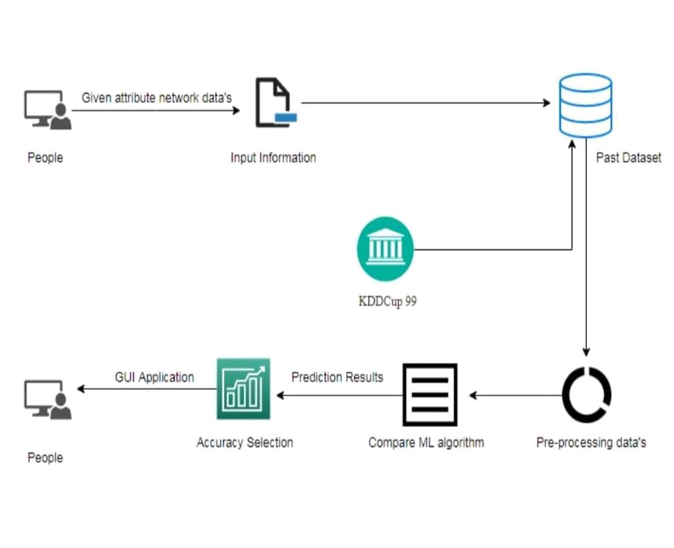

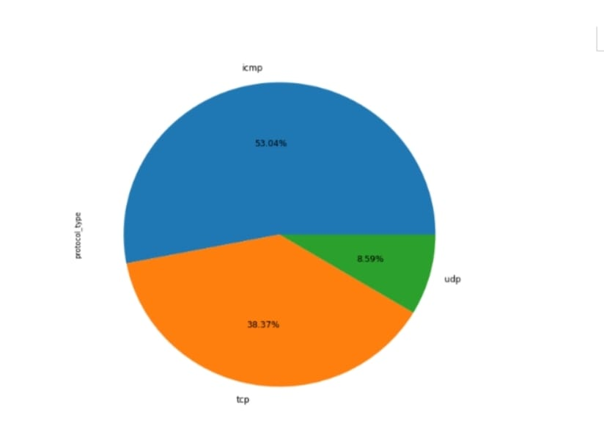

Percentage Level of Protocol Type

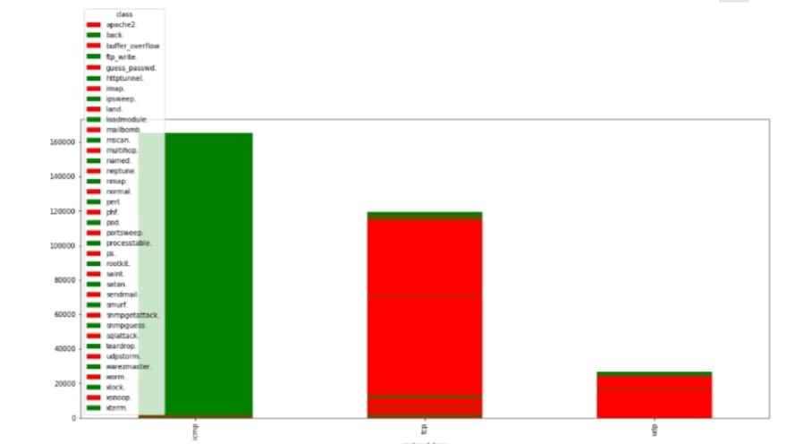

Comparison of service type and protocol type

**Risk Assessment and Analysis:**

Conducting comprehensive risk assessments to identify vulnerabilities, potential threats, and the impact of various attack vectors on the network. This

process involves evaluating assets, understanding their value, and prioritizing security measures accordingly.

**Network Segmentation:**

Implementing network segmentation to isolate sensitive data and critical systems from less secure parts of the network. This strategy limits the lateral movement of attackers and reduces the attack surface.

**Intrusion Detection and Prevention Systems (IDPS):**

Deploying advanced IDPS to monitor network traffic for suspicious activity. This includes both signature-based and anomaly-based detection methods to identify and block potential threats in real time.

**Threat Intelligence and Monitoring:**

Utilizing threat intelligence services to stay informed about emerging threats and vulnerabilities. Continuous monitoring of network traffic, logs, and endpoints

can help detect and respond to unusual activities promptly.

**Incident Response Planning:**

Developing and maintaining a comprehensive incident response plan that outlines the steps to be taken in the event of a security breach. Regular drills and updates to the plan ensure that the organization is prepared to respond effectively

**5. RESULT & DISCUSSION**

**Improved Detection Rates:**

Machine learning models significantly increase the accuracy of threat detection compared to traditional methods, often achieving detection rates exceeding 90%. This allows organizations to identify potential attacks earlier in the attack lifecycle. Advanced algorithms can minimize false positives, ensuring that security teams can focus on genuine threats rather than being overwhelmed by alerts.

**Faster Response Times:**

Continuous real-time analysis enables swift identification of anomalies, facilitating quicker incident response. This rapid reaction can prevent or mitigate the impact of an attack before it escalates.

The integration of automated response mechanisms allows for immediate actions to be taken when threats are detected, further reducing response times.

**Enhanced Understanding of Threat Landscapes:**

By analyzing historical data, these systems help organizations understand common attack patterns and vectors, improving overall threat intelligence.

Machine learning models can provide predictive insights, allowing organizations to anticipate potential threats and take proactive measures to fortify defenses.

**Cost Efficiency:**

By preventing successful attacks and minimizing their impact, organizations can significantly reduce costs associated with data breaches, including recovery expenses and regulatory fines.

Automated threat detection and response free up cybersecurity personnel to focus on strategic initiatives rather than reactive firefighting.

**Adaptability to Emerging Threats:**

Machine learning systems can continuously learn from new data, adapting to evolving threats and ensuring that detection capabilities remain relevant over time.

The ability to integrate with IoT devices and cloud services enhances the scope of threat detection in increasingly complex environments.

**6. APPLICATIONS:**

**Data Collection Infrastructure:**

Network Sensors: Devices like Intrusion Detection Systems (IDS) and firewalls to capture network traffic and logs. Integration with various data sources, including server logs, application logs, and external threat intelligence feeds.

**Data Storage Solutions:**

Scalable databases (e.g., SQL, NoSQL) to store and manage large volumes of historical data and real-time logs. Network attack prediction leverages machine learning (ML) and artificial intelligence (AI) techniques to detect and predict cyberattacks before they occur. This application aims to secure networks by identifying abnormal behavior patterns that may indicate potential threats. Here's how it works and some common approaches:

**Feature Extraction:**

Collect historical network traffic data, including packet transfers, IP addresses, ports, protocols, and timestamps. Anomaly Detection is used to Analyze patterns of normal traffic behavior to define a baseline, detecting deviations that may indicate attacks.

Key features like traffic volume, connection duration, and packet sizes are extracted to build robust models.

**Machine Learning Techniques:**

Supervised Learning: Models are trained on labeled datasets where attack types (e.g., DDoS, phishing) are known. Algorithms like decision trees, support vector machines (SVMs), or deep learning (e.g., neural networks) can classify new instances of network behavior as normal or malicious.

Unsupervised Learning: In situations where labeled attack data is scarce, unsupervised methods like clustering (e.g., k-means) are used to detect anomalies without prior knowledge of attack types.

Reinforcement Learning: Adaptive techniques are employed to continuously learn and improve based on network feedback, making them more effective at evolving attack methods.

**Popular Models for Prediction:**

Deep Learning (CNNs, RNNs, LSTMs): Neural networks that excel in finding patterns in large, complex datasets. Recurrent neural networks (RNNs) and long short-term memory (LSTM) networks are particularly useful for analyzing time series data in network traffic. Effective for classification tasks by constructing multiple decision trees and combining their outputs. Autoencoders is used for anomaly detection by training on normal network traffic and flagging deviations as potential attacks.

**Threat Intelligence Integration:**

Incorporating real-time threat intelligence feeds with global attack data to improve prediction accuracy. Using external data sources to correlate local network activity with known attack patterns.

**Challenges:**

Attacks represent a small fraction of total traffic, making it harder for models to distinguish them from normal traffic.

Minimizing false alarms while maintaining high sensitivity to actual attacks is crucial.

Constant updates to models are needed to stay ahead of new or evolving attack strategies.

**7. FUTURE SCOPE**

**Advanced Machine Learning Techniques:**

The adoption of deep learning methods, including convolutional neural networks (CNNs) and recurrent neural networks (RNNs), will improve the ability to analyze complex patterns in large datasets, enhancing detection accuracy.

**Integration with Artificial Intelligence:**

Natural Language Processing (NLP): Utilizing NLP can aid in analyzing unstructured data, such as threat reports and user communications, to identify emerging threats and trends.

**Behavioral Analysis:**

Enhanced algorithms will improve the ability to detect deviations from normal behavior, leading to more timely and accurate threat identification.

**Automated Response Systems:**

Future systems may evolve to not only predict attacks but also initiate automated responses to mitigate threats in real-time, reducing the need for human intervention.

**Collaborative Defense Strategies:**

Encouraging collaboration between organizations to share threat intelligence will enhance the overall effectiveness of prediction systems, as collective insights can identify trends and emerging threats more effectively.

**Regulatory Compliance and Ethics:**

Future prediction systems will need to ensure compliance with evolving data protection regulations, necessitating transparent data handling and user privacy considerations.

**Enhanced User Training and Awareness:**

Incorporating training programs that educate employees about recognizing and responding to potential threats can complement automated systems, reducing the risk of human error.

**8. CONCLUSION**

The development of a network attack prediction system utilizing machine learning represents a pivotal advancement in the field of cybersecurity. As cyber threats continue to grow in complexity and frequency, organizations must adopt innovative approaches to enhance their security posture. The comprehensive methodology outlined in this framework encompassing data collection, preprocessing, model selection, training, evaluation, and real-time deployment ensures a robust approach to identifying and mitigating threats.

By leveraging historical and real-time data, these systems can uncover patterns that might elude traditional security measures. Machine learning algorithms such as Decision Trees, Random Forests, Support Vector Machines, and Neural Networks provide the analytical power necessary to process vast amounts of data, enabling the detection of anomalies that indicate potential attacks. This ability to discern subtle signs of malicious activity allows for timely and effective interventions, minimizing the window of vulnerability that attackers can exploit.

Furthermore, the continuous improvement aspect of these systems is crucial in maintaining their effectiveness. As cyber threats evolve, so too must the defenses that organizations employ. Regular updates and feedback loops ensure that machine learning models remain relevant, adapting to new tactics and techniques used by cybercriminals. The integration of these systems with existing security frameworks fosters a multi-layered defense strategy, enhancing overall resilience against attacks.

**9. REFERENCE:**

**[1] D. Kim and J. Lee (2023).**

ML-BasedIntrusion Detection in 5G Networks. SpringerLink - This study investigates how machine learning can enhance intrusion detection in 5G

communication networks.

**[2] G. Singh, N. Patel, and S. Kumar (2022).** Cyberattack Predictions Using Supervised Machine

Learning. IJSDR - This paper provides an overview of machine learning techniques used to predict and prevent network attacks.

**[3] S. Rahman, J. Karim, and F. Khan (2023).** Next-Generation Cyberattack Prediction for IoT

Systems Using Hybrid Models. Journal of Cloud Computing.

**[4] M. Bashir and Y. Ahmed (2024).** Cyberattack Prevention and Detection Using Deep Learning Models. IEEE Xplore.

**[5] H. Zhao, X. Li, and J. Chen (2023).** Predictive Security Models Using ML for Network

Traffic Anomalies. SpringerLink.