**INNOVATIVE FLOOD RISK ASSESSMENT INTEGRATING**

**(LSTM) NETWORK FOR RAINFALL PREDICTION AND IMAGE BASED DAMAGE ANALYSIS**

*KAVINYA P 1,GAYATHRI S2*

Final Year Students1,2, Department of Information Technology, Jerusalem College of Engineering,Chennai-600100

Email:[kavinyapit2021@jerusalemengg.ac.in](mailto:kavinyapit2021@jerusalemengg.ac.in)

[gayathrisit2021@jerusalemengg.ac.in](mailto:kavinyapit2021@jerusalemengg.ac.in)

**ABSTRACT**

Our project emphasizes the importance of Flooding is a critical natural disaster that poses significant risks to communities, resulting in fatalities, significant property destruction, and economic disruption. Despite advancements in technology, the unpredictability of floods and the inadequacy of existing prediction methods often hinder timely responses from authorities. This results in delayed evacuations and inadequate resource allocation, exacerbating the disaster's impact. Current methods of assessing flood damage are also lacking, often failing to provide accurate, timely insights into the extent of destruction. As a result, authorities struggle to prioritize recovery efforts effectively, leading to prolonged suffering for affected communities. There is a pressing need for an integrated system that combines accurate flood prediction with effective damage assessment. By leveraging rainfall data and advanced image analysis techniques, this project seeks to develop a comprehensive solution that not only predicts floods but also evaluates the resulting damage in real time. This system is designed to deliver prompt notifications to authorities, enabling proactive disaster management. Furthermore, it will assist in estimating the economic impact of floods, ensuring that resources are allocated efficiently for recovery efforts. The project addresses a vital gap in flood preparedness, aiming to save lives and reduce economic losses.

***keyword***

| Machine learning ,Rainfall data , Model Evaluation, Feature Extraction, Flood prediction, Image based Analysis. | | |  |
| --- | --- | --- | --- |
|  | | |  |
|  | |
|  |  |
|  |  |
|  |  |
|  |

# Introduction

# 

Floods cause major destruction to lives and economies around the world. The traditional methods for predicting these do not account for dynamic factors such as climate changes. This project integrates machine learning to provide accurate predictions for floods and real-time assessment for damage. It utilizes rainfall data and satellite imagery to deliver timely alerts and efficient resource management. It enhances disaster preparedness, thus minimizing losses and improving recovery efforts.

1. **METHODOLOGY**

It predicts floods with machine learning algorithms on satellite image analysis and then predicts the level of damage that could be inflicted upon a flood by analyzing damage level classification on CNN models, like VGG16. Damage is estimated to its accuracy through fuzzy logic refinement, and a real-time alert is given, thereby aiding the authorities in the swift decision-making of disaster management. Continuous monitoring allows for real-time updates and, hence, an effective response to recovery in a flood scenario.

1. **PRE-PROCESSING**

Pre-processing is vital for preparing meteorological and satellite imagery data in this flood risk assessment system. Meteorological data undergoes cleaning to handle missing values and outliers, normalization for consistency, and encoding of categorical variables. It is then formatted as time-series data for LSTM networks. Satellite imagery is cleaned using filters, resized to standard dimensions, normalized, and augmented with techniques like rotation and flipping. Images are annotated with damage severity labels for supervised learning. Both datasets are synchronized by time and location, then split into Training, Validation, and Test sets, ensuring readiness for accurate flood prediction and damage analysis.

ht​=σ(Wh​xt​+Uh​ht−1​+bh​)  
  
Where:

ℎ 𝑡 ​ is the hidden state at time 𝑡 ,𝑊 ℎ ​ and 𝑈 ℎ ​ are weight matrices,

𝑥 𝑡 ​ is the input at time 𝑡 t (e.g., rainfall at time 𝑡),

ℎ 𝑡 − 1 is the hidden state from the previous time step,

𝑏 ℎ is the bias term, and 𝜎 σ is the activation function (such as tanh or ReLU).

# IMPLEMENTATION OF IMAGE BASED ANALYSIS

The image-based dataset collection for this project focuses on capturing high-resolution satellite images before and after flood events to assess damage. These images are sourced from platforms like Sentinel-2, Landsat, and Google Earth Engine, ensuring wide spatial coverage and high-quality data. The dataset includes images of urban, rural, and coastal regions affected by floods, with each image labeled to indicate the extent of damage, categorized as none, minor, moderate, or severe. Additionally, some images may include annotations on the estimated economic impact of the damage. These images are pre-processed by resizing, normalization, and augmentation techniques to prepare them for analysis using Convolutional Neural Networks (CNNs) for damage classification.

The pre-processing of the image-based dataset for flood damage assessment involves cleaning the images by removing noise using filters, resizing them to a consistent dimension (e.g., 224x224 pixels), and normalizing The pixel values are scaled to a range between 0 and 1. To enhance dataset diversity and mitigate overfitting, data augmentation techniques such as rotation, flipping, and cropping are applied.

**SEGMENTATION**

Segmentation in flood damage assessment divides satellite images into distinct regions to identify flood-affected areas. The images are first preprocessed by resizing, normalizing, and augmenting to ensure consistency. Advanced models like U-Net or Mask R-CNN are used for pixel-level classification to differentiate between affected and unaffected areas. Post-flood images are compared with pre-flood ones to classify damage as none, minor, moderate, or severe. This process allows for precise damage assessment, helping prioritize areas for disaster response and efficient resource allocation.

* 1. **Author information**

4.2.1 Gayathri Sakthivel

Kavinya Prabakaran

4.2.2 Affiliation

Jerusalem College of Engineering

B.Tech Information Technology

Anna University Chennai

4.2.3 Superscripts

[gayathrisit2021@jerusalemengg.ac.in](mailto:gayathrisit2021@jerusalemengg.ac.in)

[kavinyapit2021@jerusalemengg.ac.in](mailto:kavinyapit2021@jerusalemengg.ac.in)

# Math

# 5.1 Equations

F(i,j)=m∑​n∑​I(i+m,j+n)⋅K(m,n)

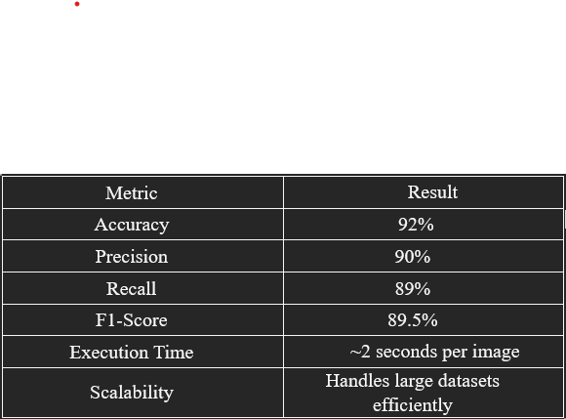

1. Tool: You are strongly recommended to use Math
   1. **Measurement units and numbers**

First, historical rainfall data spanning the past 10 years is collected from reliable meteorological sources, along with satellite images of flood-affected regions for damage analysis. The collected data undergoes preprocessing to remove inconsistencies, handle missing values, and normalize it for effective model training. The dataset is then split into training (70%) and testing (30%) sets to ensure accurate model evaluation.

# RESULTS AND FIGURES

**6.1 ACCURATE FLOOD PREDICTIONS**

1. The model effectively utilizes historical rainfall data to generate accurate forecasts for the next 5 to 10 years. By analyzing patterns in precipitation, it identifies potential flooding events, thereby enabling proactive measures for disaster preparedness.
2. The application of LSTM networks for flood prediction not only aids in immediate disaster management but also informs long-term urban planning and resource allocation, ultimately contributing to enhanced community resilience against flooding. Overall, the successful use of LSTM networks in this domain underscores their significance in modern machine learning approaches for disaster risk reduction.

## COST ESTIMATE

The image-based analysis module offers a comprehensive, accurate, and scalable solution for flood damage assessment. By combining deep learning (VGG16) with fuzzy logic, the system ensures both precision and contextual relevance, enabling authorities to respond swiftly and allocate resources effectively.

.

## Figures

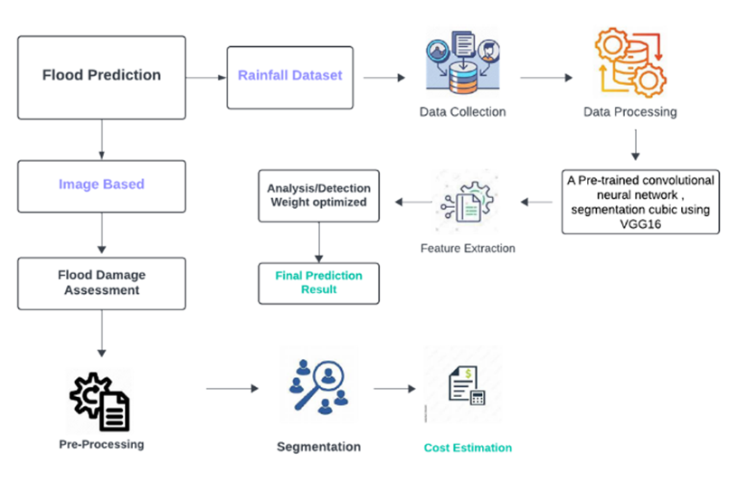

**Figure 1.** Architecture

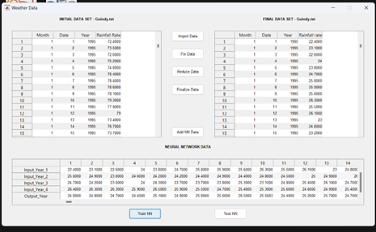

**Figure 2.**data collection

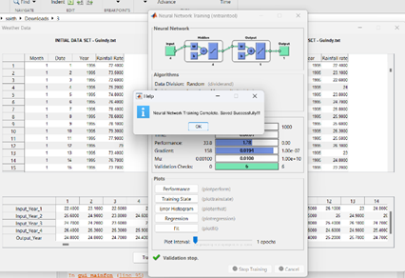

**Figure 3. data training**

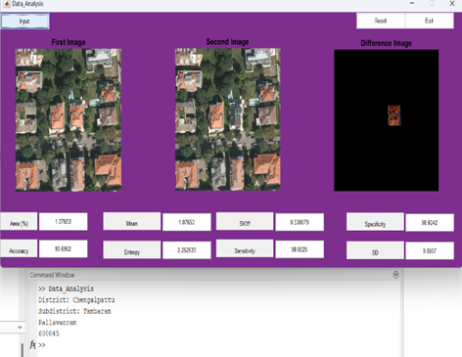

**Figure 4. cost estimate**

1. **CONCLUSIONS**

The proposed system architecture introduces the system splits the rainfall dataset into training and testing sets to improve model generalization. Data augmentation is applied to enhance the image dataset for more accurate flood analysis. LSTM networks are integrated to manage time series data for better flood prediction. Cross-validation ensures the model remains reliable and avoids overfitting. Hyperparameter

# acknowledgment

Acknowledgement section future scope of the proposed system involves integrating advanced weather models, real-time IoT data, enhanced image analysis with 3D imagery, and economic impact estimation to create a scalable, globally adaptable system for flood prediction and damage assessment, while incorporating climate change adaptability and community-centric features for effective disaster management.

**REFERENCES**

1. M. Thomas et al., "A Framework to Assess Remote Sensing Algorithms for Satellite-Based Flood Index Insurance," in IEEE Journal of Selected Topics in Applied Earth Observations and Remote Sensing, vol. 16, pp. 2589-2604, 2023, doi: 10.1109/JSTARS.2023.3244098.
2. M. S. Farooq et al., "FFM: Flood Forecasting Model Using Federated Learning," in IEEE Access, vol. 11, pp. 24472-24483, 2023, doi: 10.1109/ACCESS.2023.3252896.
3. Y. Liu, L. Wang, S. Du, L. Zhao and X. Liu, "Flood Forecasting Method Based on Improved VMD-FOS-QR-RBL," in IEEE Access, vol. 11, pp. 4207-4218, 2023, doi: 10.1109/ACCESS.2022.3232405.
4. C. Krullikowski et al., "Estimating Ensemble Likelihoods for the Sentinel-1-Based Global Flood Monitoring Product of the Copernicus Emergency Management Service," in IEEE Journal of Selected Topics in Applied Earth Observations and Remote Sensing, vol. 16, pp. 6917-6930, 2023, doi: 10.1109/JSTARS.2023.3292350.
5. J. Zhao et al., "Urban-Aware U-Net for Large-Scale Urban Flood Mapping Using Multitemporal Sentinel-1 Intensity and Interferometric Coherence," in IEEE Transactions on Geoscience and Remote Sensing, vol. 60, pp. 1-21, 2022, Art no. 4209121, doi: 10.1109/TGRS.2022.3199036.
6. K. Aatif, M. A. Fahiem and F. Tahir, "Forecasting Floods Using Deep Learning Models: A Longitudinal Case Study of Chenab River, Pakistan," in IEEE Access, vol. 12, pp. 115802-115819, 2024, doi: 10.1109/ACCESS.2024.3445586.
7. J. Jiang et al., "Heterogeneous Dynamic Graph Convolutional Networks for Enhanced Spatiotemporal Flood Forecasting by Remote Sensing," in IEEE Journal of Selected Topics in Applied Earth Observations and Remote Sensing, vol. 17, pp. 3108-3122, 2024, doi: 10.1109/JSTARS.2023.3349162.