Predicting Lithium Ion Battery Remaining Life with Boosting Algorithms and Random Forest Enhanced by Explainable AI for Feature Relevance.

Keren Persis P1

Research Scholar,

Department of Computer Science and Engineering,

Saveetha School of Engineering,

Saveetha Institute of Medical and Technical Sciences,

Saveetha University, Chennai,Tamilnadu, India,

Pincode: 602105.

kerenpersis@gmail.com  
  
Dr. R. Geetha2

Research Guide, Corresponding Author,

Department of Electronics and Communication Engineering,

Saveetha School of Engineering,

Saveetha Institute of Medical and Technical Sciences,

Saveetha University, Chennai, Tamilnadu, India,   
Pincode: 602105.  
geethaphd2013@gmail.com

**ABSTRACT**

This research compares the efficiency of various boosting algorithms, including AdaBoost, CatBoost, Gradient Boosting, and LightGBM, with Random Forest for predicting the Remaining Useful Life (RUL) of lithium-ion batteries. A central focus of the study is evaluating the contribution of features to the model outputs using SHAP and LIME. The dataset for RUL prediction has approximately 4,000 training records and 1,500 test records. Additionally, five synthetic datasets were generated using resampling to assess model performance across metrics such as Mean Squared Error (MSE), Root Mean Squared Error (RMSE), Mean Absolute Error (MAE), and R-squared (R²).Both Random Forest and Gradient Boosting displayed similar predictive performance on the training data. However, on unseen test data, AdaBoost proved to be more robust, with an MSE of 0.66, RMSE of 0.812, MAE of 0.492, and R² of 0.898.According to SHAP analysis with AdaBoost, discharge capacity and battery current were identified as the most critical features for predicting RUL. LIME analysis for instances highlighted energy discharge capacity and charge-discharge capacity as the key contributors to RUL prediction.

Keywords: Remaining Useful Life , SHAP (SHapley Additive exPlanations),LIME (Local Interpretable Model-agnostic Explanations), Adaboost, Catboost, Light GB, Gradient Boosting.

1. **INTRODUCTION**

Lithium-ion batteries (LIBs) are designed with different chemistry to cater to a variety of applications, each with its own strengths and challenges. **Lithium Iron Phosphate (LFP)**, for instance, is known for its high thermal stability, long cycle life, and safety, making it ideal for electric vehicles (EVs) and energy storage systems. However, its lower energy density means LFP batteries store less energy in the same weight or volume compared to other types. This becomes a drawback in applications requiring compact, high-energy solutions, and users need to predict the remaining useful life (RUL) to ensure optimal performance over time and to avoid unexpected failures. **Lithium Nickel Manganese Cobalt Oxide (NMC)** batteries offer a good balance between power output, energy density, and cycle life, which is why they are widely used in electric vehicles and medical devices. However, they are expensive and prone to thermal runaway at high temperatures, posing safety risks if not carefully managed. Predicting the remaining life in NMC batteries helps mitigate risks by identifying degradation patterns early, allowing for preventive maintenance and ensuring both safety and longevity, especially in electric vehicles[37].

**Lithium Cobalt Oxide (LCO)** batteries, commonly used in mobile phones and laptops, have a high energy density, making them suitable for lightweight consumer electronics. However, their shorter lifespan and poor thermal stability limit their use in high-performance or safety-critical applications. Estimating the RUL in LCO batteries helps manufacturers and users manage replacements before batteries degrade to unsafe levels or lose significant capacity, improving device reliability.**Lithium Manganese Oxide (LMO)** batteries are known for their safety and fast charging capabilities, making them useful in power tools and electric vehicles. However, their moderate energy density and shorter cycle life compared to other chemistries present challenges in applications requiring high durability. Monitoring the remaining life of LMO batteries ensures they can be used efficiently without reaching the end of their cycle prematurely, optimizing costs and maintenance schedules.

**Lithium Nickel Cobalt Aluminum Oxide (NCA)** batteries, found in high-performance applications like Tesla electric vehicles, have a high energy density and long lifespan but are expensive and less safe than LFP. Accurate RUL prediction is crucial to prevent unexpected failures and maintain performance, especially given the high costs involved in battery replacements. **Lithium Titanate (LTO)** batteries, on the other hand, offer excellent safety and an extremely long cycle life, making them ideal for grid storage and electric buses. However, their lower energy density limits their use in applications requiring compactness. Predicting the RUL for LTO batteries allows for more efficient deployment in long-term applications like energy storage, ensuring they perform as expected over time[37].

In all types of lithium-ion batteries, predicting the remaining useful life is essential to avoid sudden failures, optimize performance, reduce maintenance costs, and enhance safety. It allows for smarter battery management and helps users and manufacturers extend the useful life of their battery systems, making them more reliable and cost-effective over their lifespan.

### Lithium-ion batteries degrade over time due to various factors like charge/discharge cycles, temperature fluctuations, and usage conditions. This degradation affects the performance and safety of the battery, making it essential to predict when a battery will fail or require maintenance.Lithium-ion batteries degrade over time due to various factors like charge/discharge cycles, temperature fluctuations, and usage conditions. This degradation affects the performance and safety of the battery, making it essential to predict when a battery will fail or require maintenance.The degradation process involves a mix of chemical, mechanical, and thermal processes, making it difficult to model using first-principles physics or chemistry alone. ML/DL can model this behavior using historical data to capture complex patterns and trends.Machine learning and deep learning rely on historical data such as voltage, current, temperature, and charge/discharge cycles to predict future performance and remaining life.

Machine learning (ML) is becoming increasingly important in enhancing the performance, safety, and lifespan of lithium-ion batteries. ML algorithms can help in several areas such as predicting the current health status of a battery and how much capacity is left compared to when the battery was new.In electric vehicles, predicting State of Health helps in planning for maintenance and preventing unexpected failures.Regression models like Random Forest, XGBoost, and Gradient Boosting are often used to predict the State of Health (SOH) based on variables like voltage, temperature, and current. Deep learning models like LSTM (Long Short Term Memory)and GRU (Gated Recurrent Unit) are also applied to time-series battery data. High-quality, labeled battery data (with historical cycles) is essential for training robust machine learning models. Without enough data, even the most advanced models may struggle[5].

### Predicting RUL helps prevent unexpected battery failures, ensuring timely maintenance or replacement. This is especially important in electric vehicles, energy storage systems, and portable electronics.Predicting battery life enables efficient battery management, reducing costs associated with over-servicing like replacing batteries too early or under-servicing like risking failure.Accurate RUL predictions can prevent safety hazards associated with battery degradation, such as thermal runaway or fires. **Deep Learning** algorithms handle sequential data and time-series well, making them ideal for modeling the charge/discharge cycles of batteries. LSTMs and GRUs are often used because they can capture long-term dependencies in time-series data.A gradient boosting decision tree algorithm, highly effective for tabular data and capable of handling missing or unbalanced data. XGBoost can often outperform deep learning models on small to medium-sized datasets.**AdaBoost, CatBoost, XGBoost, and LightGBM are so popular,** These algorithms belong to the **ensemble learning** family, particularly **boosting** methods, which are effective at reducing bias and variance in predictions. Boosting algorithms create multiple weak models often decision trees and combine them to form a stronger model. **Boosting Methods are** are highly efficient in handling large datasets, unbalanced data, and minimizing errors in prediction, making them ideal for RUL prediction tasks

This study will utilize two test datasets, one for training the model and another for testing its performance. Additionally, five synthetic datasets were generated to analyze the performance of various models, including Random Forest, CatBoost, AdaBoost, Gradient Boosting, and LightGBM. The models will be trained using the primary training dataset, validated with the test dataset, and further assessed through cross-validation and the synthetic datasets.The contribution of features to the model's output was analyzed using SHAP for global predictions and LIME for local instances.

1. **RELATED WORK**

Wang 2023, His study proposes an optimized Random Forest (RF) regression model for online battery prognostics and health management. The approach involves estimating the State of Health (SOH) and predicting the Remaining Useful Life (RUL) of batteries by extracting aging features (AFs) from the incremental capacity curve (ICC). These AFs, which quantify battery capacity degradation, are analyzed using Pearson’s correlation coefficient to understand their relationship with capacity. To predict degradation trends, the AFs are extrapolated through a closed-loop least square method. The RF model is then developed to capture the relationship between the AFs and battery capacity, with hyperparameters optimized using Bayesian optimization (BO) to improve the model's learning and generalization.The RF model, validated with open-access battery aging datasets, demonstrates high accuracy with an average SOH estimation error of 1.8152% and an average RUL prediction error of 32 cycles. The model is deployed using a co-simulation setup involving MATLAB and LabVIEW for online application in a Battery Management System (BMS). Future work aims to address the influence of temperature variations and failure thresholds, as well as develop an estimator for online battery capacity measurement under uncontrolled environmental conditions and explore the utilization of retired electric vehicles (EVs)[45].

Andrioaia 2024, The author introduces a data-driven approach for predicting the Remaining Useful Life (RUL) of Li-ion batteries used in Unmanned Aerial Vehicles (UAVs) by employing machine learning techniques. The study compares the performance of three machine learning model such as Support Vector Machine Regression (SVMR), Multiple Linear Regression (MLR), and Random Forest (RF) using four performance indicators namely Mean Absolute Error (MAE), Mean Squared Error (MSE), Root Mean Squared Error (RMSE), and R² score. Data from experimental studies on battery degradation is utilized to train these models. The results indicate that SVMR and RF exhibit superior performance in RUL prediction, highlighting their effectiveness in modeling nonlinear dynamical systems.The paper also contrasts data-driven methods with model-based approaches for RUL estimation[33]. Unlike model-based methods, which may not generalize well across different battery types or structures, data-driven methods offer better generalization and flexibility. The study emphasizes that a well-trained data-driven model, incorporating diverse discharge features, can be more broadly applicable. The proposed methods, particularly SVMR and RF, provide highly accurate predictions with R² scores around 0.99, making them suitable for integration into Prognostic and Health Management (PdM) systems for UAVs and other Li-ion battery-powered devices like electric cars and scooters.

Oyucu 2024, His study focuses on enhancing the cost-effectiveness of energy storage systems by accurately predicting the discharge capacity of lithium-ion batteries (LiBs). Various machine learning models, including AdaBoost, Gradient Boosting, XGBoost, LightGBM, CatBoost, and ensemble learning methods, were evaluated to determine their performance in predicting LiB discharge capacity. The LightGBM model emerged as the most effective, exhibiting the lowest Mean Absolute Error (MAE) and Mean Squared Error (MSE), and the highest R-squared value, indicating superior predictive accuracy. Gradient Boosting and XGBoost showed similar but slightly lesser performance. Additionally, SHAP analysis revealed that features such as temperature, cycle index, voltage, and current significantly influence predictions, with temperature being a critical factor impacting discharge capacity. These machine learning models, particularly when combined with explainable AI frameworks, offer significant potential for optimizing LiB management in various real-world applications, such as battery management systems for electric vehicles, smart grids, and industrial settings. However, practical challenges such as model complexity and real-time data processing need to be addressed to ensure effective implementation in industrial scenarios. Future research should focus on integrating sophisticated algorithms and real-time monitoring to enhance battery management and extend battery life.

LightGBM has Demonstrated the best performance with the lowest MAE (0.103) and MSE (0.019), and the highest R-squared value (0.887), indicating the strongest predictive accuracy.Gradient Boosting and XGBoost has Showed similar performance levels, slightly trailing LightGBM.Ensemble Learning has Proved competitive, highlighting the benefits of combining multiple models for improved performance[2].

Yin 2023, His study addresses the challenge of predicting the State of Health (SoH) and Remaining Useful Life (RUL) of lithium-ion batteries by proposing a novel model based on curve compression and CatBoost. The traditional issue with SoH and RUL predictions stems from the difficulty in effective feature engineering due to the complex nature of battery attributes. To overcome this, the study introduces an improved curve compression technique coupled with CatBoost, a powerful gradient boosting algorithm, to enhance prediction accuracy.The proposed model employs an advanced threshold selection method for curve compression, based on curvature analysis, which improves the performance of battery attribute compression across different cycles. Additionally, to ensure consistency in feature sequence length, the study uses spline interpolation and local anomaly factor detection to normalize data. This preprocessing step helps in creating uniform feature sequences for effective input into the CatBoost model. The dynamic time regularization algorithm is then applied to determine the optimal feature length by calculating the shortest distance between the feature sequence and the original curve.Experimental results show that the proposed model significantly outperforms other prediction models. In the research object dataset, it achieves R squared values higher than 0.98 and MSE values around 0.000001[4]

2022, Liu The paper presents a novel approach for predicting the Remaining Useful Life (RUL) of lithium-ion (Li-ion) batteries, which is crucial for ensuring the reliable and efficient operation of power systems. The proposed method integrates Convolutional Neural Networks (CNN) with XGBoost in a Coati-integrated CNN-XGBoost framework. The CNN is employed to automatically extract features from battery discharge capacity data using image processing techniques. These features capture intricate patterns in the data, which are then combined with additional features extracted from the first 100 cycles of battery data, based on the battery's charging policy.The combined feature set is fed into an XGBoost model for RUL prediction. To enhance the performance of the CNN, the Coati Optimization Method (COM) is used for hyperparameter tuning. This optimization step significantly improves the predictive accuracy of the RUL model. The integration of CNN's feature extraction capabilities with XGBoost's predictive power aims to leverage the strengths of both methodologies.The effectiveness of the proposed approach is demonstrated through numerical results, achieving a Root Mean Square Error (RMSE) of 106 cycles and a Mean Absolute Percentage Error (MAPE) of 7.5%. These results indicate the model's high accuracy and reliability in predicting the early RUL of Li-ion batteries. This approach provides a robust solution for battery management, offering valuable insights into the remaining life of batteries and enhancing the efficiency of power systems[38].

Han, 2023The study introduces a new model called the Denoising Transformer-based Neural Network (DTNN) for predicting the Remaining Useful Life (RUL) of lithium-ion batteries. This model is claimed to significantly outperform traditional machine learning models and various deep learning architectures in terms of prediction accuracy and reliability. The DTNN achieved an impressive R² value of 0.991, indicating a high level of explained variance in the predictions. It also demonstrated a very low mean absolute percentage error (MAPE) of 0.632% and an absolute RUL error of 3.2 cycles.The DTNN model's performance surpasses that of other models such as Random Forest (RF), Decision Trees (DT), Multilayer Perceptron (MLP), Recurrent Neural Network (RNN), Long Short-Term Memory (LSTM), Gated Recurrent Unit (GRU), Dual-LSTM, and DeTransformer. These results underscore the effectiveness of the DTNN in delivering precise and reliable RUL predictions, making it a highly promising tool for battery management systems. This suggests that the DTNN model could offer significant improvements in battery management applications by providing more accurate predictions of battery life, ultimately enhancing the efficiency and reliability of power systems[14].

Nair, 2023 The author discusses the importance of accurately predicting the remaining useful life (RUL) of lithium-ion (Li-ion) batteries for improving predictive maintenance and ensuring reliability. In this study, three machine learning models—XDFM, A-LSTM, and GBM—are analyzed and compared for their RUL prediction capabilities. The models' performance is evaluated using root-mean-square error (RMSE) and mean absolute error (MAE) metrics during training and testing.A Shapley-based Explainable AI (XAI) technique is used to identify and select the most important features influencing RUL prediction. The XDFM model outperforms both A-LSTM and GBM, consistently achieving the lowest RMSE and MAE values across different batteries and operational cycles, especially when XAI-selected features are used. For example, XDFM achieves an average RMSE of 0.027 and MAE of 0.01 with XAI-selected features, demonstrating superior predictive accuracy[40].

The author emphasizes that incorporating additional sensor data (e.g., humidity, vibration) could further enhance RUL prediction accuracy. Moreover, this method can be extended to other energy storage technologies, such as supercapacitors and fuel cells, to assess their performance and lifespan, contributing to more reliable and efficient energy storage systems.

**MATERIALS AND METHODS**

The dataset was preprocessed to ensure that missing values were handled, and the data was normalized to facilitate effective model training and evaluation.It was a dataset taken from kaggle.**Cell Voltage (Ecell\_V) which** Represents the voltage across the battery cell at any given moment during the experiment. This serves as an essential measure of the cell’s health and its ability to maintain a stable voltage under various conditions. **Cell Current (I\_mA) which** Denotes the current flowing through the cell in milliamperes. This metric is crucial for understanding the electrical load experienced by the battery and its dynamic response under different operational scenarios.**Cycle Number (cycleNumber) which** Indicates the total number of charge-discharge cycles the battery has undergone. This metric is used to track battery aging and assess the degradation process over time.**Cycle Segment (Ns) which** Breaks down each cycle into distinct phases, allowing for a more detailed analysis of specific charging and discharging stages. This segmentation aids in identifying different battery operation and degradation patterns.

Random Forest is an ensemble learning method that uses multiple decision trees to make predictions. Each tree is built from a random subset of features and data samples. The final prediction is made by averaging the predictions of all trees.**AdaBoost** assigns weights to each data point and focuses on misclassified points, boosting the overall performance by improving on errors iteratively. **is a**n optimized version of gradient boosting, known for its regularization techniques (to reduce overfitting) and handling large datasets efficiently

**CatBoost**  is optimized for categorical data and reduces overfitting and the need for extensive preprocessing. **LightGBM** splits trees leaf-wise as opposed to depth-wise like other boosting algorithms, making it faster and more efficient for large datasets[8].In this study, multiple machine learning models were implemented and compared for the prediction of RUL , they are Gradient Boosting,  **CatBoost Regressor, LightGBM Regressor (LGBMRegressor) Adaboost and Random Forest.**  **CatBoost Regressor is a** gradient boosting model optimized for categorical data, known for reducing overfitting and improving prediction performance.**LightGBM Regressor (LGBMRegressor) is a** gradient boosting model that focuses on speed and memory efficiency.

To improve model interpretability and feature importance identification, the **Shapley Additive Explanations (SHAP)** framework was employed. SHAP values were calculated to determine the contribution of each feature (e.g., Cell Voltage, Cell Current, Cycle Number) to the RUL prediction task.The dataset was split into training and testing sets using **train\_test\_split** from the sklearn library, with a typical split ratio of 80:20.The data was normalized using **MinMaxScaler** to ensure consistency in feature scaling.A cross-validation approach with **5-fold cross-validation** was employed to ensure that the models were not overfitting and could generalize well to unseen data. **Scikit-learn** was used for data preprocessing, train-test splitting, and model evaluation.**SHAP** library was employed for calculating feature importance and improving model interpretability.

**Pseudocode:**

1. Read Data

pd.read\_csv

1. **Split Data**

Split the data into training (80%) and testing (20%) sets.

1. Prepare Features and Target

· X contains all columns except the target column 'Ns' and 'time\_s'.

· y is the target column 'Ns'.

1. Initialize and train the random forest model.
2. Initialize and train the Gradient Boosting Model
3. Initialize and train the Ada boost model with Decision Tree as base estimator.
4. Initialize and train the LightGBM Model
5. Initialize and train the train CatBoost Model
6. Predict on test data and evaluate results using random forest model, Gradient Boosting Model, Ada boost model, LightGBM Model, CatBoost Model and perform Cross validation to check overfitting.
7. Cross Validate the Model
8. Generate Synthetic Data

resample(X, y, n\_samples=n\_samples, random\_state=np.random.randint(0, 1000))

1. Evaluate Models on Synthetic Data and the metrics are MSE, RMSE, MAE and R squared.
2. Test Models on Synthetic Data
3. Use SHAP to assess the global predictions of each model
4. Use LIME to assess the prediction of model for local instances.

**EXPERIMENT**

Experiment was conducted on google colab platform. Google Colab provides a robust platform for running machine learning models and conducting data analyses, including tasks involving multiple models, synthetic datasets, and Explainable AI (XAI) techniques like SHAP.It offers 12 GB of RAM and access to GPUs such as NVIDIA K80, which is generally adequate for handling five models and five synthetic datasets. This configuration supports moderate compute and memory needs, making it suitable for many standard machine learning tasks.

In this study, various machine learning models were employed to predict the Remaining Useful Life (RUL) of lithium-ion batteries. The models tested include Random Forest, Gradient Boosting, AdaBoost, LightGBM, and CatBoost. Each model was evaluated based on its performance metrics, including Mean Squared Error (MSE), Root Mean Square Error (RMSE), Mean Absolute Error (MAE), and the Coefficient of Determination (R²). These metrics provide a comprehensive assessment of each model's accuracy and predictive capability.To further test the robustness of the models, synthetic datasets were generated. Using the resample function from sklearn, five synthetic datasets were created by randomly sampling from the original dataset. This approach aimed to simulate different data conditions and test how well the models generalize to new, unseen data. Each synthetic dataset consists of 1000 samples, and the models were retrained and evaluated on these datasets to ensure their predictive stability.The use of synthetic data allows for a more thorough validation of model performance, highlighting the ability of each model to handle variations in the data. This method also helps in assessing the models’ generalizability beyond the original dataset, providing insights into their robustness and accuracy in real-world scenarios[29].

**“Train\_test\_split” is a** function to split the dataset into training and testing set. It Splits the data into training (80%) and testing (20%) sets to evaluate model performance.**RandomForest Regressor i**nitializes the Random Forest model with 100 trees and a maximum depth of 10.**GradientBoosting Regressor** initializes the Gradient Boosting model with 100 estimators, a learning rate of 0.1, and a maximum depth of 5.The LGBMRegressor is a popular implementation of the LightGBM (Light Gradient Boosting Machine) algorithm for regression tasks.**lgb.LGBMRegressor i**nitializes the LightGBM model with specified parameters such as n\_estimators as 100, learning\_rate as 0.1, max\_depth as 5, random\_state as 42. **CatBoost Regressor i**nitializes the CatBoost model with specified parameters n\_estimators as 100, learning\_rate as 0.1, max\_depth as 5, random\_state as 42. Here the the model will use 100 trees and each tree's contribution to the final prediction is scaled by 0.1.

Resampling[40] the dataset is often used to create synthetic data for testing purposes. It can help simulate different training scenarios and evaluate how well a model performs with varied data.A new feature matrix with n\_samples samples, resampled from the original X.Similarly A new target vector with n\_samples samples, resampled from the originally.

**AdaBoost** works by training multiple instances of this weak learner (decision trees), each time adjusting the training process to focus more on data points that were incorrectly predicted by the previous learners. This helps the model gradually improve its accuracy.n\_estimators=100 means that AdaBoost will train **100 decision trees** (weak learners). Each tree is trained on a modified version of the dataset, where misclassified (or poorly predicted) data points from previous trees are given higher weight, making the next tree pay more attention to those difficult-to-predict points.This decision tree is "weak" because its depth is limited, so it cannot capture very complex patterns in the data. However, when combined with other weak learners in the AdaBoost process, the overall model becomes much stronger.

**LightGBM** (lgb.LGBMRegressor), which is a **gradient boosting framework** designed for high performance and efficiency, especially on large datasets.The model will train 100 **boosted trees** sequentially, each attempting to correct the mistakes of the previous trees (gradient boosting).CatBoost is a gradient boosting algorithm that handles categorical features automatically without needing to preprocess them (like one-hot encoding).It provides high accuracy and is robust to overfitting, even on small datasets.In CatBoost, just like in other gradient boosting algorithms, a **sequence of decision trees** is boosted. Each tree tries to minimize the residuals (errors) from the previous trees. This iterative process continues for 100 trees (n\_estimators=100), each time trying to correct the errors made by the previous tree[].

Overall, Models are tested on multiple synthetic datasets and cross-validation is performed to evaluate the model's performance on multiple folds of the data.the study involves a detailed examination of various machine learning algorithms for RUL prediction and includes a rigorous evaluation process using both original and synthetic datasets to ensure comprehensive model assessment and validation.

Finally Feature importance of various model was observed using LIME and SHAP.Both LIME and SHAP help interpret model predictions by showing which features contribute most to the predictions.LIME (Local Interpretable Model-agnostic Explanations) explains individual predictions by perturbing the input data and observing the effect on the model's predictions.SHAP (SHapley Additive exPlanations) provides consistent feature importance values for each prediction by calculating the Shapley value from game theory. This method is more globally interpretable and often preferred for complex models.**LIME** is useful when the need is to explain individual predictions in detail.**SHAP** provides a more global view of feature importance and can also break down individual predictions.Influential feature can be found out by the **mean absolute SHAP value** for each feature measures how much, on average, the feature contributes to the model’s prediction, across all instances in the dataset. Features with higher mean SHAP values are considered more important because they have a larger impact on the model's output.**Average Impact on Model Output Magnitude** refers to the **magnitude** (or absolute value) of SHAP values, averaged across all instances for a feature. It indicates the **overall influence** that a feature has on the prediction, regardless of whether the influence is positive or negative[47].

In SHAP's **waterfall plot**, which is a visualization of SHAP values for an individual prediction.the waterfall plot provides a clear, step-by-step explanation of how each feature influences the prediction for an individual instance. **E(F(x))** is the baseline average, and the SHAP values show how each feature shifts the prediction to reach the final output **F(x)**.

**RESULTS AND DISCUSSION**

Random Forest performs exceptionally well, with a very low error (MSE and RMSE) and a high R² value close to 1. This indicates that the model fits the data well. However, such a low error might indicate that the model is overfitting to the training data, especially if the model's performance is significantly worse on a new test set.Gradient Boosting shows extremely low error metrics, almost negligible,so this model might need to be tested on additional validation sets to verify its performance.These results are perfect, which is highly unlikely and a very clear indicator of overfitting. In practice, no model should achieve perfect results with absolutely no error unless it has memorized the training data entirely.LightGBM also performs exceptionally well, with low errors and a high R² value, which indicates strong performance on the training data. Like the other models, the errors are very small, so it’s important to evaluate how this model performs on unseen test data.CatBoost has slightly higher error metrics than the other models, but it still has an excellent R² score. It is possible that this model generalizes slightly better compared to the others, as it shows a more balanced error distribution.

**TABLE 1: Model’s Performance on Training Data sheet and Test Data Sheet**

|  |  |  |  |  |
| --- | --- | --- | --- | --- |
| **MODEL** | **MSE** | **RMSE** | **MAE** | **R2** |
| Random Forest (Training) | 4.2e-05 | 0.006 | 0.0003 | 0.999 |
| Random Forest (Test) | 1.023 | 1.011 | 0.674 | 0.842 |
| Gradient Boosting (Training) | 2.7e-09 | 5.2e-05 | 3.7e-05 | 0.999 |
| Gradient Boosting(Test) | 0.924 | 0.961 | 0.634 | 0.857 |
| AdaBoost (Training) | 0.0 | 0.0 | 0.0 | 1.0 |
| AdaBoost (Test) | 0.66 | 0.812 | 0.492 | 0.898 |
| LightGBM (Training) | 0.0002 | 0.0171 | 0.0030 | 0.9999 |
| LightGBM(Test) | 1.70 | 1.30 | 0.969 | 0.737 |
| CatBoost (Training) | 0.0013 | 0.036 | 0.0191 | 0.9996 |
| Cat Boost(Testing) | 1.379 | 1.174 | 0.879 | 0.787 |

On the test data, performance drops for all models. Random Forest, while still performing decently, shows an **R²** of 0.842, indicating some reduction in predictive power, and an increased **RMSE** of 1.011. Gradient Boosting and AdaBoost perform comparatively better on the test data, with **R²** scores of 0.857 and 0.898, respectively, and relatively lower error metrics.

LightGBM shows the most significant drop in performance with an **R²** of 0.737 and higher error values, suggesting that it struggles to generalize as effectively as the other models. CatBoost, while still performing reasonably, also experiences a noticeable drop with an **R²** of 0.787 on the test data, indicating some degree of overfitting compared to its training performance. Overall, the results indicate that while all models fit the training data well, they vary in their ability to generalize to unseen test data.The significant drop in performance from the training to the test data, particularly with models like **LightGBM** and **CatBoost**, suggests potential overfitting or insufficient generalization. Cross-validation will help provide a more robust measure of model accuracy by assessing performance across multiple folds, reducing the likelihood of biased or overfitted results.

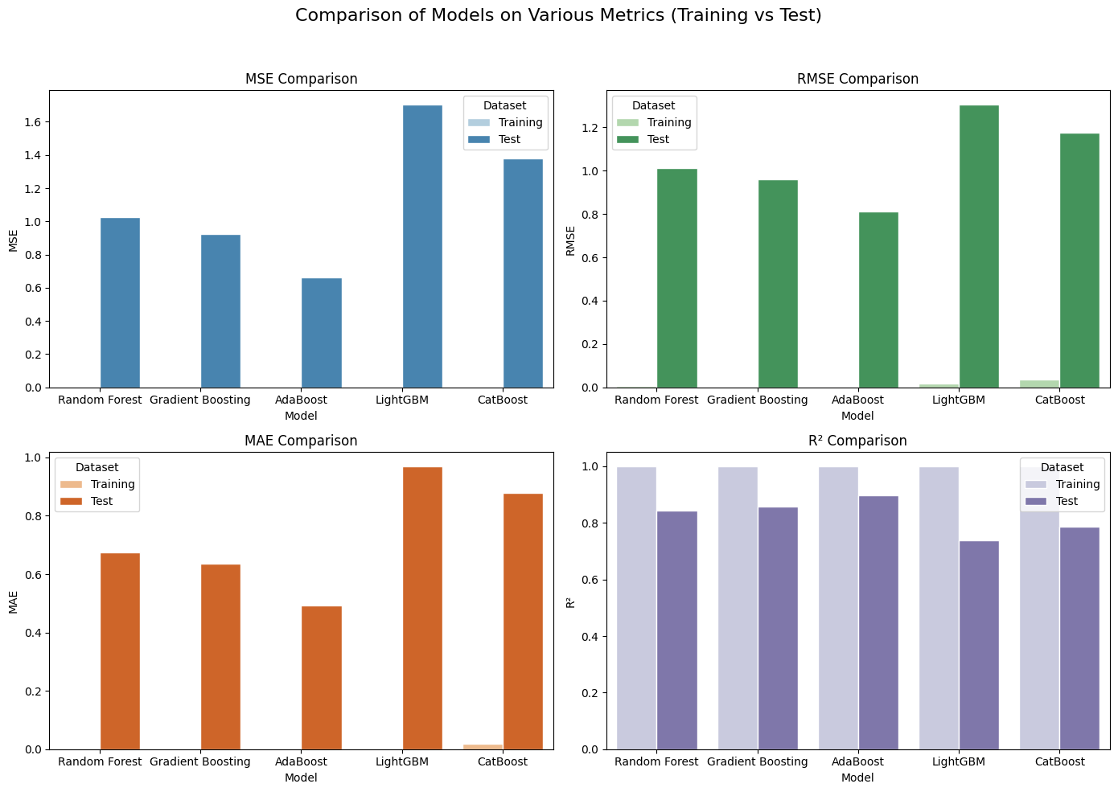

Fig 1 Model’s Performance with Training and Test Data

**AdaBoost** had the best performance on test data, with lower MSE, RMSE, MAE, and a high R² of 0.898.**Gradient Boosting** and **Random Forest** performed reasonably well but with noticeable drops in accuracy compared to training data.**LightGBM** and **CatBoost** showed significant drops in performance, indicating potential overfitting issues.**AdaBoost** is the top performer on the test set.**LightGBM** and **CatBoost** showed large discrepancies between training and test performance, suggesting overfitting.**Gradient Boosting** performed well but did not outperform AdaBoost on the test data.

The model's efficacy has been noted to significantly deteriorate when applied to the test dataset despite exhibiting impressive performance metrics on the training dataset. This discrepancy suggests potential overfitting and calls for a more reliable evaluation framework. To address this, application of cross-validation is proposed as a robust method to re-evaluate the model's performance. By generating synthetic datasets, the models can be tested on different data distributions and patterns, helping to detect weaknesses that may not appear in the original test set. Evaluating the **MSE**, **RMSE**, **MAE**, and **R²** metrics on these synthetic datasets will provide deeper insights into how well each model performs in varied scenarios, ensuring more reliable and generalized model performance.

**Cross Validation on Training Data Sheet**

Gradient Boosting shows excellent performance on training data with minimal errors. Test data performance is consistent with the high training performance, though not as high. Cross-validation results reflect a strong generalization capability, indicating that Gradient Boosting is likely better at handling new, unseen data compared to Random Forest.

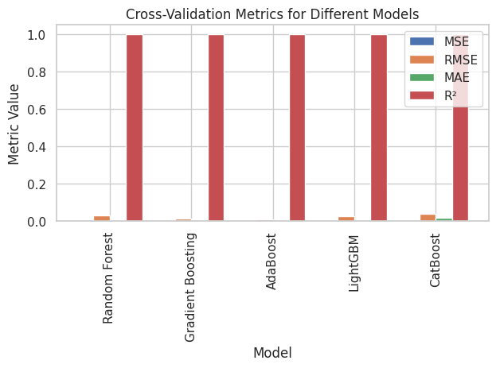

Fig 2 Cross Validation Of Models

AdaBoost achieves perfect scores on training data. The test data results show a decline in performance, but the cross-validation results are impressive, suggesting AdaBoost might be more robust than it appears on test data, but still overfitting to some degree in unseen data which can be compromised.

Cross-validation evaluates model performance on multiple subsets of the data, providing a more reliable estimate of how the model will perform on unseen data.the cross-validation results are close to the training results, it suggests that the model can generalize well to similar data distributions.**AdaBoost** shows the **best performance** with the lowest errors and highest R².**Gradient Boosting** and **LightGBM** also perform well but with slightly higher errors than AdaBoost.**Random Forest** is still strong, while **CatBoost** lags slightly behind in terms of error metrics

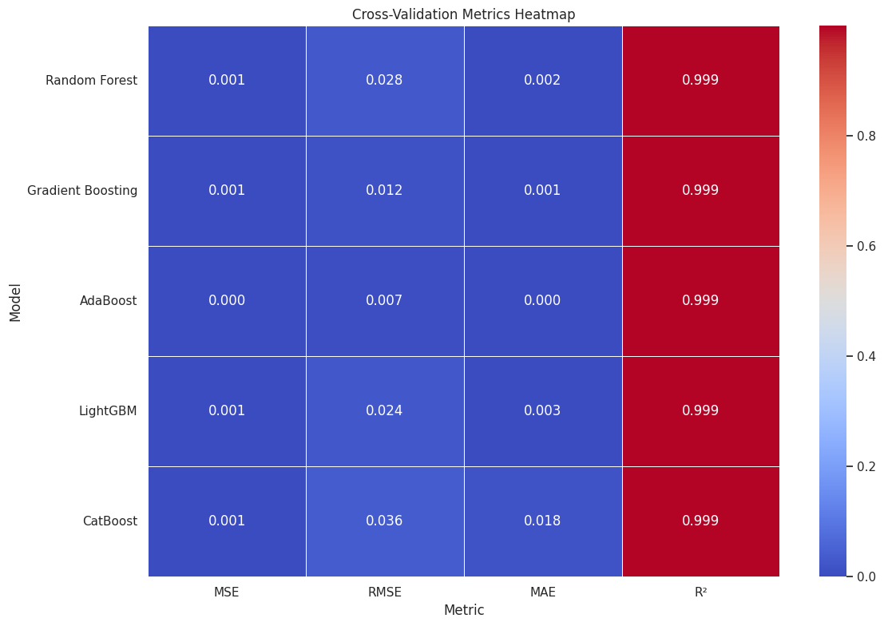

Fig 3 Evaluation Metrics

**Validating Models using Synthetic Data sheets:**

The generate\_random\_data function creates synthetic datasets by resampling the original data. This function allows for generating multiple synthetic datasets with different random samples.The resample function from sklearn.utils is used to create these new datasets. Each synthetic dataset is generated with a different random seed to introduce variability.In this experiment 5 synthetic datasets are generated to validate the model.This approach helps identify potential issues such as overfitting and assess model performance across different conditions.

**Random Forest** generally performs well with low MSE, RMSE, and MAE across most datasets, indicating strong predictive power. However, there is some variability, particularly on Dataset 4, suggesting potential overfitting or sensitivity to data changes

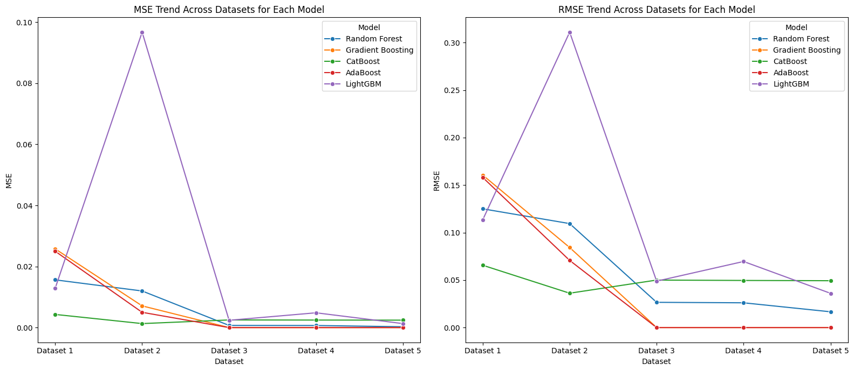

Fig 4 Trends of MSE, RMSE over different data sheet.

.**Gradient Boosting**  Shows excellent performance with near-perfect results on some datasets but exhibits slightly higher errors on Dataset 4. The model's performance is generally robust, with minimal variance.**CatBoost:** Demonstrates good performance with low MSE and RMSE, although MAE and R² values vary more across datasets. This suggests that while CatBoost generally performs well, there is some fluctuation depending on the dataset.**AdaBoost** Performs exceptionally well on most datasets, with perfect results on Datasets 1, 2, and 3. However, it shows higher error rates on Dataset 4, indicating potential overfitting or model limitations on certain data types.**LightGBM** Shows consistent performance with relatively low MSE and RMSE across datasets, though there is some variability, particularly on Dataset 4.

Overall, it is robust but slightly less stable compared to other models.**Gradient Boosting** and **AdaBoost** achieve near-perfect performance on several datasets, but **Gradient Boosting** consistently performs well across multiple datasets with fewer fluctuations.**LightGBM** also performs consistently well but shows more variability on some datasets.**Random Forest** and **CatBoost** perform well overall, but with more variability in results compared to Gradient Boosting and AdaBoost.**Gradient Boosting** appears to be the best performer on synthetic data validation due to its consistent high scores and minimal error metrics across most datasets. It achieves near-perfect results in most cases and demonstrates robustness in various scenarios.

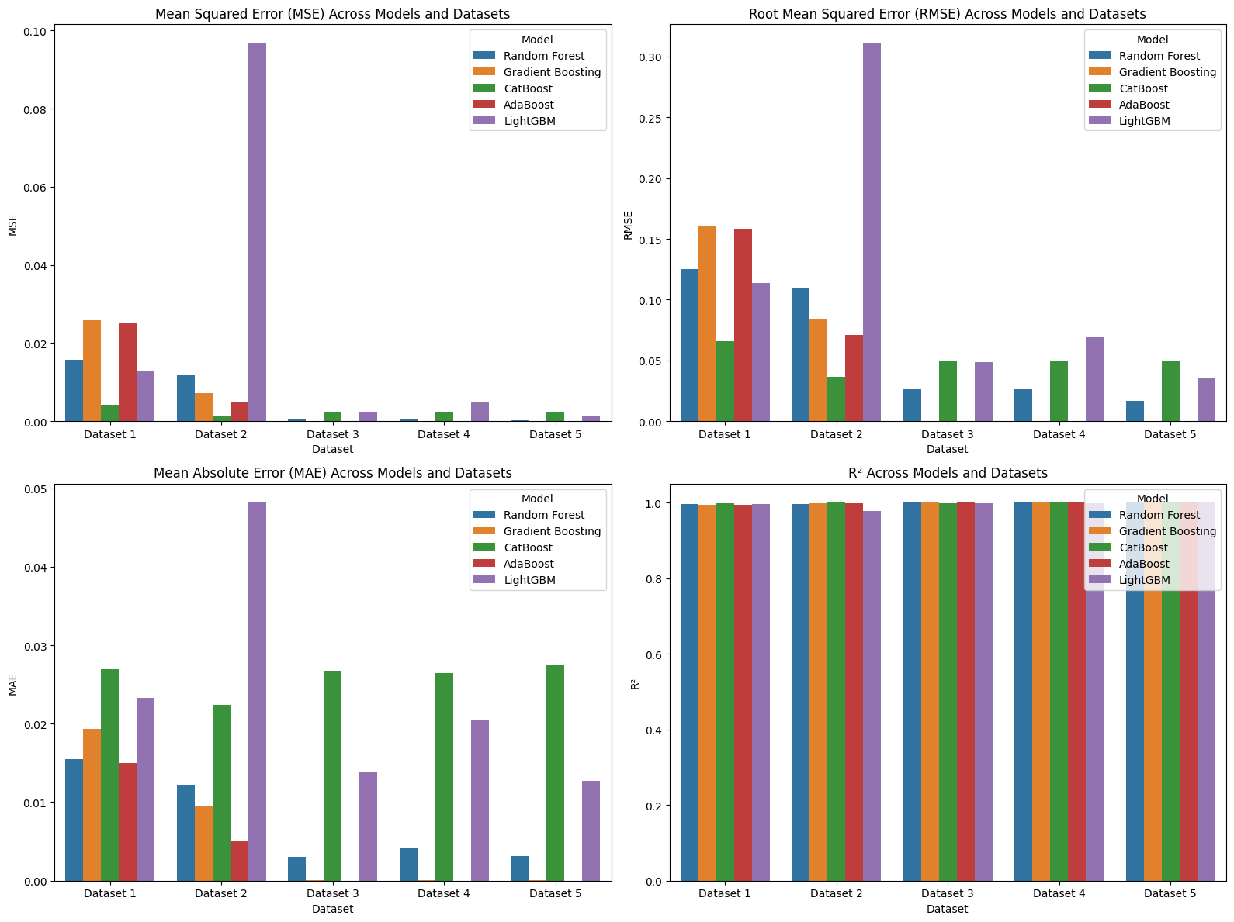

Fig 5 Evaluation metrics across models in Resampled data’s

The SHAP (SHapley Additive exPlanations) summary plots illustrate how each feature contributes to the model predictions for both training and test datasets.

According to random forest model,The most important feature is QDischarge\_mA\_h, showing the highest impact on the model’s predictions. This suggests that the discharge capacity has the strongest influence on predicting battery behavior.Features like Ns, Temperature\_\_C, and cycleNumber contribute minimally to the model.EnergyDischarge\_W\_h and EnergyCharge\_W\_h also play significant roles, but their contributions are lower compared to QDischarge\_mA\_h.Similar to the training data, QDischarge\_mA\_h remains the most critical feature in the test dataset. EnergyDischarge\_W\_h and EnergyCharge\_W\_h follow a similar importance pattern.The low importance of cycleNumber and Temperature\_\_C is consistent across both training and test data, indicating that these features have minimal predictive value in the Random Forest model.

**Table 2 Feature Importance of various model using SHAP, Summary Plot**

|  |  |
| --- | --- |
| Training Data | Test Data |
| IMG_256  Random Forest Model | IMG_256  Random Forest Model |
| IMG_256  Gradient Boost on Training | IMG_256  Gradient Boost on Testing |
| IMG_256  Light BGM on Training | IMG_256  Light BGM on Testing |
| IMG_256  Cat Boost on Training Data | IMG_256  Cat Boost on Testing Data |
| IMG_256  Adaboost on Testing Data | IMG_256  Adaboost on Testing Data |

Across **Random Forest** and **Gradient Boosting**, these two features, **QDischarge\_mA\_h and EnergyDischarge\_W\_h** dominate the model predictions in both training and test datasets. This indicates that the models rely heavily on discharge-related characteristics of the battery for predicting Remaining Useful Life (RUL) or similar outcomes.The **CatBoost** model stands out for giving the highest importance to I\_mA and **QDischarge\_mA\_h** indicating that this feature provides significant predictive power for this particular model.The **AdaBoost** model relies almost exclusively on I\_mA and **QDischarge\_mA\_h** for its predictions, suggesting that it simplifies the prediction process by focusing on a single, highly influential feature.The Light GBM relies on **EnergyDischarge\_W\_h and EnergyChargre\_W\_h,**suggesting that it simplifies the prediction process.Across all models, Temperature\_\_C and cycleNumber are consistently shown to have minimal impact on model predictions. These features do not appear to provide useful information for the models in this dataset.

The feature contributions across various models (Random Forest, Gradient Boosting, AdaBoost, LightGBM, and CatBoost) for predicting the target variable Ns using LIME has been proven through the following results.

|  |  |
| --- | --- |
| **Feature importance of Sample Instance 0 across various models using LIME** | **Feature Analysis** |
| IMG_256 | **Random Forest**  **Predominant Positive Feature:** QDischarge\_mA\_h,EnergyDischarge\_W\_h  **Predominant Negative Feature**:I\_mA, Ecell\_V  **Null Effect Feature:**Cycle Number |
| IMG_256 | **Gradient Boosting**  **Predominant Positive Feature:** QDischarge\_mA\_h,EnergyDischarge\_W\_h  **Predominant Negative Feature:** I\_mA,Q charge\_mA\_h  **Null Effect Feature:**Cycle Number and Temperature\_C |
| IMG_256 | **AdaBoost**  **Predominant Positive Feature:** QDischarge\_mA\_h,EnergyDischarge\_W\_h  **Predominant Negative Feature:**Q charge\_mA\_h  **Null Effect Feature:**Cycle Number |
| IMG_256 | **LightGBM**  **Predominant Positive Feature:**EnergyDischarge\_W\_h(only Positive Feature)  **Predominant Negative Feature**: I\_mA, Ecell\_V, Q charge\_mA\_h  Null Effect Feature: Cycle Number |
| IMG_256 | **CatBoost**  **Predominant Positive Feature:**EnergyDischarge\_W\_h, QDischarge\_mA\_h(All were positive features)  **Predominant Negative Feature:** NIL  **Null Effect Feature:**Cycle Number |

**QDischarge\_mA\_h** and **EnergyDischarge\_W\_h** consistently emerge as the most significant positive features across almost all models, reflecting their strong influence on the predictions. In contrast, features like **I\_mA** and **Ecell\_V** negatively impact the predictions in models such as Random Forest and LightGBM, indicating that higher values in these features tend to reduce the predicted Ns.Interestingly, some features, such as **Cycle Number**, have a null effect across all models, indicating that it does not significantly contribute to the predictions. In certain cases, such as in Gradient Boosting, **Temperature\_C** also shows no contribution. This suggests that these features may be redundant or less influential in this particular predictive task.

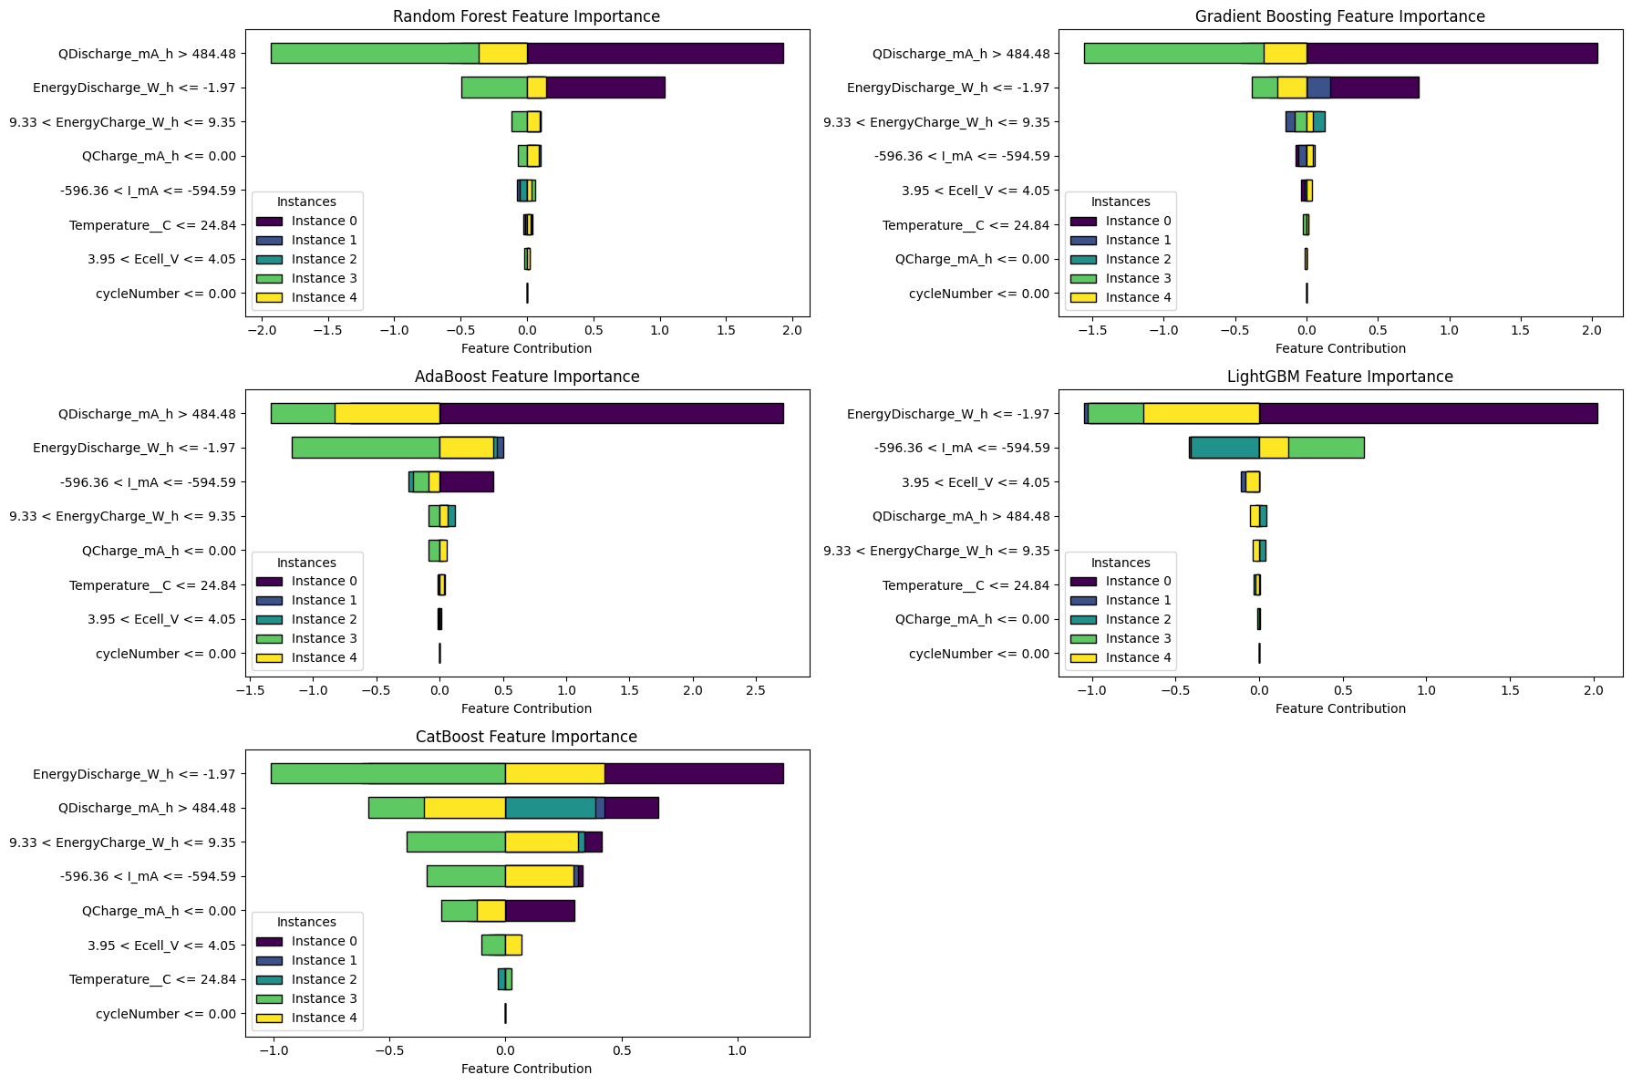

Fig : Feature importance of 5 instances over various models

Meanwhile, **QCharge\_mA\_h** exhibits a negative impact in models like Gradient Boosting and AdaBoost, highlighting a more complex relationship between charge capacity and the target variable.CatBoost stands out in its behavior, showing no negative feature contributions, with all relevant features, including **EnergyDischarge\_W\_h** and **QDischarge\_mA\_h**, positively influencing the predictions. This differs from the other models, where a mix of positive and negative contributions is common. Overall, while there is alignment across models in terms of the most impactful features, subtle differences in the handling of specific features like **QCharge\_mA\_h** and **I\_mA** suggest varying feature importance strategies in these models.

**CONCLUSION**

All models achieved high accuracy on the training data, with **AdaBoost** and **Gradient Boosting** showing the best performance, achieving near-perfect scores (MSE: 0, R²: 1.0) in training data.The models like **Random Forest** and **CatBoost** also performed extremely well, though **LightGBM** slightly underperformed in comparison.In test data performance **AdaBoost** outperformed others with an MSE of 0.66, RMSE of 0.812, and R² of 0.898, suggesting its strong generalization ability on unseen data.**Gradient Boosting** and **Random Forest** also performed well with comparable MSE and RMSE values, though **Random Forest** had a slightly lower R² (0.842) than Gradient Boosting (0.857).**AdaBoost** consistently performed best across synthetic datasets, maintaining near-perfect accuracy in most cases. **Gradient Boosting** and **LightGBM** also demonstrated strong performance, with low errors in synthetic datasets, except for slight variations in Dataset 4.

**CatBoost** and **Random Forest** were slightly less stable across synthetic datasets, showing some performance degradation on more complex datasets, though they still achieved good results overall.**QDischarge\_mA\_h (Discharge Capacity)** and **EnergyDischarge\_W\_h (Energy Discharge)** consistently emerged as the most **positively influential features** across all models, as identified by both **LIME** and **SHAP**. This suggests that the models heavily rely on the energy discharged and discharge capacity to predict the RUL, which aligns with domain knowledge, since the discharge behavior of a battery is highly correlated with its health and remaining life.**I\_mA (Current)** and **Ecell\_V (Voltage)** frequently appeared as **negative features** in the models (e.g., **Random Forest**, **LightGBM**). This means that higher values of these features might be associated with a shorter RUL, potentially due to increased internal resistance and voltage drops indicating battery degradation. Notably, **QCharge\_mA\_h (Charge Capacity)** was identified as a negative feature in several models (**Gradient Boosting**, **AdaBoost**, **LightGBM**), indicating that the charging capacity may also serve as a signal for battery health, though its relationship may vary depending on the charging cycles and conditions.

**FUTURE SCOPE**

Future work should focus on the **explainability** of models using tools like **SHAP** and **LIME** to understand the feature contributions better. This could help optimize the model further by focusing on the most important battery features for RUL prediction, like discharge capacity and battery current.The insights from feature importance analyses suggest focusing on **energy discharge** and **discharge capacity** when refining models. Features like **current** and **voltage** could be further explored to understand why they negatively influence predictions.The null effect of **Cycle Number** and **Temperature** suggests that more granular features (e.g., **internal resistance**, **degradation states**) could be introduced to enhance model predictions.Building on the insights provided by **SHAP** and **LIME**, there is scope to explore more advanced explainable AI techniques. For instance, integrating **Counterfactual Explanations** or **Explanatory Local Model Analysis (ELMA)** could provide further insights into how individual features influence model predictions and allow for more interpret able results.

Further testing on real-world battery datasets (in addition to synthetic data) can enhance the model's robustness in diverse use cases. Testing in different operational environments, temperature ranges, and battery types could provide more reliable predictions across various conditions.Applying data augmentation techniques to both real and synthetic datasets can enhance the diversity of the training data and improve model performance. For example, introducing variations in **charging/discharging cycles** or **operational conditions** could make the models more robust.

**Conflict of Interest**  
No conflict of interest in this manuscript.

**REFERENCES**

1. J. Chen, P. Kollmeyer, S. Panchal, Y. Masoudi, O. Gross, A. Emadi, Sequence Training and Data Shuffling to Enhance the Accuracy of Recurrent Neural Network Based Battery Voltage Models, Tech. Rep. No. 2024-01-2426, SAE Technical Paper, 2024.
2. Oyucu, S.; Ersöz, B.; Sağıroğlu, Ş.; Aksöz, A.; Biçer, E. "Optimizing Lithium-Ion Battery Performance: Integrating Machine Learning and Explainable AI for Enhanced Energy Management". Sustainability 2024, 16, 4755. https://doi.org/10.3390/su16114755.
3. Qiao, J. Liu, X.; Chen, Z. Prediction of the Remaining Useful Life of Lithium-Ion Batteries Based on Empirical Mode Decomposition and Deep Neural Networks. *IEEE Access* 2020, *8*, 42760−42767.
4. Yin, J.Zhang, M.; Feng, T. State of Health Prediction for Lithium-Ion Batteries through Curve Compression and CatBoost. World Electr. Veh. J. 2023, 14, 180. <https://doi.org/10.3390/wevj14070180>
5. Xu, J.; Zhen, A.; Cai, Z.; Wang, P.; Gao, K.; Jiang, D. State of Health Diagnosis and Remaining Useful Life Prediction of Lithium-Ion Batteries Based on Multi-Feature Data and Mechanism Fusion. *IEEE Access* 2021, *9*, 85431−85441.
6. Xing, Y.; Ma, E.; Tsui, K. L.; Pecht, M. An ensemble model for predicting the remaining useful performance of lithium-ion batteries. *Microelectron. Reliab.* 2013, *53*, 811−820.
7. Jie Li, Shiming Zhao, Md Sipon Miah, Mingbo Niu, Remaining useful life prediction of lithium-ion batteries via an EIS based deep learning approach,Energy Reports,Volume 10,2023,Pages 3629-3638,ISSN 2352-4847,https://doi.org/10.1016/j.egyr.2023.10.030.
8. Shahid A. Hasib, S. Islam, Md F. Ali, Subrata. K. Sarker, Li Li, Md Mehedi Hasan, Dip K. Saha,Enhancing prediction accuracy of Remaining Useful Life in lithium-ion batteries: A deep learning approach with Bat optimizer,Future Batteries,Volume 2,2024,100003,ISSN 2950-2640,https://doi.org/10.1016/j.fub.2024.100003.
9. A hybrid CNN-BiLSTM approach for remaining useful life prediction of EVs lithium-Ion battery January 2023 Measurement and Control 56(1-2):002029402211036 DOI: 10.1177/00202940221103622 LicenseCC BY 4.0Dexin GaoXin LiuZhenyu ZhuQing Yang
10. Q. Xu, M. Wu, E. Khoo, Z. H. Chen, and X. L. Li, “A hybrid ensemble deep learning approach for early prediction of battery remaining useful life,” IEEE/CAA J. Autom. Sinica, vol. 10, no. 1, pp. 177–187, Jan. 2023 doi: 10.1109/JAS.2023.123024
11. Strange, Calum and Ibraheem, Rasheed and dos Reis, Gonçalo,”Online Lifetime Prediction for Lithium-Ion Batteries with Cycle-by-Cycle Updates, Variance Reduction, and Model Ensembling”,Energies, VOLUME 16, 2023, <https://www.mdpi.com/1996-1073/16/7/3273,> ISSN 1996-1073,
12. M. Catelani, L. Ciani, R. Fantacci, G. Patrizi and B. Picano, "Remaining Useful Life Estimation for Prognostics of Lithium-Ion Batteries Based on Recurrent Neural Network," in IEEE Transactions on Instrumentation and Measurement, vol. 70, pp. 1-11, 2021, Art no. 3524611, doi: 10.1109/TIM.2021.3111009.
13. Yuliani, Asri Rizki and Ramdan, Ade and Zilvan, Vicky and Supianto, Ahmad Afif and Krisnandi, Dikdik and Yuwana, Raden Sandra and Prajitno, Dicky and Pardede, Hilman, “Remaining Useful Life Prediction of Lithium-Ion Battery Based on LSTM and GRU” 2022 ISBN 9781450385244 Association for Computing Machinery <https://doi.org/10.1145/3489088.3489092> 10.1145/3489088.3489092
14. Han, Yunlong & Li, Conghui & Zheng, Linfeng & Lei, Gang & Li, Li. (2023). Remaining Useful Life Prediction of Lithium-Ion Batteries by Using a Denoising Transformer-Based Neural Network. Energies. 16. 6328. 10.3390/en16176328.
15. K. Park, Y. Choi, W. J. Choi, H. -Y. Ryu and H. Kim, "LSTM-Based Battery Remaining Useful Life Prediction With Multi-Channel Charging Profiles," in IEEE Access, vol. 8, pp. 20786-20798, 2020, doi: 10.1109/ACCESS.2020.2968939.
16. Zhuqing Wang, Ning Liu, Chilian Chen, Yangming Guo, Adaptive self-attention LSTM for RUL prediction of lithium-ion batteries, Information Sciences, Volume 635, 2023, Pages 398-413, ISSN 0020-0255, <https://doi.org/10.1016/j.ins.2023.01.100.>
17. B. Jenkins, A. Krupadanam, A.M. Annaswamy, Fast adaptive observers for battery management systems, IEEE Trans. Contr. Syst. Technol. (2019), https://doi.org/ 10.1109/TCST.2019.2891234.
18. Y. Zou, X. Hu, H. Ma, S.E. Li, Combined state of charge and state of health estimation over lithium-ion battery cell cycle lifespan for electric vehicles, J. Power Sources 273 (2015) 793–803, https://doi.org/10.1016/j.jpowsour.2014.09.146.
19. J. Wu, Z. Wei, W. Li, Y. Li, D.U. Sauer, Battery Thermal- and Health-Constrained Energy Management for Hybrid Electric Bus based on Soft Actor-Critic DRL Algorithm, IEEE Trans. Indus. Info. (2020), https://doi.org/10.1109/ TII.2020.3014599.
20. S. Wang, D. Guo, X. Han, L. Lu, K. Sun, W. Li, D.U. Sauer, M. Ouyang, Impact of battery degradation models on energy management of a grid-connected DC micro-grid, Energy 207 (2020) 118228, https://doi.org/10.1016/j. energy.2020.118228.
21. W. Li, D. Cao, D. Jost, ¨ F. Ringbeck, M. Kuipers, F. Frie, D.U. Sauer, Parameter sensitivity analysis of electrochemical model-based battery management systems for lithium-ion batteries, Appl. Energy 269 (2020) 115104, https://doi.org/ 10.1016/j.apenergy.2020.115104.
22. Life Prognostic of Lithium-ion Batteries with Li(NiMnCo)O2 Cathode with Capacity Diving. *IEEE Access* 2020, *8*, 58717−58729.
23. Hu, X.; Che, Y.; Lin, X.; Onori, S. Battery Health Prediction Using Fusion-Based Feature Selection and Machine Learning. *IEEE Trans. Transp. Electrification* 2021, *7*, 382−398.
24. Wikner, E.; Björklund, E.; Fridner, J.; Brandell, D.; Thiringer, T. How the utilised SOC window in commercial Li-ion pouch cells influence battery ageing. *J. Power Sources Adv.* 2021, *8*, 100054.
25. Edge, J.S.; O’Kane, S.; Prosser, R.; Kirkaldy, N.D.; Patel, A.N.; Hales, A.; Ghosh, A.; Ai, W.; Chen, J.; Yang, J.; et al. Lithium ion battery degradation: What you need to know. *Phys. Chem. Chem. Phys.* 2021, *23*, 8200–8221.
26. Montaru, M.; Fiette, S.; Koné, J.L.; Bultel, Y. Calendar ageing model of Li-ion battery combining physics-based and empirical approaches. *J. Energy Storage* 2022, *51*, 104544.
27. Román-Ramírez, L.; Marco, J. Design of experiments applied to lithium-ion batteries: A literature review. *Appl. Energy* 2022, *320*, 119305.
28. Braco, E.; San Martín, I.; Sanchis, P.; Ursúa, A. Fast capacity and internal resistance estimation method for second-life batteries from electric vehicles. *Appl. Energy* 2023, *329*, 120235.
29. Srivastava, N., Hinton, G., Krizhevsky, A., Sutskever, I., & Salakhutdinov, R. (2014). Dropout: A Simple Way to Prevent Neural Networks from Overfitting. Journal of Machine Learning Research, 15, 1929-1958.
30. Wei, J.; Dong, G.; Chen, Z. Remaining Useful Life Prediction and State of Health Diagnosisfor Lithium-Ion Batteries Using Particle Filter and Support Vector Regression. *IEEE Trans. Ind. Electron.* 2018, *65*, 5634−5643.
31. P.Keren Persis, R.Geetha,2023,A Comparative Analysis on the Conventional Methods, Benefits of Recycling the Spent Lithium-ion Batteries with a Special focus on Ultrasonic Delamination,IEEE conferenceProceedings <https://ieeexplore.ieee.org/document/10110162>
32. Impact of fully connected layers on performance of convolutional neural networks for image classification, S H Shabbeer Basha, Shiv Ram Dubey, Viswanath Pulabaigari, Snehasis Mukherjee 2019,Neurocomputing
33. Andrioaia, D.A.; Gaitan, V.G.; Culea, G.; Banu, I.V. "Predicting the RUL of Li-Ion Batteries in UAVs Using Machine Learning Techniques". Computers 2024, 13, 64. <https://doi.org/10.3390/computers13030064>
34. Yunpeng Liu, Bo Hou, Moin Ahmed, Zhiyu Mao, Jiangtao Feng, Zhongwei Chen,A hybrid deep learning approach for remaining useful life prediction of lithium-ion batteries based on discharging fragments,Applied Energy,Volume 358,2024,122555,ISSN 0306-2619,https://doi.org/10.1016/j.apenergy.2023.122555
35. Brahim ZraibiBrahim, ZraibiMohamed MansouriMohamed MansouriSalah Eddine Loukili, Comparing deep learning methods to predict the remaining useful life of lithium-ion batteriesApril 2022Materials Today Proceedings 62(10)
36. Xiao L, Liu Z, Zhang Y, Zheng Y. Bearings remaining useful life prediction with combinatorial feature extraction method and gated recurrent unit network. In: Proceedings of the 2020 IEEE 9th data driven control learn. syst. conf. DDCLS 2020; 2020, p. 360–5. https://doi.org/10.1109/DDCLS49620.2020.9275098
37. P.Keren Persis, R.Geetha,2022 A Conceptual Analysis on Lithium ion Batteries in the Field of Energy with its Limitation and Future Perspective,IEEEconference Proceedings <https://ieeexplore.ieee.org/document/10047404>
38. Liu, H.; Xiao, Q.; Jin, Y.; Mu, Y.; Meng, J.; Zhang, T.; Jia, H.; Teodorescu, R. Improved LightGBM-Based Framework for Electric Vehicle Lithium-Ion Battery Remaining Useful Life Prediction Using Multi Health Indicators. Symmetry 2022, 14, 1584. <https://doi.org/10.3390/sym14081584>
39. H. Li, M. Yazdi, H.Z. Huang, C.G. Huang, W. Peng, A. Nedjati, K.A. Adesina, “A fuzzy rough copula Bayesian network model for solving complex hospital service quality assessment,” Complex & Intelligent Systems, (2023): 536 1-27. DOI: https://doi.org/10.1007/s40747-023- 01002-
40. Nair, Pranav & Vakharia, Vinay & Borade, Himanshu & Shah, Milind & Wankhede, Vishal Ashok. (2023). Predicting Li-Ion Battery Remaining Useful Life: An XDFM-Driven Approach with Explainable AI. Energies. 16. 5725. 10.3390/en16155725.
41. Cong, X.; Zhang, C.; Jiang, J.; Zhang, W.; Jiang, Y.; Jia, X. An Improved Unscented Particle Filter Method for Remaining Useful Life Prognostic of Lithium-ion Batteries with Li(NiMnCo)O2 Cathode with Capacity Diving. *IEEE Access* 2020, *8*, 58717−58729.
42. Jafari, S.; Shahbazi, Z.; Byun, Y.C.; Lee, S.J. Lithium-Ion Battery Estimation in Online Framework Using Extreme Gradient Boosting Machine Learning Approach. *Mathematics* 2022, *10*, 888
43. Sulzer, V., Marquis, S. G., Timms, R., Robinson, M., & Chapman, S. J. (2021). Python battery mathematicalmodelling (PyBaMM). *Journal of Open Research Software*, *9*(1). https://doi.org/10.5334/jors.309
44. Tranter, T. G., Timms, R., Heenan, T. M. M., Marquis, S. G., Sulzer, V., Jnawali, A., Kok, M. D. R., Please, C. P., Chapman, S. J., Shearing, P. R., & others. (2020). Probing heterogeneity in Li-ion batteries with coupled multiscale models of electrochemistry and thermal transport using tomographic domains. *Journal of The Electrochemical Society*, *167*(11), 110538. <https://doi.org/10.1149/1945-7111/aba44b>
45. Shaheer Ansari, Afida Ayob, M.S. Hossain Lipu, Aini Hussain, Mohamad Hanif Md Saad,Remaining useful life prediction for lithium-ion battery storage system: A comprehensive review of methods, key factors, issues and future outlook,Energy Reports,Volume 8,2022,Pages 12153-12185,ISSN 2352-4847,

<https://doi.org/10.1016/j.egyr.2022.09.043.>

1. Wang, G.; Lyu, Z.; Li, X. "An Optimized Random Forest Regression Model for Li-Ion Battery Prognostics and Health Management". Batteries 2023, 9, 332. <https://doi.org/10.3390/batteries9060332>
2. Minghan Bao, Dexun Liu, Yuyao Wu, Zhengying Wang, Jing Yang, Lin Lan, Qiang Ru, "Interpretable machine learning prediction for li-ion battery's state of health based on electrochemical impedance spectroscopy and temporal features" Electrochimica Acta, Volume 494,2024,ISSN 0013-4686, <https://doi.org/10.1016/j.electacta.2024.144449.>