**Enhancing Oil-Water Separation: Impact of Nanoparticle Coatings on Quartz Particles**

Nthabiseng J. Ramanamane1*, Mothibeli Pita2

1 Department of Mechanical Engineering, Bioresources and Biomedical Engineering, School of Engineering and the Built Environment, University of South Africa, Florida 1710, Private Bag X06, South Africa, [ramannj@unisa.ac.za](mailto:ramannj@unisa.ac.za), [pitam@unisa.ac.za](mailto:pitam@unisa.ac.za)

**ABSTRACT**

Efficient separation of oil-water emulsions is critical for addressing environmental pollution caused by industrial wastewater. This study investigates the application of quartz material coated with hydrophobic nanoparticles to enhance oil-water separation efficiency. Quartz samples were prepared and analysed under different conditions: raw, washed, and coated with one to four layers of hydrophobic nanoparticles. Surface morphology was evaluated using Scanning Electron Microscopy (SEM), revealing the impact of nanoparticle distribution, surface roughness, and inter-particle separation on wettability. The first coating demonstrated optimal nanoparticle distribution, resulting in superior wettability and oil rejection efficiency, reducing oil and grease concentration to 29.3 mg/L. Successive coatings led to clustering and irregular surface morphology, adversely affecting separation performance. Mathematical models were developed to quantify key parameters, including oil rejection efficiency, nanoparticle uniformity, and separation efficiency. The findings highlight the potential of quartz material with a single hydrophobic nanoparticle coating as a low-cost, efficient solution for oil-water separation, providing insights into optimizing coating processes for environmental applications.

***keyword***

|  |  |  |  |
| --- | --- | --- | --- |
| Oil-water separation, Quartz material, Hydrophobic nanoparticles, Wettability, Surface morphology, Scanning Electron Microscopy (SEM), Oil rejection efficiency, Nanoparticle coating, Environmental pollution, Wastewater treatment. | | |  |
|  | | |  |
|  | |
|  |  |
|  |  |
|  |  |
|  |

# Introduction

# 

Oily wastewater is a significant byproduct of various industrial processes, including oil and gas exploration, petrochemicals, textiles, food production, and metalworking industries [1,2]. When inadequately treated, industrial waste, including oily wastewater, poses serious risks to human health, the environment, and ecosystems. This issue has garnered global attention, prompting the enforcement of regulations for waste treatment, reuse, and discharge limits, particularly concerning oily wastewater [3]. In this context, membrane filtration has emerged as a promising, energy-efficient, and environmentally friendly solution due to its ease of use, high removal efficiency, and minimal secondary pollution [4]. Recent research has increasingly focused on materials with optimal wettability for treating oily wastewater. However, traditional commercial ceramic membranes are costly due to expensive raw materials and high sintering temperatures, making polymer membranes more economical for conventional wastewater treatment [5]. Consequently, developing low-cost ceramic membranes or supports using inexpensive minerals such as bauxite, quartz, kaolin, coal gangue, or clay-sand has become a critical area of research in the field of ceramic membranes [6–8]. Amongst other low cost inexpensive mineral materials used for oily wastewater separation, quartz was reported as the promising material for membrane filtration processess [9,10].

Several studies were conducted to investigate the oporating parameters of the quartz sands, for insttance Hengyang et al. [11] improved the mechanical performance of quartz sand membranes by introducing a sintering agent, achieving a consistent pore size of 270 nm and an oil rejection efficiency exceeding 97%. While, Jinglin et al. [12] investigated varying pore sizes, finding that membranes with a pore size of 190 nm achieved a examined quartz sand membranes sintered at 1000°C, reporting a pore size of 16.24 nm, compressive strength of 31.05 MPa, and a maximum oil removal rate of 71.25%, highlighting the benefits of higher sintering temperatures for mechanical strength. Although several studies have been conducted using quartz sands and measuring operational parameters, there is limited research on the impact of nanoparticle coating on the surface of the quartz particles to improve the wettability of the material for enhanced oil-water separation purity. Therefore, the current study will analyse the impact of hydrophobic nanoparticles on quartz martial surfaces, specifically dry-graded silica particles ( $SiO_{2} 98\%, Fe_{2}O_{3} 0,18\%,$ particle size 0.8-1.8 mm) to improve the oil-water separation quality and develop mathematical models to quantify key parameters.

1. **MATERIALS AND METHODS**

The dry-graded silica particles ( $SiO_{2} 98\%, Fe_{2}O_{3} 0,18\%,$ particle size 0.8-1.8 mm) were prepared using the crushing technique where the desired particle sizes between 0.8-1.8 mm were obtained as indicated in Figure 1.

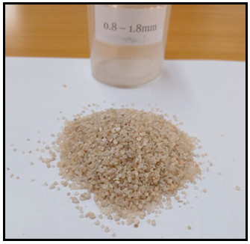

**Figure 1.** Crushed quartz particles

After crushing, the quartz material was thoroughly cleaned using a descaling chemical to eliminate surface impurities and contaminants prior to coating. The cleaned quartz was then air-dried at room temperature (25 °C) for 24 hours. Once dry, the material was spread in a thin, even layer on a flat surface. A high-pressure spray gun was employed to apply hydrophobic nanoparticles to the quartz particles, aiming to enhance surface wettability. Coatings were applied sequentially, ranging from one to four layers, to evaluate their performance in oil-water separation [13].

To ensure uniform coating, the spray gun nozzle was positioned at a 90-degree angle, maintaining a 5 mm distance from the particle surface. After coating, the quartz particles were prepared for analysis using Scanning Electron Microscopy (SEM) to examine surface morphology, as illustrated in Figure 2. For a comprehensive comparison of surface wettability, the samples were categorized into four groups: raw, washed, and coated (with one to four layers of nanoparticles).

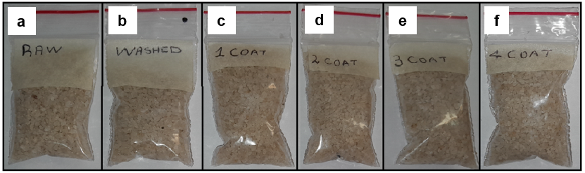

**Figure 2.** Samples prepared for SEM characterization, illustrating the progression from untreated to multiple coated stages. The samples include (a) Raw quartz material, showcasing its natural surface structure; (b) Quartz after washing, highlighting the cleaned surface; (c) Quartz with the first nanoparticle coating, showing the initial distribution of nanoparticles; (d) Quartz with a second coating, indicating changes with an additional layer; (e) Quartz with a third coating, demonstrating further nanoparticle buildup; and (f) Quartz with the fourth coating, representing the final stage before SEM analysis. These samples enable detailed analysis of surface morphology and nanoparticle adherence through SEM imaging.

**2.1 Oil/water separation using quartz martial**

Dry-graded silica particles (SiO₂ 98%, Fe₂O₃ 0.18%, particle size 0.8–1.8 mm) were utilized to investigate the quality of permeate during oil-water separation. The study employed the gravitational bed gravity-accelerated technique, as illustrated in Figure 3, to ensure a separation process free from mechanical or electrical influence. Diesel in water was used to simulate industrial oily wastewater in the experiments [14–16].

**Figure 3.** Illustrates the quartz material employed for oil and water separation, with (a) showing the quartz filtration bed and (b) depicting the oil and water mixture

**2.2 Mathematical models developed to analyze quartz material performance**

The mathematical models were developed to analyze the performance of quartz materials in oil-water separation.

Eq. (1) indicates the **Oil Rejection Efficiency (ORE), t**his model measures the quartz material's ability to reduce oil content after treatment, where $C_{initial}$ is oil and grease concentration in the feed water (mg/L) and $C_{final}$ represents the Oil and grease concentration in the treated water (mg/L).

$ORE\left(\%\right)=\frac{C_{initial}-C_{final}}{C_{initial}}×100$ (1)

Eq. (2) represents the **Surface Wettability Contribution (SWC),** this model evaluates the contribution of surface wettability to the oil rejection process, accounting for the number of coatings, where $n$ is the number of hydrophobic nanoparticle coatings applied to the quartz material.

$SWC=\frac{ORE\left(\%\right)}{n}$ (2)

Eq. (3) indicates the **Separation Performance Index (SPI),** the SPI assesses the material’s efficiency in separating water from the oil-water mixture, incorporating permeate volume and feed concentration. Where $V_{Clean water}$ is the Volume of water separated (L) and $V_{total feed}$ is the total volume of the oil-water feed (L).

$SPI=\frac{V_{Clean water}}{V_{total feed}}×OER$ (3)

Eq. (4) shows the **Nanoparticle Coverage Consistency (NCC),** to assess the uniformity of nanoparticle coating on the quartz surface, this equation was developed based on SEM image data. Where $σ_{s}$ is standard deviation of inter-particle distances (µm) and $µ_{s}$ is mean inter-particle distance (µm).

$NCC=1-\frac{σ_{s}}{µ_{s}}$ (4)

Eq. (5) shows the **Surface Morphology Factor (SMF),** where surface roughness plays a role in oil separation. The SMF quantifies the relationship between roughness and effective surface area, where $A_{actual}$ is the measured surface area, considering roughness and $A_{flat}$ indicates the projected flat surface area.

$SMF=\frac{A_{actual}}{A_{flat}}$ (5)

Eq. (6) represents the **Oil Removal Capacity (ORC),** this model calculates the amount of oil removed by the material per unit mass or volume of quartz, where $M_{quartz }$ is the mass of quartz material used (g).

$ORC=\frac{C_{initial}-C_{final}}{M_{quartz }}$ (6)

Using these models, the efficiency and performance metrics for each coating stage (raw, washed, first to fourth coatings) can be calculated. For example:

* **ORE and SWC** help determine the effectiveness of each coating.
* **NCC and SMF** evaluate nanoparticle orientation and surface morphology from SEM data.
* **SPI and ORC** provide insights into separation efficiency and the material's oil removal capacity.

1. **RESULTS AND DISCUSSIONS**

The SEM was used to investigate the surface morphology of quartz particles and the gravitational bed gravity-accelerated technique was used to validate the miscrospopic results. The permeate quality was assessed using the oil and grease analysis to test the water quality afer oil and water separation.

**3.1 SEM analysis**

Figures 4–9 below present the Scanning Electron Microscopy (SEM) results obtained during the analysis of quartz material. The images include the raw quartz (Figure 4), the quartz material after the washing process (Figure 5), and the surfaces coated with hydrophobic nanoparticles, progressing from the first coating (Figure 6) to the fourth coating (Figure 9). These results illustrate the changes in surface morphology at each stage of preparation and coating.

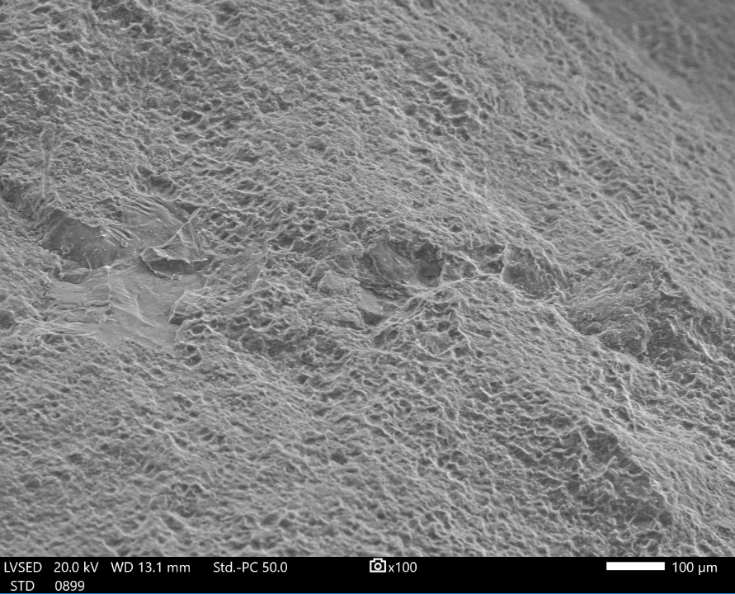

**Figure 4.** Presents the Scanning Electron Microscopy (SEM) image of the raw quartz material, highlighting its surface morphology prior to any treatment or coating

Figure 4 shows raw quartz material: The raw quartz material exhibits a rough and uneven surface with visible impurities and irregularities [17,18]. The surface morphology indicates the presence of contaminants that can hinder effective oil-water separation. The roughness is inconsistent, and the absence of hydrophobic treatment leaves the surface with poor wettability characteristics.

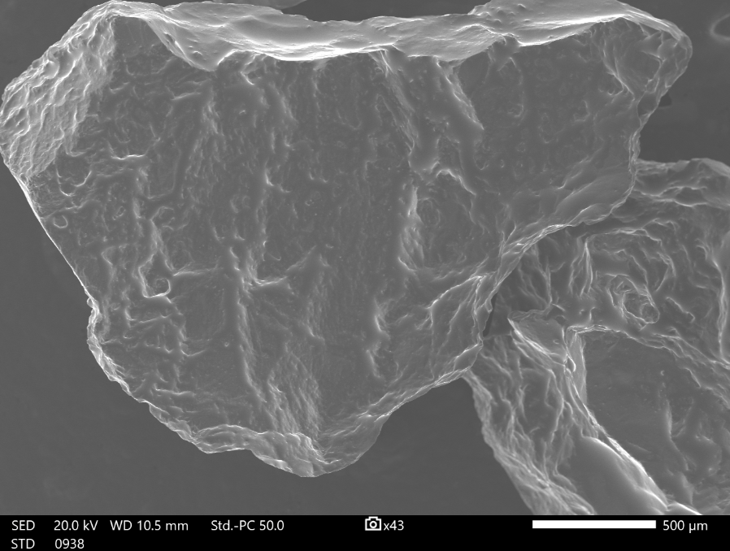

**Figure 5.** Displays the Scanning Electron Microscopy (SEM) image of the quartz material after the washing process, illustrating the cleaned surface morphology following the removal of impurities and contaminants

Figure 5 shows washed quartz material: After the washing process, the SEM image (Figure 5) reveals a significant reduction in surface impurities. The surface becomes cleaner, with more uniform roughness compared to the raw material. This cleaning process is essential for preparing the quartz material to enhance the adhesion and uniformity of subsequent nanoparticle coatings [19,20]. Despite the improvement in cleanliness, the material still lacks hydrophobic properties, making it unsuitable for efficient oil-water separation.

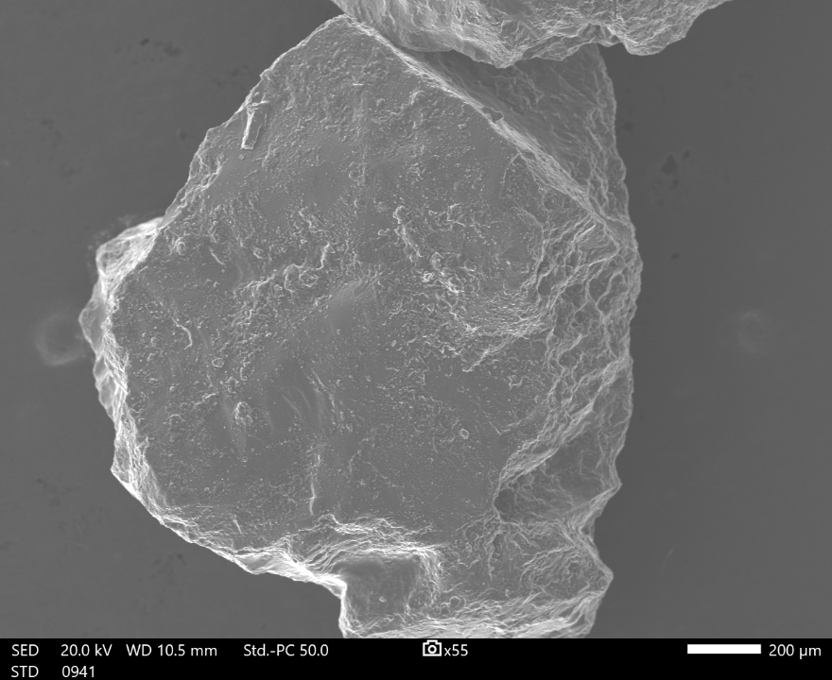

**Figure 6.** illustrates the Scanning Electron Microscopy (SEM) image of the quartz material surface after the first coating with hydrophobic nanoparticles, highlighting the initial layer of coverage applied to enhance surface wettability

Figure 6 shows first coating: The SEM image of the first coating shows a relatively uniform layer of hydrophobic nanoparticles on the quartz surface. The distribution of nanoparticles is consistent, with minimal clustering [21–23]. This even coverage contributes to optimal surface wettability, as the hydrophobic nanoparticles enhance the surface energy, making it resistant to water adhesion. The inter-separation distances between nanoparticles are small and consistent, allowing the surface to maintain a balance between roughness and smoothness, which is crucial for effective oil-water separation. The first coating achieves the best wettability due to the uniformity of nanoparticle coverage. The balance between surface roughness and smoothness ensures that water droplets roll off the surface without being trapped, maximizing the material's hydrophobicity.

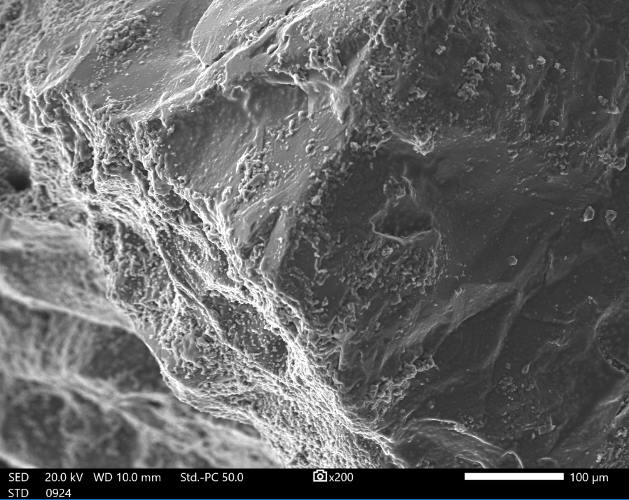

**Figure 7.** depicts the Scanning Electron Microscopy (SEM) image of the quartz material surface after the second coating with hydrophobic nanoparticles, demonstrating increased coverage and further enhancement of the surface properties

Figure 7 shows second coating: The second coating introduces additional nanoparticles, increasing the surface roughness. While the coverage remains relatively uniform, slight clustering of nanoparticles begins to appear. The increased roughness improves hydrophobicity slightly but introduces variability in nanoparticle distribution, which may result in uneven wettability [24,25]. The inter-separation distance becomes narrower, and although the hydrophobic properties are maintained, the balance seen in the first coating is slightly diminished.

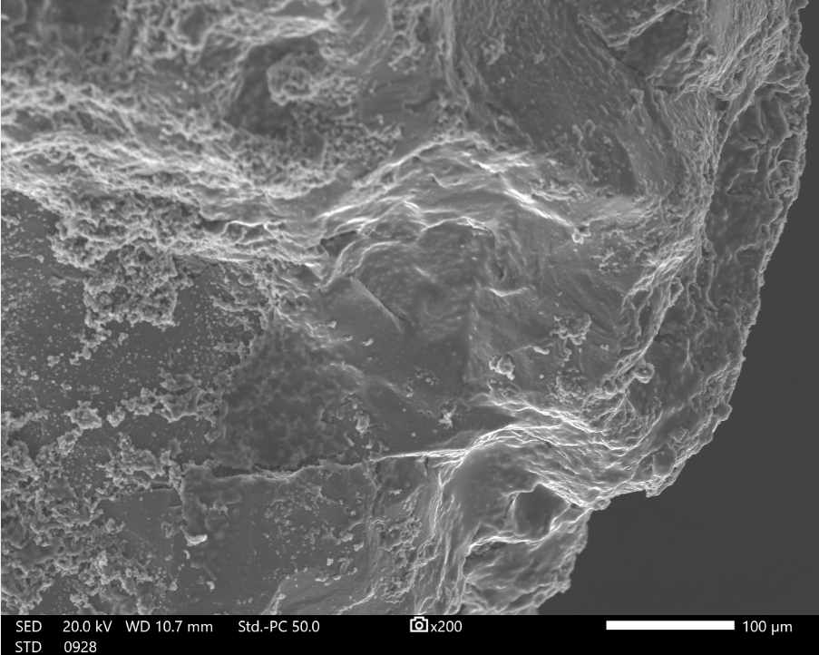

**Figure 8.** Presents the Scanning Electron Microscopy (SEM) image of the quartz material surface after the third coating with hydrophobic nanoparticles, showcasing the progressive build-up of the coating layer to improve surface wettability

Figure 8 shows third coating: In the third coating, the SEM image indicates a significant increase in surface roughness due to the accumulation of nanoparticles. Clustering becomes more pronounced, and the surface starts to lose its uniformity. The increased roughness can create localized areas where water droplets adhere, reducing overall wettability. Additionally, the nanoparticle orientation is less controlled, leading to uneven distribution [26]. The inter-separation distance decreases further, and the material begins to approach saturation in terms of coating efficiency.

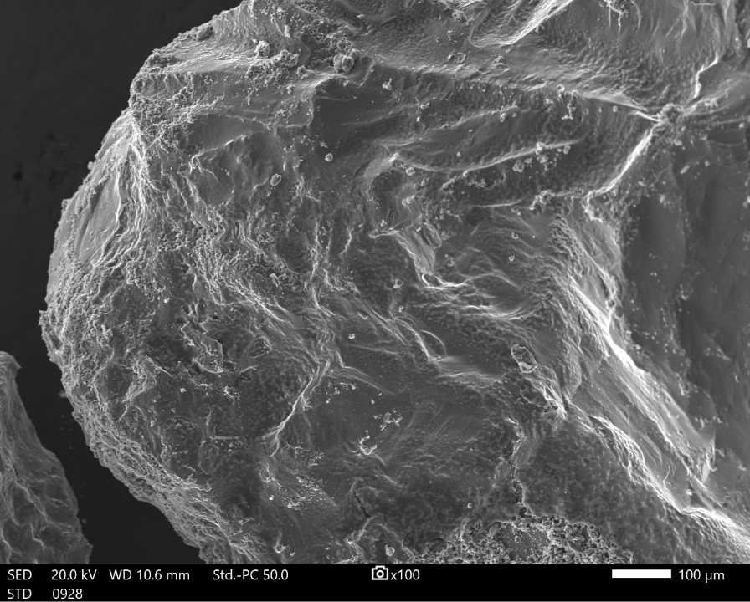

**Figure 9.** Displays the Scanning Electron Microscopy (SEM) image of the quartz material surface after the fourth coating with hydrophobic nanoparticles, illustrating the enhanced and uniform coverage achieved through multiple coatings to optimize surface wettability

Figure 9 shows fourth coating: The fourth coating shows a densely packed layer of nanoparticles with significant clustering and irregularities. The excessive accumulation of nanoparticles leads to reduced surface smoothness, and the increased roughness negatively affects wettability [27]. The nanoparticle distribution becomes highly uneven, with some regions oversaturated and others undercoated. The inter-separation distances are minimal, and the surface morphology no longer supports optimal hydrophobicity. This stage demonstrates diminishing returns in terms of wettability improvement.

The first coating achieves the best wettability because it strikes an optimal balance between surface roughness and smoothness. Uniformly distributed nanoparticles create a consistent hydrophobic layer that enhances surface energy without introducing excessive irregularities. This configuration allows water droplets to form spherical shapes and roll off the surface effectively, maximizing separation efficiency [28–30]. In subsequent coatings, increased roughness and clustering disrupt the uniformity of the hydrophobic layer, creating localized hydrophilic regions where water may adhere. This phenomenon reduces the effectiveness of the surface in repelling water, explaining why the first coating demonstrates superior performance.

The SEM analysis clearly shows that the first coating of quartz material with hydrophobic nanoparticles offers the best combination of surface properties for oil-water separation. The uniform distribution, minimal clustering, and optimal inter-separation distances contribute to superior wettability and hydrophobic performance. Excessive coatings result in diminishing returns, highlighting the importance of careful optimization in material preparation for practical applications.

* 1. **Oil and grease analysis**

The oil and grease analysis was performed to assess the quality of permeate (water) obtained after the oil/water separation process. This evaluation aimed to determine the effectiveness of quartz material in separating oil/water emulsions. The findings from the analysis are summarized in Table 1, highlighting the performance of the quartz material under different conditions.

The findings revealed that the best results were observed with the first coating, where the hydrophobic nanoparticles were evenly distributed, ensuring optimal wettability and efficient separation. While, additional coatings introduced irregularities, clustering, and excessive roughness, which compromised the separation efficiency and led to significantly higher oil content in the permeate.

**Table 1.** Impact of nanoparticle coatings on quartz material

|  |  |  |
| --- | --- | --- |
| **Quartz material** | **Oil and grease (mg/L)** | **Impact of nanoparticles** |
| Raw | 1859.8 | No treatment; high oil content due to lack of hydrophobic properties. |
| Washed | 1583.7 | Removal of surface impurities slightly reduces oil content but lacks hydrophobicity for effective separation. |
| First coating | 29.3 | Achieves the most efficient oil-water separation. Uniformly distributed nanoparticles enhance wettability, significantly reducing oil content in permeate. |
| Second coating | 547.4 | Slightly less effective; increased roughness and nanoparticle clustering reduce uniform hydrophobic coverage. |
| Third coating | 27177 | Poor performance; excessive nanoparticle layering and clustering increase hydrophobic irregularities, trapping oil. |
| Fourth coating | 73439.7 | Ineffective; oversaturation of nanoparticles disrupts surface properties, causing severe inefficiencies in separation. |

* 1. **Comparison of oil and grease analysis with SEM findings**

The findings from Table 1 and the SEM analysis converge to highlight the exceptional performance of the first coating. The uniform nanoparticle distribution and balanced surface properties observed in the SEM analysis directly justify the low oil and grease content (29.3 mg/L) achieved in Table 1. Subsequent coatings degrade performance due to increased roughness, clustering, and loss of uniformity, underscoring the importance of optimizing the coating process for practical applications. Table 2 shows the comparison of oil and grease analysis with SEM findings.

**Table 2.** Comparison of Oil and Grease Analysis with SEM Findings

|  |  |  |  |  |
| --- | --- | --- | --- | --- |
| **Quartz material** | **Oil and grease (mg/L)** | **SEM findings** | **Justification** |  |
| Raw | 1859.8 | Rough, uneven surface with contaminants; no hydrophobic properties. | High oil content due to poor wettability and lack of treatment. |  |
| Washed | 1583.7 | Cleaner surface with reduced impurities; lacks hydrophobic properties. | Slight reduction in oil content; impurities removed but hydrophobicity still absent. |  |
| First coating | 29.3 | Uniform nanoparticle distribution, minimal clustering, optimal surface roughness and smoothness. | Best performance; enhanced wettability due to balanced surface morphology, allowing effective oil rejection and clean water permeation. |  |
| Second coating | 547.4 | Increased surface roughness, slight nanoparticle clustering, reduced uniformity. | Performance declines as clustering disrupts uniform wettability, leading to variability in oil rejection. |  |
| Third coating | 27177 | Significant clustering, excessive roughness, irregular surface morphology. | Inefficient separation due to excessive nanoparticle layers and clustering, which trap oil and reduce hydrophobicity. |  |
| Fourth coating | 73439.7 | Oversaturated surface with severe clustering and disrupted morphology. | Extremely poor performance; oversaturation causes irregularities, leading to oil retention and minimal water separation efficiency. |  |

The analysis of Table 2 highlights the critical impact of surface morphology and nanoparticle distribution on the quartz material's ability to separate oil from water. The raw and washed quartz materials demonstrated poor separation efficiency due to the absence of hydrophobic properties, as indicated by high oil and grease content (1859.8 mg/L and 1583.7 mg/L, respectively). Washing improved surface cleanliness but did not significantly enhance wettability.

The first coating of hydrophobic nanoparticles showed exceptional performance, reducing oil and grease content to 29.3 mg/L. This was attributed to the uniform nanoparticle distribution observed in the SEM analysis, which created an optimal balance of surface roughness and smoothness. This configuration enhanced wettability, allowing efficient oil rejection and water permeation.

Subsequent coatings (second to fourth) led to a decline in separation efficiency, with oil and grease content increasing dramatically. The SEM analysis revealed that additional coatings introduced clustering, excessive surface roughness, and irregular morphology, disrupting the uniform wettability necessary for effective oil-water separation. The oversaturation of nanoparticles in the fourth coating resulted in severe inefficiencies, with oil and grease content rising to 73439.7 mg/L.

Overall observation, the findings underscore that a single, well-distributed coating of hydrophobic nanoparticles provides optimal separation performance, while excessive nanoparticle layering diminishes efficiency due to surface irregularities and clustering. These results emphasize the importance of optimizing coating processes for practical applications in oil-water separation technologies.

1. **CONCLUSIONS**

This study demonstrates the effectiveness of hydrophobic nanoparticle coatings on quartz material for oil-water separation. The results indicate that the first coating of hydrophobic nanoparticles significantly enhanced the wettability of the quartz surface, leading to optimal oil rejection efficiency and improved separation performance. SEM analysis revealed that uniform nanoparticle distribution and balanced surface roughness were crucial factors in achieving high separation efficiency. However, subsequent coatings (second to fourth) resulted in clustering and irregular surface morphology, which negatively impacted the material's ability to separate oil from water, as seen by the increase in oil and grease content.

The developed mathematical models provided a quantitative framework for evaluating oil rejection efficiency, surface morphology, and separation performance. These models reinforced the conclusion that a single, well-distributed coating of hydrophobic nanoparticles offers the most efficient solution for oil-water separation. The study underscores the potential of using low-cost quartz material with optimized nanoparticle coatings as an effective and sustainable approach to treating oily wastewater, contributing to the development of more efficient, environmentally friendly filtration technologies.

While the first coating of hydrophobic nanoparticles showed the best performance, further investigations into the optimal thickness, type, and concentration of nanoparticles can help maximize oil rejection efficiency without introducing clustering or irregularities on the surface.

# acknowledgment

This work is supported by the University of South Africa.

**REFERENCES**

[1] Kalla S. Use of membrane distillation for oily wastewater treatment - A review, J Environ Chem Eng, 2021; 9:104641.

[2] Avornyo A, Chrysikopoulos C V. Applications of graphene oxide (GO) in oily wastewater treatment: Recent developments, challenges, and opportunities, J Environ Manage, 2024; 353:120178.

[3] Barambu NU, Bilad MR, Bustam MA, Kurnia KA, Othman MHD, Nordin NAHM. Development of membrane material for oily wastewater treatment: A review, Ain Shams Eng J, 2021; 12:1361–1374.

[4] Sahu S, Dhar Purkayastha D. WO3·H2O micro-flowers decorated PVDF/Ti3C2 MXene membrane for oily wastewater treatment, Sep Purif Technol, 2024; 330:125486.

[5] Wang J, Liu T, Lu C, Gong C, Miao M, Wei Z, Wang Y. Efficient oil-in-water emulsion separation in the low-cost bauxite ceramic membranes with hierarchically oriented straight pores, Sep Purif Technol, 2022; 303:122244.

[6] Jiang Q, Lin B, Zhong Z, Fan Y, Xing W. Ultra-low temperature co-sintering of water glass (WG)-bonded silicon carbide ceramic membranes for oil-water separation, J Memb Sci, 2024; 692:122311.

[7] Sun Y, Yang Z, Li L, Wang Z, Sun Q. Facile preparation of isotactic polypropylene microporous membranes with bioinspired hierarchical morphology for nano-scale water-in-oil emulsion separation, J Memb Sci, 2019; 581:224–235.

[8] Abu-Thabit NY, Kalam Azad A, Mezghani K, Akhtar S, Saeed Hakeem A, Drmosh QA, Yusuf Adesina A. Rapid, Sustainable, and Versatile Strategy Towards Fabricating Superhydrophobic Cotton Textile Membranes for Separation of Emulsified and Stratified Oil/Water Mixtures, Sep Purif Technol, 2024; 330:125352.

[9] Abuhantash F, Abuhasheesh YH, Hegab HM, Aljundi IH, Al Marzooqi F, Hasan SW. Hydrophilic, oleophilic and switchable Janus mixed matrix membranes for oily wastewater treatment: A review, J Water Process Eng, 2023; 56:104310.

[10] Sun L, Wang Z, Gao B. Ceramic membranes originated from cost-effective and abundant natural minerals and industrial wastes for broad applications – a review, Desalin Water Treat, 2020; 201:121–138.

[11] Mao H, Cao H, Fan W, Li W, Wu Y, Chen X, Qiu M, Verweij H, Fan Y. Application of piezoelectric quartz for self-cleaning membrane preparation, Ceram Int, 2022; 48:16599–16610.

[12] Gao J, Cao H, Hu X, Mao H, Chen X, Qiu M, Verweij H, Fan Y. Journal of the European Ceramic Society Piezoelectric porous α -quartz membrane by aqueous gel-casting with enhanced antifouling and mechanical properties, J Eur Ceram Soc, 2023; 43:109–120.

[13] Sob PB, Alugongo AA, Tengen TB. The stochastic effect of nanoparticles inter-separation distance on membrane wettability during oil/water separation, Int J Eng Res Technol, 2020; 13:842–866.

[14] Wei B, Luo X, Song X, Guo H, Dai L, Zhang H, Wang G. Quartz sand filter media with special wettability for continuous and efficient oil/water separation and dye adsorption, Processes, 2020; 8:.

[15] Guan C, Xu F, Li Y, Zhu L, Xia D. Construction of dual-functional membrane with novel structured β-cyclodextrin hybridization for simultaneous oily wastewater separation and hazardous aromatics removal, J Water Process Eng, 2022; 47:102756.

[16] Liu P, Niu L, Tao X, Li X, Zhang Z, Yu L. Preparation of superhydrophobic-oleophilic quartz sand filter and its application in oil-water separation, Appl Surf Sci, 2018; 447:656–663.

[17] Sadek SA, Al-Jubouri SM. Highly efficient oil-in-water emulsion separation based on innovative stannic oxide/polyvinylchloride (SnO2/PVC) microfiltration membranes, J Ind Eng Chem, 2024; 140:577–588.

[18] Sara A. Sadek SMA-J. Highly efficient oil-in-water emulsion separation based on innovative stannic oxide/polyvinylchloride (SnO2/PVC) microfiltration membranes, Prog To Be Publ, 2024; .

[19] Yu X, Ji J, Wu QY, Gu L. Direct-coating of cellulose hydrogel on PVDF membranes with superhydrophilic and antifouling properties for high-efficiency oil/water emulsion separation, Int J Biol Macromol, 2024; 256:128579.

[20] Wang T, Wang W, Hu C, Zheng J, Zhu Z, Liu B. Design of carboxymethyl cellulose/alginate aerogels with anti-fouling and light-driven self-cleaning for enhanced oily wastewater remediation, Carbohydr Polym, 2024; 342:122358.

[21] Siddiqui MU, Arif AFM, Bashmal S. Permeability-selectivity analysis of microfiltration and ultrafiltration membranes: Effect of pore size and shape distribution and membrane stretching, Membranes (Basel), 2016; 6:1–14.

[22] Salama A. Modeling of flux decline behavior during the filtration of oily-water systems using porous membranes: Effect of pinning of nonpermeating oil droplets, Sep Purif Technol, 2018; 207:240–254.

[23] Tummons EN, Tarabara V V., Chew JW, Fane AG. Behavior of oil droplets at the membrane surface during crossflow microfiltration of oil-water emulsions, J Memb Sci, 2016; 500:211–224.

[24] Yue C, Liu J, Zhang H, Dai L, Wei B, Chang Q. Increasing the hydrophobicity of filter medium particles for oily water treatment using coupling agents, Heliyon, 2018; 4:e00809.

[25] Basak S, Barma S, Majumdar S, Ghosh S. Silane-modified bentonite clay-coated membrane development on ceramic support for oil/water emulsion separation using tuning of hydrophobicity, Colloids Surfaces A Physicochem Eng Asp, 2024; 681:132812.

[26] Zhang Z, Yang Y, Li C, Liu R. Porous nanofibrous superhydrophobic membrane with embedded Au nanoparticles for the integration of oil/water separation and catalytic degradation, J Memb Sci, 2019; 582:350–357.

[27] Mao H, Fan W, Cao H, Chen X, Qiu M, Verweij H, Fan Y. Self-cleaning performance of in-situ ultrasound generated by quartz-based piezoelectric membrane, Sep Purif Technol, 2022; 282:120031.

[28] Sun F, Li TT, Ren HT, Lou CW, Lin JH. Rational design of dopamine-decorated gradient structure membrane with novel hydrophibic/underwater-oleophobic for oil/water separation, J Mater Res Technol, 2023; 22:2251–2261.

[29] Li Z, Zhao L, Wang L, Xiao X, Wang X, An H, Ye H, Xin Q, Zhang Y. Photothermal responsive liquid-filled membrane with anti-fouling properties for oil/water separation, J Memb Sci, 2024; 696:122546.

[30] Francis L, Mohammed S, Hashaikeh R, Hilal N. Fabrication and characterization of superhydrophilic graphene-based electrospun membranes for efficient oil-water separation, J Water Process Eng, 2023; 54:104066.