**AI-Driven Evaluation of Sports Training Effectiveness Using GABP Neural Networks**

LiangFa Li1,3，AnYing Hao2,3*

1.Department of physical education, Guangdong University of foreign studies, Guangzhou, Guangdong, China

2. Sport Art College of Guangzhou Sports University,Guangzhou510500,Guangdong Province,China

3.Graduate School：Adamson University, 900 San Marcelino Street, Ermita 1000 Manila, Philippines, 1000

Email: [hayllf@163.com](mailto:hayllf@163.com)

**Abstract:** To enhance the evaluation of athletes' physical fitness training effects, a method based on the GABP neural network is proposed. This approach integrates statistical analysis of training outcomes with effect evaluation parameters, employing a mechanical parameter analysis model. By combining constraint parameters with statistical and mechanical methods, a superiority search model for evaluating training effect parameters is established. Key components include modeling the distribution of explosive force inertia, adaptive prediction of training effects, and constructing explanatory and control variables for evaluation. The method optimizes evaluation based on parameter search results and leverages the GABP neural network for comprehensive analysis. Simulation results demonstrate high accuracy and strong confidence in the evaluation outcomes, confirming the effectiveness of the proposed method.

**Keywords:** Artificial intelligence; GABP network; neural network; sports training effect；

1. **Introduction**

To ensure the quality and effectiveness of sports training (ST) management, a systematic and comprehensive assessment index system is essential. This system provides objective and accurate evaluations of training outcomes, offering a clear understanding of the state and effectiveness of ST. Accurate assessments form the foundation for improving various aspects of training, requiring not only insights from experts but also the application of scientific methods to evaluate and interpret the implementation of training programs comprehensively.

Training evaluation index system is conducive to guiding, improving and enhancing the work of ST. Through the assessment of ST work, one can practically and objectively understand the work situation of ST, and the other can deeply understand the strengths and weaknesses of training work, so as to better improve and enhance ST work.

The ST evaluation index system provides a reference basis for sports managers to improve management effectiveness. Only by providing accurate, timely and comprehensive information feedback to ST managers, it is possible to develop corresponding countermeasures and correct decisions, otherwise managers can only imagine in managing ST work. Sports project management center managers to monitor and manage the degree of progress of ST work is also an important task necessary to better complete the training work, if only rely on subjective experience judgment, without a good and objective assessment index system, it is easy to come up with an unfair evaluation and affect the effectiveness of training work. Scientific, objective and accurate evaluation indexes are the necessary execution documents for ST managers to supervise ST work.

ST evaluation index system improves the motivation of ST participants and workers. Only a fair and scientific evaluation of ST can truly motivate ST participants and workers, and also facilitate the transformation of ST operational mechanisms and strengthen the implementation of training. Without a fair and scientific evaluation index system, there may be some unjust illusions and improper culture, which seriously hinders the normal and efficient development of ST.

Athletes' daily training plays a crucial role in enhancing their competitive performance, providing coaches with insights into their current status and skill levels. This enables the development of targeted training programs and accurate assessments of training effects, which are essential for improving performance. Training effect assessments are influenced by factors such as psychological state and training environment and can be categorized into linear and nonlinear approaches. While linear methods lack precision in capturing the complexities of training outcomes, nonlinear methods account for these factors more comprehensively and are increasingly favored in research.

The use of physiological state indicators enhances the scientific evaluation of training effects by linking an athlete's physical condition to performance outcomes. Assessing training effects based on physical function allows for adjustments to training tasks, enabling a more scientific approach to managing the entire training process. Previous studies have explored models for evaluating physical fitness in elite male bodybuilders and specific athletic abilities in youth badminton players, contributing valuable insights into the assessment of athletic performance across various sports.

Machine learning algorithms, particularly support vector machines, are highly effective in nonlinear evaluation methods, offering improved accuracy for assessing athletes' training effects through optimized kernel functions and parameters. Given the inherent variability and randomness in evaluating training outcomes, developing efficient evaluation methods is of significant practical importance.

Leveraging big data information fusion techniques enhances the accuracy of evaluating physical fitness training effects by analyzing the distribution and correlation of training data. This approach is pivotal for optimizing training methods and has gained considerable attention in research. By integrating fusion feature analysis methods, the evaluation of physical fitness training effects can be further refined.

This paper proposes a GABP neural network-based evaluation method for assessing athletes' physical fitness training effects. An empirical analysis model is developed, combining statistical results and evaluation parameters to construct explanatory and control variable models. Optimal evaluations are performed using parameter search results, and the GABP neural network framework is constructed and optimized. Simulation tests validate the method, demonstrating its effectiveness in accurately assessing training outcomes.

1. **Related work**
   1. **ST assessment indexes**

In recent years, significant progress has been made in ST and assessment systems through extensive research by domestic and international experts and scholars. These studies have provided a robust theoretical foundation for ST evaluation and have substantially advanced related work, including developing methodologies, models, and frameworks. Research has delved into various aspects, such as the content and methods of ST, assessment models, and factors influencing athletic performance, forming the basis for the development of ST assessment index systems. The rapid development of theoretical frameworks for assessment and their application to sports statistical theory has introduced practical and effective methodologies across multiple domains of sports. These advancements enable comprehensive and systematic evaluations of the scientific rigor of sports practices, contributing to better ST management, training programs, and teaching methods. The integration of these approaches has actively supported the evolution of ST assessment systems, offering significant insights for improving their implementation. For instance, studies like Li Pei's "Reflections on Improving the Performance Assessment of Sports Organizations in China" address critical issues in the current performance assessment practices of sports organizations. This research not only evaluates the status quo but also provides thoughtful considerations for future improvements in performance assessment, focusing on enhancing accuracy, efficiency, and relevance to organizational goals.

Despite these advancements, challenges remain. Many existing systems lack uniformity and fail to account for regional variations and the unique requirements of different sports disciplines. Moreover, the application of ST assessment systems at provincial levels, such as in the Shaanxi Provincial Sports Management Center, still faces hurdles in achieving comprehensive and actionable evaluations. Limited adoption of advanced technologies like big data analytics and artificial intelligence further restricts the potential for dynamic and real-time assessments.

Future efforts should emphasize the integration of modern data-driven approaches to enhance the precision and adaptability of assessment systems. Expanding research to include diverse sports environments and incorporating interdisciplinary perspectives, such as psychology and biomechanics, will strengthen the foundation of ST assessment. Additionally, collaboration between researchers, practitioners, and policymakers will be essential to develop universally applicable yet customizable systems that cater to the unique needs of regional and organizational contexts. This multifaceted approach can foster more effective and sustainable sports training evaluation practices.

1. The need for a perfect performance assessment system in a perfect human resource management system of sports organizations.
2. The level of performance assessment in sports organizations will develop towards the combination of individual performance assessment and organizational performance assessment.
3. The advancement of sports professionalization in China requires a robust and objective performance assessment mechanism. As a critical component of human resource management, a well-designed performance assessment system can effectively support and drive the development of sports vocationalization.

**2.1.1 Research on coaches' evaluation system by experts and scholars**

A study on constructing a scientific training ability assessment index system for coaches focused on four key dimensions: individual competitive performance, team leadership performance, basic cultural quality, and professional expertise. The system incorporated weight assignments, evaluation standards, and methods to ensure an objective, reasonable, and comprehensive assessment of coaches' training abilities. This framework aims to provide a structured approach to evaluating and enhancing coaching effectiveness.

**2.1.2 Research on ST assessment system of sports teams by experts and scholars**

Several studies have focused on constructing evaluation index systems for different aspects of sports development. One study developed an evaluation system for youth sports clubs, addressing issues such as development, operational management, and resource independence, with a focus on "human, financial, and material" factors. Another study proposed a comprehensive evaluation framework for high-level sports teams in colleges and universities, incorporating a structured approach with multiple levels of indicators to ensure a thorough assessment. Additionally, research on after-school ST evaluation in higher education institutions emphasized key factors such as training conditions, processes, and outcomes, using a system of secondary and tertiary indicators to improve training quality and performance comprehensively. These evaluation systems contribute to the structured and systematic improvement of sports programs.

**2.1.3 Research on the evaluation of intangible assets of athletes by experts and scholars**

Research on athlete intangible asset evaluation has proposed criteria based on factors such as competition results, contributions to sports development, public recognition, and personal charisma. These studies, along with theoretical advancements in ST evaluation, contribute to addressing gaps in evaluation systems for sports project management. However, there remains a scarcity of systematic and comprehensive evaluation frameworks for ST, particularly in the context of provincial sports management centers like those in Shaanxi Province. Existing research on ST and fuzzy mathematical theory is limited, highlighting the need for more robust and detailed evaluation systems.

**2.2 BP neural networks**

BP neural network (BPNN) is a network model established by interconnecting multiple neurons to simulate the mapping relationship of real things by simulating the biological nervous system and using rich event data for training to obtain simulation results of class events [11]. BPNN structure diagram is shown in Figure 1.

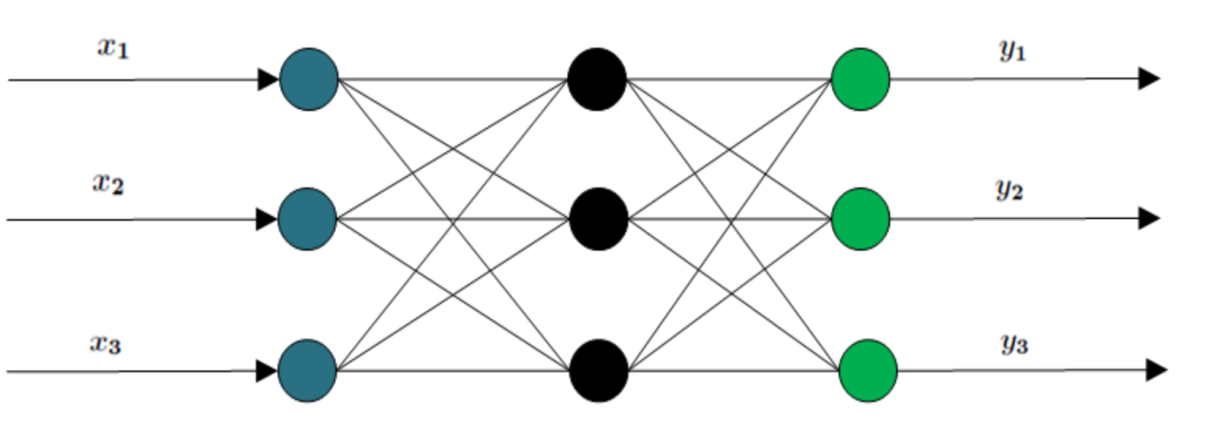

Figure 1 BPNN structure diagram

The BP algorithm adjusts weights iteratively by calculating input-output differences layer by layer, starting with a random input sample and desired output, until the network output matches the target within a set range.

 (1)

 (2)

The global error is calculated as

 (3)

The algorithm verifies if the error value is within the planned range; if not, it continues iterating until the maximum training limit is reached, after which it restarts the next training round.

**2.3 Genetic Algorithm**

GA simulate natural evolution to search for optimal solutions by starting with a population of potential solutions, where individuals represent genes and chromosomes are formed from gene combinations. Using binary encoding for mapping, the population evolves generation by generation through selection, crossover, and mutation based on fitness, ultimately identifying the best individual as the approximate optimal solution, as illustrated in Figure 2.



Figure 2 Basic flow of GA genetic algorithm

The algorithm constitutes a set of solutions from the candidate set, and the fitness value of the set is obtained according to the fitness condition, and the candidate solutions are selected by the fitness, and after removing some of the solution sets that do not satisfy the fitness function, the retained candidate set is executed with selection, crossover, and mutation operations to obtain a new candidate solution, i.e., a new population [17]. Genetic algorithms use broad solution coverage and probabilistic variation rules during chromosome population searches to promote global optimization, guide search directions, and adapt genetic structures effectively to different environments.

1. **GABP neural network model application**

**3.1 Re-optimization of the BPNN**

The size of the data set varies, and for some data sets with relatively small amount of data, both of the above-mentioned neural networks do not have enough training volume, which will lead to insufficient threshold adjustment, too fast convergence and other problems, thus making the final prediction accuracy greatly reduced. Facing this problem, this paper proposes an application method that optimally corrects the GA-BPNN (referred to as TC-GABPNN model) using the results of time series. Since the time series prediction model does not take into account the irregularity and causality between the development of things and the inverse ratio of prediction accuracy and duration, based on the small sample capacity, some optimizations are made to the thresholds and results of the original GA-BPNN[18].

The implementation process of the time series prediction model is as follows.

1. Collecting historical information manually, organizing it according to the traditional classification method and plotting it as a statistical graph based on the time series.
2. The values of each period in the time series are analyzed for the induced causes.
3. Performing valuation operations for long-term trends, seasonal variations, and irregular variations, and finding the nearest similar mathematical pattern to represent them.
4. Calculate the future time series forecast values. The model obtained in step (3) and the predicted irregular variation values are computed by using additive or multiplicative models.

Errors from the single-pass outputs of BPNN and time series models are analyzed through one-dimensional linear regression to determine the functional fit of errors, which is then used to correct BPNN transmission values. By applying a meta-linear regression correction function yr = f (x error), the output error E is adjusted by subtracting yr, refining the thresholds and transfer weights in the three-layer GA-BPNN architecture. This approach compensates for limited training samples, improving prediction accuracy in the corrected GA-BPNN model.

**3.2 GABP neural network model**

The GA enhances the global search capability of BPNN by optimizing connection weights and network structure, improving generalization. In the three-layer BPNN, where input and output nodes are fixed, genetic algorithms optimize network nodes for better performance.

 (4)

Where:  is the value of the connection power of node i connected to node j; is the node j threshold; n and m are the number of populations and individuals, respectively, and p is the preselection probability; and are the actual output and the model prediction, respectively, and the network connection power and structure are obtained by solving the nonlinear optimization problem through the genetic algorithm, and when the E obtained from the calculation is less than the set error ε value, the model is applied to the When the calculated E is less than the set error ε, the model is applied to the actual problem processing[21].

This paper enhances the BP network by setting training iterations, training error 𝜖1, and testing error 𝜖2. When both errors meet preset values, the connection weight space is defined as [$U$ min-δ1, $U$ max+δ2]. The genetic algorithm uses the maximum objective function value as its fitness function, defined accordingly.

 (5)

Incorporating the fitness function into Equation (1) yields the mathematical expression for the optimized model.

 (6)

The encoded string consists of a control code and weight values. The control code, represented as a binary string (0 for no connection, 1 for connection), determines the number of hidden nodes in the network, with its length based on a multiple of input nodes. The weight values control connection strengths numerically, with the string length defined by the number of input and output nodes.

The initial population consists of L different individuals, each individual consists of a 0-1 code string of string length l1 and l2 random numbers distributed in the interval [$U$ min-δ1, $U$ max+δ2]. The crossover variation of individuals is carried out with pc probability. When the ith individual is crossed with the (i+1) individual the operation yields.

 (7)

Where: and are the individuals before and after the crossover, respectively, and ci is the uniform random number [19]. Similarly the variation operation of individuals with pm probability gives:

 (8)

Where and are the individuals before and after mutation, respectively, and ci is the random number distributed in the interval [$U$ min -δ1- , $U$ max +δ2-] taken to ensure that the mutated individuals remain within the search interval. The crossover mutation operation was repeated until the population evolved to the Kth generation. The individuals with the highest fitness in the K-th generation are decoded to determine the corresponding connection weights and hidden node count, which are then used as model inputs to find the optimal solution [20]. The total sample N is divided into training samples 𝜙1, 𝜙2, and detection samples 𝜙3. Training sample 𝜙1 undergoes evolutionary operations to the K-th generation, after which the decoded individuals provide the neural network structure and weight coefficients. Training sample 𝜙2 is then input into the network to derive the relational equation.

 (9)

The network power coefficients and hidden nodes of the input samples are obtained, and φ3 is brought into Eq. (9) to detect the generalization ability of the network.

**3.3 Algorithm construction**

Figure 3 illustrates the flowchart of the algorithm construction process based on the optimized BPNN.



Figure 3 Flow chart based on optimized BPNN

**4. Experimental results and analysis**

To validate the method's effectiveness in evaluating athletes' physical training outcomes, simulation tests were conducted using SPSS14.0 for statistical analysis of constraint parameters and training effects. Additionally, mechanical sensors were employed to collect physical data for the assessment.

Table 1 Statistical analysis values of athletes' physical training effect evaluation

|  |  |  |  |  |
| --- | --- | --- | --- | --- |
| Variables | Mean Value | Standard | Minimum value | Statistical mean |
| Exercise time | 0.261 | 0.681 | 0.142 | 4.784 |
| Fitness | 0.365 | 0.544 | 0.368 | 3.136 |
| Daily EX | 0.566 | 0.457 | 0.465 | 3.582 |
| Training intensity | 0.454 | 0.476 | 0.364 | 3.346 |
| Number of correlations | 0.415 | 0.544 | 0.422 | 4.155 |

The descriptive statistical analysis results of athletes' training effect assessment, presented in Table 1, were used to evaluate the training effects, while the physical training mechanics parameter acquisition results are illustrated in Figure 4.



Figure 4: Results of mechanical parameters



Figure 5 Evaluation output of athletes' physical fitness training effect

As illustrated in Figure 5, the proposed method demonstrates superior accuracy and enhanced feature tracking performance compared to traditional approaches. This improvement is evident in its ability to capture and analyze key parameters more effectively, ensuring a more reliable evaluation process. Additionally, the confidence level of the assessment was tested, yielding robust and consistent results. A detailed comparison of these outcomes, highlighting the advantages of the method, is presented in Figure 6.

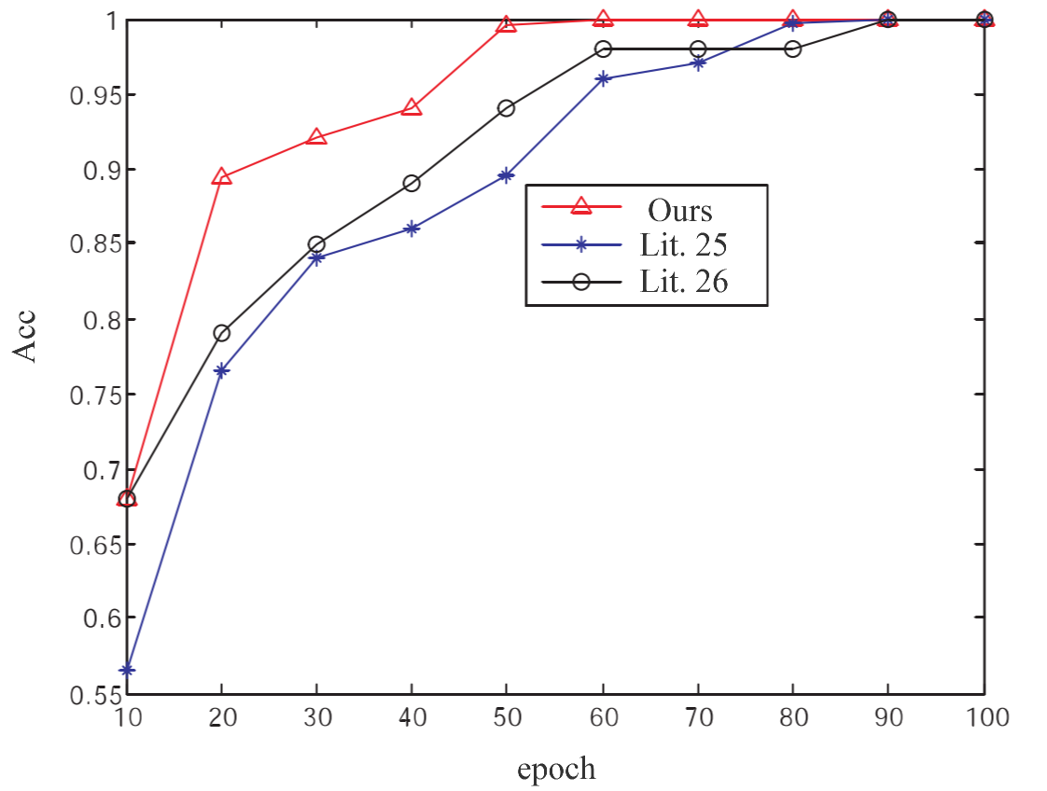

Fig. 6 Comparison test of evaluation accuracy

**5. Conclusion**

This paper tackles the limitations of the BPNN in nonlinear mapping and its lack of effective feedback mechanisms by incorporating the GA to optimize network structure. The introduction of GA enhances the global search capability, broadens the application scope, and significantly improves the generalization ability of the neural network. The study employs the GABP neural network, integrates statistical analysis of mechanical characteristics, and utilizes large-scale data sampling to perform big data fusion processing of mechanical parameters from athletes' training. Furthermore, it conducts correlation scheduling and fuzzy degree feature analysis for evaluating training effects and establishes a moment of inertia distribution model for explosive force in athletes' physical training. The findings demonstrate that this method achieves high accuracy and confidence in evaluations, providing valuable guidance for improving training effectiveness.

Despite its advantages, the proposed approach has some limitations. First, the reliance on large-scale data sampling and fusion processing can introduce challenges related to data quality and computational efficiency, particularly when dealing with incomplete or noisy datasets. Second, the model’s dependence on mechanical characteristics may overlook other crucial factors, such as psychological and environmental influences, which also play a significant role in training outcomes. Third, while the method enhances generalization, further validation on diverse datasets and sports scenarios is necessary to confirm its robustness and adaptability.

Future work will focus on addressing these limitations by integrating multi-modal data, including physiological, psychological, and environmental factors, into the evaluation framework. Advanced machine learning techniques, such as deep learning and ensemble methods, will be explored to enhance the model's ability to handle heterogeneous data and improve computational efficiency. Additionally, real-time data collection and analysis will be incorporated to provide dynamic feedback and support personalized training adjustments. These improvements aim to create a more comprehensive, adaptable, and efficient system for evaluating and optimizing athletes' training effects.

**Availability of data and material**

The data used to support the findings of this study are available from the corresponding author upon request.

**Competing interests**

Declares that he has no conflict of interest.

**Acknowledgements**

The paper did not receive any financial support

Reference

[1] Ye Shuiyong,Wu Bin,Chen Qingping,et al. Design and implementation of information inside-out network boundary security monitoring system[J]. Power and Energy,2019, 40(1):59-62.

[2] Hu Hongyu. Computer network information security and its protection strategy based on computer network technology[J]. Information Communication, 2019, 32(6):139-140.

[3] Chen Zicai. Design and application analysis of network security monitoring system for large thermal power enterprises[J]. Electrical and mechanical information, 2019(27):97-98.

[4] Liu Dongwei . Network information security management technology based on intrusion monitoring[J]. Electronic science and technology, 2019, 32(12):68-71.

[5] Jiang Shuhao,Yan Guihai,Li Jiajun,et al. Analysis of quantitative evaluation of approximability of machine learning algorithms[J]. Computer Research and Development, 2017, 54(6):1337-1347.

[6] Li Jing,Xu Lu Lu. Comparison and analysis of research hot trend prediction models based on machine learning algorithms-BP neural networks, support vector machines and LSTM models[J]. Modern Intelligence, 2019, 39(4):24-34.

[7] Li Pan,Zhao Wentao,Liu Qiang,et al. A review of research on machine learning security issues and their defense techniques[J]. Computer Science and Exploration, 2018, 12(2):171-184.

[8] Zhu Xin,Liu Xiaoman,Chen Shugang,et al. Research on online purchase behavior prediction based on machine learning fusion algorithm[J]. Statistics and Information Forum, 2017, 32(12):94-100.

[9] Zeng Yansheng. Biochemical monitoring of pre-competition training load and functional status of excellent sprinters[J]. Journal of Chengdu Institute of Physical Education, 2018, 44(4):86-91.

[10] Liu Yiyang,Li Qing. Research on the construction and current situation of physical fitness evaluation model of excellent male bodybuilders in China[J]. Journal of Beijing Sport University,2017,40(1):107-115.

[11] Liu Lancai,Xiao J. Research on the evaluation index of special athletic ability of youth male badminton players[J]. Journal of Capital Institute of Physical Education, 2019, 31(2):182-186.

[12] Ke Y,Peng J. Research on the evaluation index system of special physical training of excellent tennis players in China[J]. Journal of Wuhan Institute of Sports, 2018, 52(11):88-94.

[13] Li P,Zhu XQ,Bi N. Application of the star offset balance test in evaluating the neuromuscular training effect of female volleyball players[J]. Journal of Tianjin Institute of Physical Education, 2018, 151(1):91-97.

[14] Niu Xuesong,Bai Ye,Wang Bo. Research on the evaluation of physical fitness level of excellent freestyle skiing aerials athletes in China[J]. Journal of Shenyang Institute of Sports, 2018, 37(1):92-98.

[15] Li S. F. Analysis of the influence of tea alkaloids on the evaluation index of physical training of basketball players[J]. Fujian tea, 2018, 40(7):31.

[16]Zhou Yi,Zhang Yingqiu. Research on the performance evaluation index system of table tennis reserve talent training units in China[J]. Sports Science, 2018, 38(7):64-79.

[17] Li Guohe,Zhang Teng,Wu Weijiang,et al. A training dataset equalization method for machine learning[J]. Computer Engineering and Design, 2019, 40(3):812-818.

[18]Cao Weiquan,Chu Yanjie,Li Xian. An approximate complementary method for residual data in machine learning[J]. Journal of Xi'an Jiaotong University, 2017, 51(10):142-148.

[19]Xiang ZQ. Research on qualitative assessment of online learning attention based on machine learning[J]. Modern Information Technology, 2019, 3(3):32-33.

[20] Wang H. A Markov model-based assessment method for athletes' physical fitness training effects[J]. Journal of Chifeng College (Natural Science Edition), 2020, 36(3):96-99.

[21] BARNICHO, VAN DROOGENBROECK M. ViBe: Auniversal background subtraction algorithm for video se-quences [J]. IEEE Transactions on Image Processing，2011，20( 6) : 1709-1724．

[22] Yin C, Luo Y, Zhang D. A novel background subtraction for intelligent surveillance in wireless network[C]//2014 IEEE Wireless Communications and Networking Conference (WCNC). IEEE, 2014: 3017-3021.

[23] Chen J, Bautembach D, Izadi S. Scalable real-time volumetric surface reconstruction. ACM Trans. on Graphics (TOG), 2013, 32(4): 113. [doi: 10.1145/2461912.2461940].

[24] Franklin J A. Recurrent neural networks for music computation [J]. INFORMS Journal on Computing, 2006, 18(3): 321-338.

[25] YUT. Kinect application development practical: in themost natural way and machine dialogue ［M］. BeiJ ing:China Machine Press，2012．

[26] Payne A, Daniel A, Mehta A, Thompson B, Bamji CS. 7.6 A 512×424 CMOS 3D time-of-flight image sensor with multi-frequency photo-demodulation up to 130MHz and 2GS/s ADC. In: Proc. of the 2014 IEEE Int’l Solid-State Circuits Conf. Digest of Technical Papers (ISSCC). IEEE, 2014. 134–135. [doi: 10.1109/ISSCC.2014.6757370]