GA-based Optimized CNN Network for Image Classification

Wasim Khan¹, Phd Research Scholar, Computer Science and Engineering,
Oriental University, Indore, MP, India, wasukhan1982@gmail.com
Dr. L.K. Vishwamitra², Computer Science and Engineering,
Oriental University, Indore, MP, India, lkvishwamitra@gmail.com

Abstract: In computer vision Convolutional Neural Networks (CNNs) have revolutionized the field of image classification and AI techniques have been used with them to solve complex problems. However, designing an optimal CNN architecture for a specific task can be a complex and time-consuming process due to the large number of hyper-parameters involved. This paper proposes a novel approach that utilizes Genetic Algorithms (GAs) with CNN to automatically optimize the architecture of a CNN network for image classification tasks to improve the performance in terms of accuracy. The standard Intel image classification dataset employed for assessment of execution to enhance the performance.
Keywords: GA, CNN, Deep Learning, Image classification, neural network, FER, KNN.
- INTRODUCTION
Convolution filter weights and ReLU are two fundamental components of Convolution Neural Networks (CNN). CNN was optimised for image classification using GA. CNN weights were optimised using various batch sizes, and GA iterations were used to find the optimal weights for the classifier to get the highest accuracy [1]. GA programming is widely utilised in image classification, scheduling, and regression problems because of its great interpretability and flexibility when compared to other evolutionary techniques. Based on the concepts of natural selection and development, GA programming, as an evolutionary computation technique, may frequently provide models to address real-world issues [2]. Machine learning algorithms like CNN and deep neural networks have become extremely important in image-related work because to their feature learning capabilities, and as a result, they are frequently of great awareness in CBIR systems. CNN made a successful debut with the residual network in image classification [3]. Numerous studies have demonstrated the diagonal optimisation of spatial-spectral HSI. These phases include of the initial input data and various settings and the final analysis of classifier parameter change. Some of them focus on increasing the accuracy of the input data by changing the training model, data quantity, fair distribution, and deleting the drawing from the supplemental data [4]. CNN have progressively become the conventional of image classification applications, and performed splendidly in the ground of image classification. Based on the Tensor Flow deep learning structure, a 9-layer, 7-layer, 6-layer CNN were designed [5]. A new CNN and a novel framework of applying RF have been examined. Also, in order to get well-organized image features and decrease the dimensionality of feature vectors. It has been exposed that the skin texture retrieved by a CNN can be professionally used for the CBIR to make use of techniques [6]. DCNN-based image classification convolution neural network models classify into four categories: Early deep CNN, Res Net-based and Dense Net-based NN and Deep CNN models based on consideration mechanisms [7].
A Neural Network (NN) is a Network Structure which is accomplished of greatly ordered meting out nodes, like to the neurons in our human mind, attached or separated by software that operates on the neuron, a little part of the human mind. Each node is allied to each other nodes from different levels like a mesh. Because feed-forward networking is used by the nodes, data can only flow diagonally the system in one direction. The input layer, hidden layer 1, hidden layer2, dense layer, and output layer make up the Deep Learning network; still, there are also some layers in between these layers [8]. As a substitute to the on top of scenario, a multi-layered NN is using. Deep Learning is the accessible period for a multi-layered NN [9].
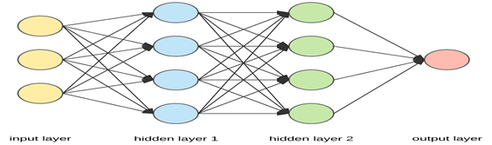
Figure 1: Diagram of NN[33]
Image classification was used to differentiate between varieties of images in the designated sets. It may be completed by a variety of algorithms, including CNN, GA, PSO, MFO, SI, MVO, and many more. This study focusses on the GA-based Optimised CNN Network for Image Classification using Intel image classification data set. From the Intel image classification dataset, six groups of 25,000 150x150 images have been chosen. Street, mountain, glacier, forest, sea, and building are the six categories into which this image classifier separates photographs. There are fourteen thousand photos in the training folder, a thousand in the testing folder, and seven thousand in the prediction folder. Intel conducted a test using the data that was posted on https://datahack.analyticsvidhya.com [22]. Image classification using CNN is completed in uncompressed form rather than squeezed one [10]. Genetic Algorithm (GA) is taking on for searching the optimal individual and its matching Deep Learning model. The iterative training process is to train the DL model and to develop the GA simultaneously [11]. To reach shows potential results on complex image classification tasks by by means of a single feature taking out method since single type of features might not successfully represent the whole image. Still, high image variations in degree, enlightenment, rotation, and surroundings increase the difficulty in retrieving essential features for classification [12]. CNN is a supervised learning technique that uses patterns seen in images to categorise and recognise objects, classes, and categories. Convolution layers, ReLU, and pooling layers make up the CNN architecture [15]. CNN mainly use for image classification and also classify audio, time series and signal data. The layers within CNNs are made up of neurons organized in three dimensions (height, breadth, and depth), Show how CNNs different from ANNs. The third dimension refers to activation volume [16] [19]. Modern gear is able to recognise images more quickly than people. Compared to alternative approaches, machine learning has a significant function and impact. One type of technique that can function effectively without human assistance is artificial intelligence (AI) [17].GA is competent of resulting the best-performing CNN architecture, together with activation function and optimization algorithm [22].
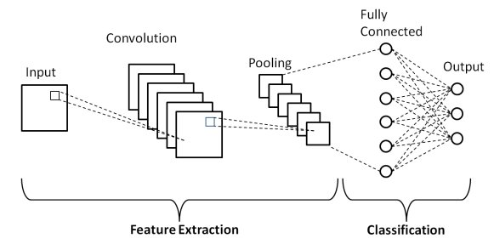
Figure 2: Diagram of CNN [33]
The classification is used the still pictures, and the expressions are acknowledged from the spatial in sequence present in the static objects. It give the impressions to be a fine task as contrasted to the second classification of facial expression recognition(FER) system and dealings stuck between the individual and mainframe machine has boosted[31].
II. RELATED WORK
The transfer learning approach, 102 flower class, may be categorised utilising an effective deep learning method by categorising several species of the Oxford-102 flowers dataset using the DenseNet121 architecture. With an accuracy of 98.6% across 50 epochs, the three dataset sets—train, validation, and test—perform better than earlier deep learning-based methods for the same dataset alone [13]. In order to identify and investigate certain flower kinds, flower categorisation is utilised. The ability to recognise certain flowers on the mark will be improved by technology. Those who want to learn more about flowers may find the method useful [14]. CNN is better than other classifiers. A model recognizes and classifies the image [16]. The Advanced CNN reaches accuracy of more. Advanced CNN are much better than other CNN, and classification takes much less time [17]. A dataset is of 21,000 images of 15 classes have been used for classification. CNN, a deep learning method is the most way in the machine learning field for image classification [18]. VGG16 CNNs model to comprehend the classification of cat and dog images. VGG16 model, adds a dropout layer, bunches standardization layer, and make a feature fusion layer to get the model find more diversified non-linear feature representations, improve precisions, and decrease the skill of the model to over fit [20]. To optimize the architecture of CNN models for a given input dataset, using different methods. With 18F-Florbetaben Amyloid PET/CT images, architectures from our methods get an average classification accuracy of 81.74%, with a network made up of only 14 weighted layers [21]. GA optimization of the decreased design space was accomplished to achieve an optimum ANN architecture. The produced optimum ANN architecture expects efficiently the power of adhesively attached joints to a high degree of accuracy [23]. An automatic CNN architecture with GAs, to successfully tackle the image classification jobs. The algorithm remains in its “automatic” features that users do not need domain knowledge of CNNs, while they can still get hold of a shows potential CNN architecture for the given images. The algorithm is validated on image classification datasets, by comparing to the state-of-the-art take in contestants covering eight manually-designed CNNs, seven usual + by hand tuning and five usual CNN architecture design algorithms [24]. Four accepted CNN based models namely, VGG16, mobile Net, Resnet50 and InceptionV3 have been used for the comparisons to get result on 1899 images for training data and 501 images for data validation [25]. The NSVM-CNN is trained and the desired pictures are extracted after the GAs optimise the returned features. The precision and performance of the approach make it the favoured choice. When compared to alternative approaches, the accuracy, recall rate, and recall rate are increased. The technique provides the most accurate and fine-grained outcomes. The method used to assist in the medical profession is represented by the experiential outcomes. A variety of 5000 datasets are used in the diagnostic parts, which rely entirely on picture retrieval [26]. When it comes to picture feature representation and classification, Deep CNN offers special benefits. The deep CNN is still considered a "black box" feature retrieval model by many academics. to investigate how each deep CNN layer relates to the others and how to make the deep NN gradual, much like humans do [27]. The four primary steps that GAs go through to get the best CNN architecture are chromosomal initialisation, selection, crossover, and mutation processes. After running GA with 10 populations and 20 generations, the experiment's best CNN architecture achieves 70.40% accuracy in categorising just the vehicle type [28]. By raising the quantity of input layers and hidden neurons, the discovering can be more precise. Image identification is an amazing model challenge for NN, and provides an outstanding means of developing more refined deep learning methods [29]. To make out scaling, translation, and other types of deformation-invariant images, DNN are engaged. For the illustration and classification of picture features, the DNN offers the maximum reward. MNIST and CIFAR-10, two deep learning standard databases, are used to assess M3 CE-CEc [30]. The scaffold creative multi classification method put to use all together studying and support of CNN model. The synergistic approach complementary multiple base models to reducing over optimized dangerous and improve oversimplification potentiality, focusing for a classification accuracy only binary judgments and retinal complaint [32].
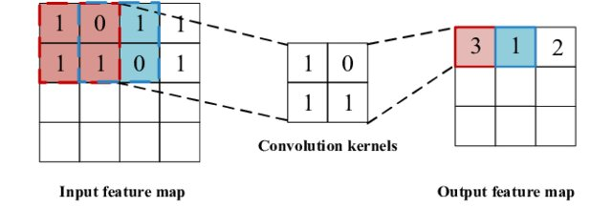
Figure 3: Diagram of CNN Process[33]
III. METHODOLOGY
The main objective is to integrate GAs with a CNN framework for image classification. Here's a breakdown of the approach:
• CNN Architecture Representation: In the GA population, every CNN architecture is encoded as a chromosome. The CNN's building pieces, including the number of convolution layers, kernel sizes, filters, and activation functions, are specified by this encoding system.
•GA Operators: Conventional GA operators like as crossover, mutation, and selection are employed to evolve the population. Priority is provided throughout the selection process to architectures that perform better on the photo categorisation task. Crossover combines genetic material from high-performing designs to create new offspring. To maintain population variability, mutation is used to introduce random changes.•Fitness Function: The performance of each CNN architecture is evaluated using a fitness function. This function typically measures the classification accuracy on a validation set.
•Training and Evaluation: Each evolved CNN architecture is trained on the training dataset. The fitness function is then evaluated on the validation set to assess its classification performance.
IV. SIMULATION SCHEME
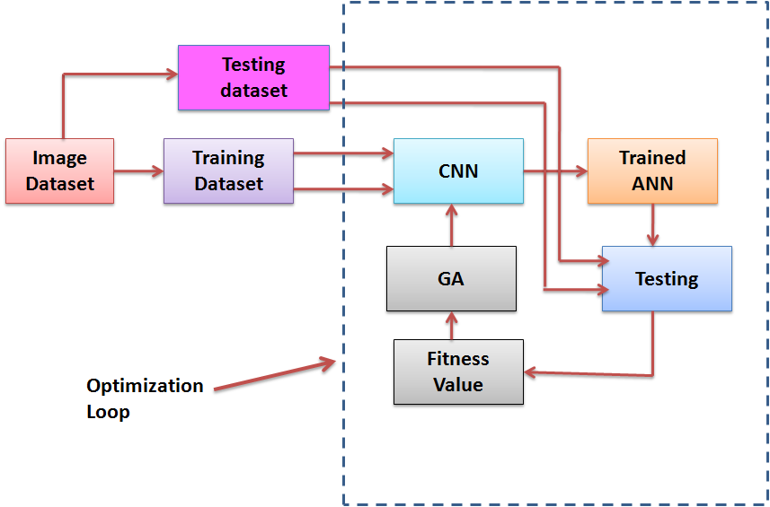
Figure 4: GA based optimization for CNN network for image classification
The proposed method is evaluated on a benchmark image classification dataset like Intel image classification database consists of 120 buildings, 120 forests, 120 glaciers, 120 mountains, 120 seas, 120 streets on these we perform KNN classification, Modified CNN based classification and GA based optimization for CNN network for image classification and Compare the performance.
The block diagram for a GA-based optimized CNN network for image classification has main components:
1. Input Data Block: This block represents the image dataset used for training and validation.
•It could be further divided into sub-blocks for training images and validation images.
2. GA Block: This block encapsulates the core functionalities of the Genetic Algorithm.
•Chromosome Generation: Generates initial population of chromosomes, each representing CNN architecture.
•Fitness Evaluation: Calculates a fitness score for each chromosome based on the classification accuracy of its corresponding CNN on the validation set.
•Selection: Selects high-performing chromosomes (CNN architectures) for reproduction.
•Crossover: Combines genetic material from selected chromosomes to create new offspring (new CNN architectures).
•Mutation: Introduces random variations in offspring chromosomes to maintain diversity.
3. CNN Block:
•This block takes a chromosome (CNN architecture) as input and translates it into a functional CNN model.
•It utilizes the decoded hyper parameters from the chromosome to define the convolutional layers, pooling layers, activation functions, and other components of the CNN.
•This block trains the constructed CNN model using the training images from the input data block.
•Training involves optimizing the CNN's weights and biases to improve its ability to classify images accurately.
4. Fitness Evaluation Block:
•This block evaluates the performance of the trained CNN on the validation images from the input data block.
•It calculates the classification accuracy, which serves as the fitness score for the corresponding chromosome (CNN architecture) in the GA block.
5. Output Block:
•This block represents the final outcome of the process.
•It could display the best-performing CNN architecture (chromosome) identified by the GA and its corresponding classification accuracy on the validation set.
6. Connections between Blocks:
•The GA block iteratively interacts with the CNN Construction, Training, and Fitness Evaluation blocks.
•The GA block provides chromosome information (CNN architecture) to the Construction block.
•The constructed CNN is then trained using the Training block.
•The Fitness Evaluation block calculates the accuracy based on validation data and feeds this score back to the GA block.This cycle continues for multiple generations until the GA converges on an optimal CNN architecture.

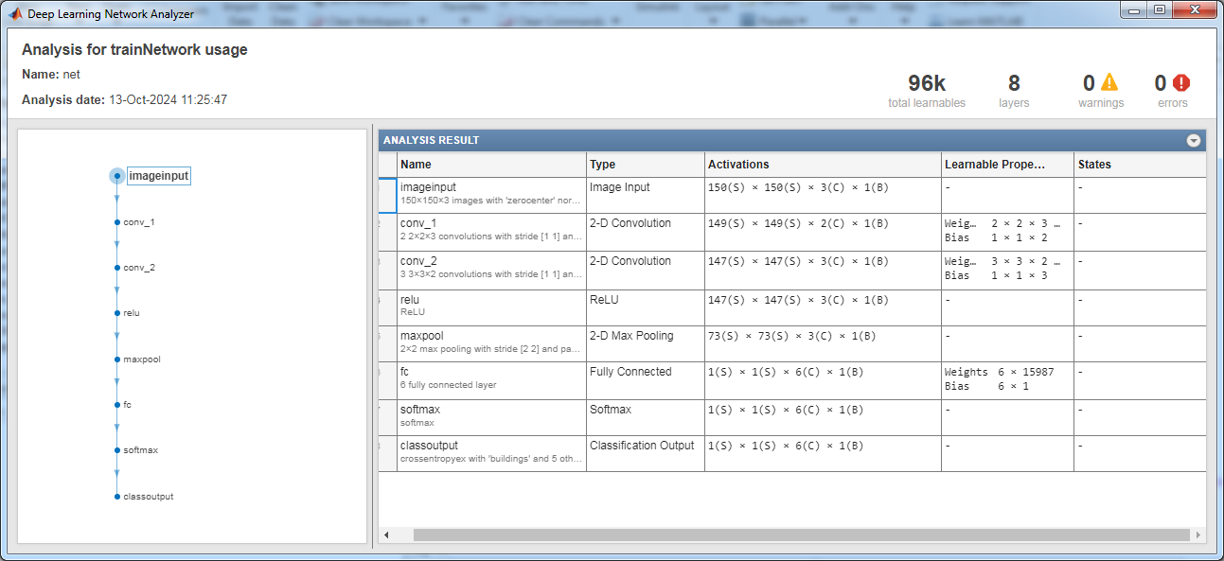

Figure 5: Proposed CNN structure

In Proposed CNN use GA to Optimized CNN Network for Image Classification with different combination of convolution matrix. In this also use repetitive number of iteration with modified CNN so that best combination will be a result. Here all steps such as image input, conv1, conv2, Relu, max pool, fully connected, soft max, class output are performing one by one.

V. RESULT AND DISCUSSION
Graph 1: Convergence curve of GA for optimizing CNN structure

Convergence curve is showing that when increasing the generation then decreases the mean fitness value.GA based CNN classification: Image training =120

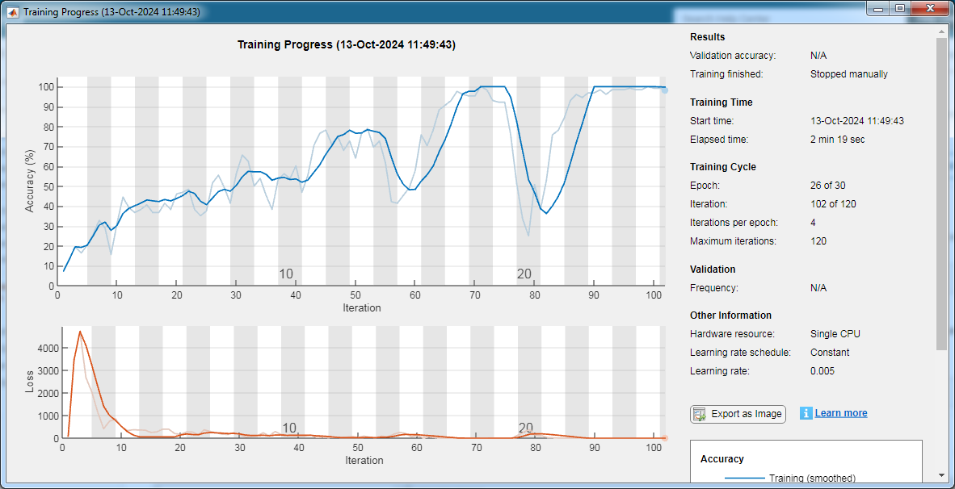

Graph 2: Training progress accuracy

In graph 2 it is clearly visible that increasing the iteration, increase the accuracy and iteration per epoch is 4.

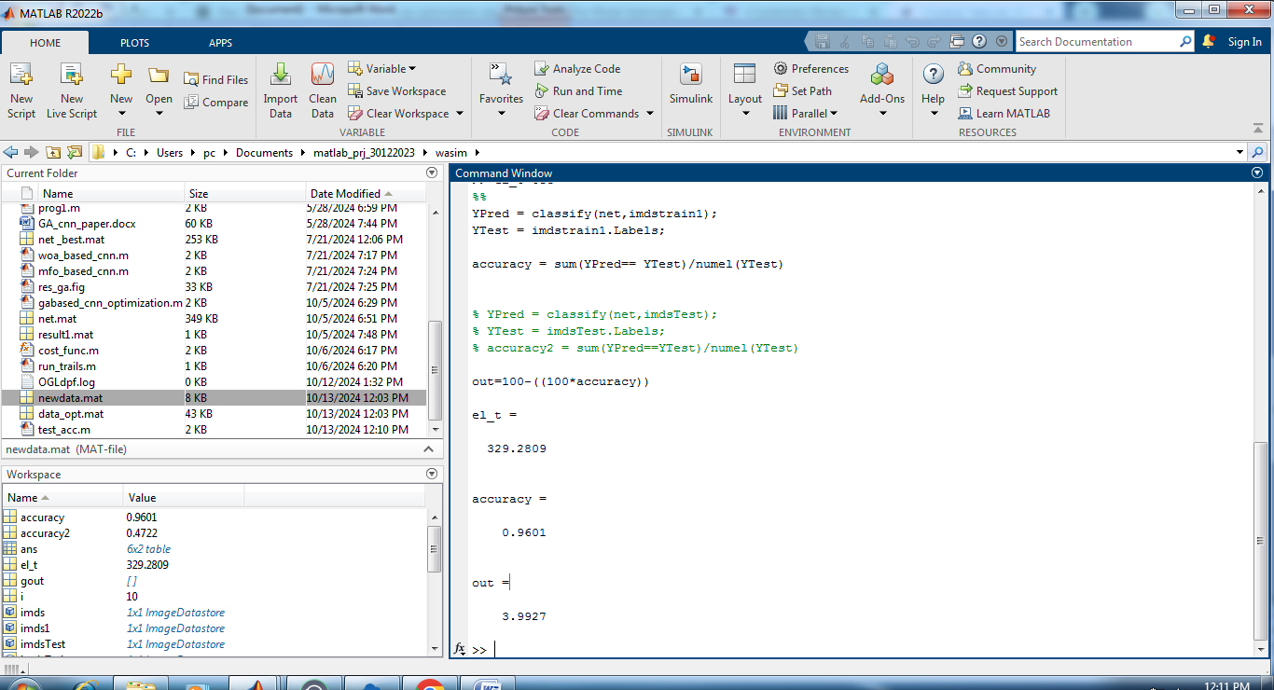

Graph 3: Training progress accuracy

Accuracy on complete set is 96.01 with elapsed time is 329.2809.

The experiment results are expected to demonstrate that the GA-optimized CNN achieves comparable or superior image classification accuracy is 96.01 percent, compared to my previous paper methods such as modified CNN based image classification accuracy is 93.61 percent and KNN based image classification accuracy is 85.3704 on complete set of image training [33]. Additionally, the method is expected to be more efficient in terms of time and computational resources required for architecture design.

VI. CONCLUSION AND FUTURE SCOPE
The CNN, KNN and GA based classification has been implemented for natural image classification. The structure of CNN may this paper proposes a GA-based approach for optimizing CNN architectures for image classification tasks. The method automates the architecture design process and has the potential to achieve high classification accuracy while reducing the time and expertise needed for manual design. Future work can explore more sophisticated CNN, GA variants and other AI based technique and investigates the application of the proposed method to larger and more complex image datasets in terms of time, accuracy and validation with respect.

REFERENCES
[1] E. Vetrimani a,* , M. Arulselvi a , G. Ramesh b (2023).” Building convolutional neural network parameters using genetic algorithm for the croup cough classification problem”, journal homepage: www.sciencedirect.com/journal/measurement-sensors, Contents lists available at ScienceDirect, Measurement: Sensors 27 (2023) 100717
[2] Qingqing Liu1,2 • Xianpeng Wang3 • Yao Wang2 • Xiangman Song1 (2023).”Evolutionary convolutional neural network for image classification based on multi-objective genetic programming with leader–follower mechanism ”,Complex & Intelligent Systems (2023) 9:3211–3228, https://doi.org/10.1007/s40747-022-00919-y
[3] S. A. Angadi aud Hemavati C. Purad* (2023).”Efficient Framework for Content-Based Image Retrieval using CNN
Classification Scores”, International Journal of INTELLIGENT SYSTEMS AND APPLICATIONS IN ENGINEERING, ISSN:2147-6799
[4] Kavitha Munishamaiaha 1 , Senthil Kumar Kannan 2 , DhilipKumar Venkatesan 2,*, Michał Jasi ´nski 3,4,* , Filip Novak 4 , Radomir Gono 4 and Zbigniew Leonowicz 3,4 (2023).” Hyperspectral Image Classification with Deep CNN Using an Enhanced Elephant Herding Optimization for Updating Hyper-Parameters”, Electronics 2023, 12, 1157. https://doi.org/10.3390/electronics12051157, https://www.mdpi.com/journal/electronics
[5] Tianjiao Liu, Jiankui Chen, Xuqing Li (2023).” Research on Image Classification Based on Convolutional Neural Network”, Published by IEEE, INSPEC Accession Number: 22682673, DOI: 10.1109/ICARCE55724.2022.10046634
[6] Davar Giveki(2023). “Designing a new deep convolutional neural network for content-based image retrieval with relevance feedback”, Published in SCOPUS Computers and Electrical Engineering Volume 106, March 2023, 108593, https://doi.org/10.1016/j.compeleceng.2023.108593
[7] Xiyu Lin (2023).” Research of Convolutional Neural Network on Image Classification”, Highlights in Science, Engineering and Technology CMLAI 2023, Volume 39
[8] M. Senthil Kumar, B. Chidambararajan, R.Ranjith, M. Sabarish, J. Samuel Jayaraj(2022). “Analysis of CNN based image classification technique” , International Journal of Creative Research Thoughts (IJCRT) , Volume 10, Issue 5 May 2022, ISSN: 2320-2882
[9] Ankit Yadav , Ibtesaam Rais , Manoj Kumar , Anurag Sharma , Abhay Kushwaha(2022).” Image Classification using Deep Learning and Tensorflow ”, International Journal for Research in Applied Science & Engineering Technology (IJRASET), Volume 10 Issue V May 2022, ISSN: 2321-9653
[10] Baba Fakruddin Ali B H and Prakash Ramachandran(2022). “Compressive Domain Deep CNN for Image Classification and Performance Improvement Using Genetic Algorithm-Based Sensing Mask Learning”, Appl. Sci. 2022, 12, 6881, https://doi.org/10.3390/app12146881, https://www.mdpi.com/journal/applsci
[11] L Wen, L Gao, X Li, H Li(2022), “A new genetic algorithm based evolutionary neural architecture search for image classification”, Swarm and Evolutionary Computation, Elsevier, Volume 75, December 2022, 101191, https://doi.org/10.1016/j.swevo.2022.101191
[12] Q Fan, Y Bi, B Xue, M Zhang(2022). “Genetic programming for feature extraction and construction in image classification”, Applied Soft Computing, Elsevier, Volume 118, March 2022, 108509, https://doi.org/10.1016/j.asoc.2022.108509
[13] Neda Alipour, Omid Tarkhaneh, Mohammad Awrangjeb, Hongda Tian(2022). “Flower Image Classification Using Deep Convolutional Neural Network”. Published by IEEE in 7th International Conference on Web Research (ICWR), INSPEC Accession Number: 20801295. Available: https://DOI: 10.1109/ICWR51868.2021.9443129
[14] ShitalPawar, Wagisha Raj, Anjana Patil(2022). “Identification of Flowers using Machine Learning”, 2022 International Conference on Innovations in Science and Technology for Sustainable Development (ICISTSD), DOI:10.1109/ICISTSD55159.2022.10010418 , Corpus ID: 255777298
[15] G. Sathiyapriya, S. Anita Shanthi(2022). “Image Classification using Convolutional Neural Network”, Publish by IEEE, INSPEC Accession Number: 21795763, DOI: 10.1109/ICEEICT53079.2022.9768622
[16] Keyu Mao, School of Data Science, Fudan University,Shanghai,China(2022). “Convolutional Neural Network for Image Classification Based on Satellite Imagery”, Publish by IEEE, INSPEC Accession Number: 21660044, DOI: 10.1109/ICBAR55169.2021.00036
[17] Manish U, Karthik Iyer, Md Farhan khan, Nehtravathi.B, Dayananda P(2022). “Image Classification Based On Convolutional Neural Networks Using Tensorflow”, International Journal of Advanced Research and Publications(IJARP), Volume 5 Issue 3, March 2022, ISSN: 2456-9992, https://www.ijarp.org
[18] M. Israk Ahmed, Shahriyar Mahmud Mamun, Asif UzZaman Asif(2021).” DCNN-Based Vegetable Image Classification Using Transfer Learning: A Comparative Study”, Published by IEEE in 2021 5th International Conference on Computer, Communication and Signal Processing (ICCCSP), INSPEC Accession Number: 20895798, DOI: 10.1109/ICCCSP52374.2021.9465499
[19] Ahmed A. Elngar, Mohamed Arafa, Amar Fathy, Basma Moustafa, Omar Mahmoud and Mohamed Shaban, Nehal Fawzy[2021]. ” Image Classification Based On CNN: A Survey ”, Journal of Cyber security and Information Management (JCIM), Vol. 6, No. 1, PP. 18-50, https://www.researchgate.net/publication/355800126
[20] Xin Li1,2, Luyu Dong1,2, Mengting Li1,2(2021).” Improved Image Classification Algorithm Based on Convolutional Neural Network”, 2021, Volume 8, e8228, ISSN Online: 2333-972, ISSN Print: 2333-9705, DOI: 10.4236/oalib.1108228
[21] Sanghyeop Lee 1 , Junyeob Kim 2 , Hyeon Kang 3 , Do-Young Kang 3,4,5, and Jangsik Park 1(2021), “Genetic Algorithm Based Deep Learning Neural Network Structure and Hyperparameter Optimization”, Appl. Sci. 2021, 11, 744. https://doi.org/10.3390/app11020744, https://www.mdpi.com/journal/applsci
[22] Karanraj Dundappa Sankeshwari1, Shubham Swaraj2, Dr.B.H Manjunatha Kumar3 (2020). “Effect of resizing images for Image Classification using Convolutional Neural Networks” , International Journal of Computer Science & Communication (ISSN: 0973-7391), Special Issue, Page67-70, December (2020), www.csjournals.com [ not used , use karna hai]
[23] Edore G. Arhore1, Mehdi Yasaee1, Iman Dayyani1(2020). “Optimisation of convolutional neural network architecture using genetic algorithm for the prediction of adhesively bonded joint strength”, Published in Spriger Structural and Multidisciplinary Optimization (2022) 65: 256, https://doi.org/10.1007/s00158-022-03359-x
[24] Yanan Sun, Member, IEEE, Bing Xue, Member, IEEE, Mengjie Zhang, Fellow, IEEE, Gary G. Yen, Fellow, IEEE, and Jiancheng Lv, Member, IEEE(2020). “Automatically Designing CNN Architectures Using Genetic Algorithm for Image Classification”, IEEE Transactions on Cybernetics, DOI:10.1109/TCYB.2020.2983860
[25] Tejasv Agarwal, Himanshu Mittal (2019). “Performance comparison of deep neural networks on image datasets”, Published by IEEE 978-1-7281-3591-5/19/$31.00 ©2019 IEEE
[26] Mudhafar Jalil Jassim Ghrabat1*† , Guangzhi Ma1*†, Ismail Yaqub Maolood1 , Shayem Saleh Alresheedi1 and Zaid Ameen Abduljabbar2 (2019). “An efective image retrieval based on optimized genetic algorithm utilized a novel SVM based convolutional neural network classifer”, Published by Springer Open Ghrabat et al. Hum. Cent. Comput. Inf. Sci. (2019) , https://doi.org/10.1186/s13673-019-0191-8
[27] Mingyuan Xin1 and Yong Wang2 (2019). “Research on image classification model based on deep convolution neural network”, Published by Springer Open Xin and Wang EURASIP Journal on Image and Video Processing (2019), https://doi.org/10.1186/s13640-019-0417-8
[28] Wahyono* 1 and Joko Hariyono2 (2019). “Determining Optimal Architecture of CNN using Genetic Algorithm for Vehicle Classification System”, IJCCS (Indonesian Journal of Computing and Cybernetics Systems), Vol.13, No.1, January 2019, pp. 63~72, ISSN (print): 1978-1520, ISSN (online): 2460-7258, DOI: https://doi.org/10.22146/ijccs.42299
[29] Md. Anwar Hossain & Md. Shahriar Alam Sajib.(2019).” Classification of Image using Convolutional Neural Network (CNN)”, Global Journal of Computer Science and Technology: D Neural & Artificial Intelligence, Volume 19 Issue 2 Version 1.0 Year 2019, Publisher: Global Journals, Online ISSN: 0975-4172 & Print ISSN: 0975-4350
[30] Mingyuan Xin1 and Yong Wang 2(2019).” Research on image classification model based on deep convolution neural network”, EURASIP Journal on Image and Video Processing, https://doi.org/10.1186/s13640-019-0417-8

Other Reference: https://www.kaggle.com/p"uneet6060/intel-image-classification/version/2#10004.jpg
[31] Ratnalata Gupta1, Prof. (Dr.) L. K. Vishwamitra(2022).” Recognizing facial expressions from videos using Convolutional Neural Networks (CNN) and Feature Aggregation”, Neuro Quantology, November 2022, Volume 20, Issue 13, Page 2653-2661, doi: 10.14704/nq.2022.20.13.NQ88332
[32] Jagadale Sachin Mohan, L. K. Vishwamitra(2024).” Design Of An Iterative Method For Enhanced Retinal Image Analysis Using Stacked Deep Learning Operations”, Published in SCOPUS Journal of Electrical Systems, Vol. 20 No. 4 (2024), https://doi.org/10.52783/jes.1822
[33] Wasim Khan, L. K. Vishwamitra(2024). “Image Classification Using Modified Convolutional Neural Network”, Published in SCOPUS Journal of Electrical Systems, Vol. 20 No. 3 (2024) :3465-3472

