**PulmoEnsemble: A Deep Learning-Based Approach for Accurate Prediction of Respiratory Diseases**

Ajay Pal Singh1,2, Vinod Kumar3, 4Dr. Ankita Nigam4

1Asstt. Professor, Chandigarh University, Mohali, Punjab, India

2PhD scholar, Mahakaushal University, Jabalpur- 482003, India  
3Associate Professor, Chandigarh University, Mohali, Punjab, India

4Professor, CSE Department Mahakaushal University, Jabalpur- 482003, India

1,2[apsingh3289@gmail.com](mailto:apsingh3289@gmail.com), [3dcsavinod@gmail.com](mailto:3dcsavinod@gmail.com) , 4[ankita270481@gmail.com](mailto:ankita270481@gmail.com)

**Abstract**: One of the main concerns is the startling rate at which respiratory illnesses are on the rise. To enhance prompt diagnosis and treatment, conditions including asthma, pneumonia, and chronic obstructive pulmonary disease (COPD) require creative solutions. Effective disease management and patient outcomes depend on early and precise identification. To address this challenge, the PULMO ENSEMBLE introduces an effective deep learning model able to analyze and identify various respiratory diseases from X-rays that capture the patient's health condition. The central objective of PULMO ENSEMBLE is to improve the processes of healthcare through the correct and efficient delivery of these processes by providing a very reliable diagnostic tool that offers minimal errors in disease identification and supports clinical decision-making. By using advanced deep learning techniques, the model is a powerful solution for healthcare professionals in accurately detecting respiratory conditions and improving the care of patients.

**Keywords**

CNN, COPD, Pneumonia, TensorFlow, Random Forest

1. **INTRODUCTION**

The focus area of this work is to identify lung diseases in x-ray pictures using machine learning models. A CNN model and a machine learning algorithm were developed using Python technologies like NumPy and TensorFlow to identify lung diseases from input photos. The project achieved a 91% test accuracy rate, which proved its efficacy. Amongst the rapidly developing field of artificial intelligence, commonly referred to as "machine learning," computers use statistical, probabilistic, and optimization methods to learn from previous data. These methods allow computers to identify subtle patterns in large, noisy, or complex datasets, which is why machine learning is crucial in the development of reliable, automated, and unbiased image processing solutions. The evaluation and prediction of lung diseases are crucial areas of ongoing research, with the potential to greatly improve future patient care. These Machine Learning assisted devices can help doctors detect hazardous diseases in the early phase. This study focuses on diseases such as respiratory tract cancer, tuberculosis, pneumonia, the major COVID-19, and other respiratory disorders, utilizing evolving techniques of Machine languages for data analysis and model development [7]. The research analyses patient data with chest X-ray images, applying a CNN with a pre-trained model for data analysis.

The objective of the study is to classify and diagnose lung diseases, providing physicians with tools to enhance patient outcomes. This paper studies and investigates the role of Data Analysis in the prognosis and management of lung diseases. With all the datasets processed and analyzed, machine-learning techniques were applied to determine the presence of lung diseases in patients. The problem is a binary classification type, where X-ray images of lungs and respiratory systems are used as input data to classify the presence of lung conditions. The primary objective of the study was to classify and diagnose lung diseases, thus providing physicians with tools to better patient outcomes. This paper studies and investigates the role of Data Analysis in the prognosis and management of lung diseases.

1. **LITERATURE SURVEY**

According to the research by Subrato Bharati et al., lung diseases are widespread across the globe, which are not being detected early and are the major concern. Early diagnosis of lung diseases is crucial, and as a result, Medico analysts used machine learning and digital image analysis techniques to develop accurate models for this purpose. Various deep learning methods, including CNN, simple neural networks, visual geometry networks, and capsule networks, have been successfully applied to predict lung disease. Globally, lung diseases are prevalent, as highlighted by Subrato Bharati et al. These include conditions like fibrosis, COPD, tuberculosis, and asthma. The need for early diagnosis of lung conditions is critical, prompting the development of a wide range of Image analysis algorithms. Deep learning models such as (VGG), CNNs, and networks based on capsule models have been employed to accurately predict lung diseases.

Recent years have seen a rise in the use of deep learning methods for the early identification of lung conditions, which is motivated by a few strong arguments [7]. The phrase "pulmonary diseases" encompasses a wide variety of conditions that collectively pose a significant burden on global health, including lung cancer, asthma, chronic obstructive pulmonary disease (COPD), and interstitial lung disorders [8].

Zeenat Tariq et al. [19] employed the Lung Disease Classification (LDC) deep learning model to attain a high accuracy of almost 97% in their discussion of cutting-edge technology. In a paper by Adam Krzy and Matthew Zak [20], the authors used transfer learning to compare the performance of three deep convolutional neural networks they had built to that of other frameworks. Additionally, a pipeline for segmenting CXR pictures before classification was created [19].

For example, MFCC is widely used for sound and voice detection. Similar methods are used in articles [15–18] to categorize ambient and bird noises. MFCC, Spectrogram, and Chromogram are two-dimensional audio characteristics or representations. Using publicly available chest X-ray and computer-generated scan datasets, four categories—where 4 categories support different disease analyses—were tested across various deep learning architectures. Among the tested models, the CNN model delivered the best performance. It got the best output with a confusion matrix calculation as of 98.05%, 98.43%, 99.5%, 98.05%, 98.24%, and 99.66% when evaluated using X-ray and CT image-based metrics.

K.R. Swetha et al. emphasize that leveraging big data in conjunction with computational intelligence and DL techniques is one of the most dynamic research areas in health and medical science. With the growing complexity of disease diagnosis and the surge in healthcare data, this area has gained increased importance.

Additionally, Swati Patil and her team have identified a novel respiratory disease associated with the coronavirus (COVID-19). The virus gets attached to the lungs through the vascular tracts, damaging the air walls and linings, leading to fluid buildup and inflammation. As a result, breathing becomes increasingly difficult as the lungs become compromised.

The main objective of this study was to compare the accuracy of available machine learning algorithms in the industry. Many models were evaluated in her study, highlighting their strengths and limitations, with the results indicating that while some classifiers perform better than others, none achieved 100% accuracy. Upon reviewing the literature, the mishandling of DICOM images was identified as a major factor contributing to lower accuracy levels. Further investigation revealed that ensemble classification methods outperformed other machine learning techniques.

In conclusion, significant machine learning models yielded accuracy levels slightly above 90%. However, to improve lung cancer classification accuracy, more precise models need to be developed and updated to ensure reliability in tumor detection. Continued research in oncology is required to better distinguish between malignant and benign tumors.

1. **PROCEDURES AND CONTENT**

The rapid pace of global change is placing increasing pressure on people's health. Factors such as climate change, environmental degradation, and unhealthy lifestyle choices are significantly elevating the risk of various diseases. With the vast computational power available today and the abundance of publicly accessible data, this is an ideal time to contribute solutions to these challenges. My approach aims to reduce medical costs by helping individuals who cannot afford healthcare, aligning with my goal to give back to the global symposium on Applied AI and Computing community.

The core of this research revolves around identifying whether a given image indicates the presence of a lung problem and leveraging deep learning algorithms for predicting lung diseases.

Even though there are many models for disease prediction, Individual disease prediction was the focus. Our Objective is to create a single model that can detect multiple diseases. In the past, models were used individually for each specific lung condition, but now the authors aim to develop an integrated model capable of addressing several disorders at once. The authors explored the importance of deep learning techniques, majorly the role of (CNNs), to identify and classify (COPD) and to showcase acute respiratory distress episodes and related life risks.

Convolutional Neural Networks are a type of neural network that are used to recognize images and videos. CNNs are used in various applications such as image recognition, object analysis, and processing of neural networks from their development. At its core, a CNN is an algorithm that uses machine learning and identifies patterns in images.

**CNN Architecture**

CNNs are built using convolutional layers, which are responsible for processing image data. After receiving and processing the input, the convolution layers pass the processed data to the subsequent layers. The term "convolution" refers to the operation that transforms the input. Each convolutional layer applies a set of filters, and these filters are key to detecting features like colors, shapes, objects, textures, edges, and curves.

The filters are typically small matrices or kernels, that are applied across the entire pixel area. The goal of these filters is to preserve the most significant features in an image, reducing its dimensions while keeping important patterns intact. The stride of the image, or the number of pixels the filter analyses across the image, controls the resolution. A stride of 1 shifts the filter by one pixel, while a stride of 2 shifts it by two pixels, reducing the size of the image and making the data more manageable.

**Why CNN for Lung Disease Detection**

CNNs excel in image analysis because of their ability to detect complex patterns and features, making them ideal for medical imaging tasks like lung disease detection. While the researchers previously used individual models for each lung condition, our current goal is to build a composite model that can handle multiple lung diseases simultaneously. CNNs' capacity to extract detailed features from medical images makes them particularly suited for tasks like classifying chronic obstructive pulmonary disease and predicting initial phases of acute respiratory distress and mortality.

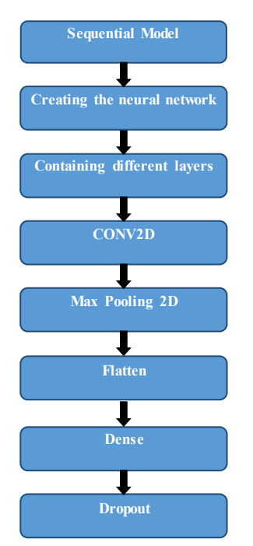

Figure: 1 (a)

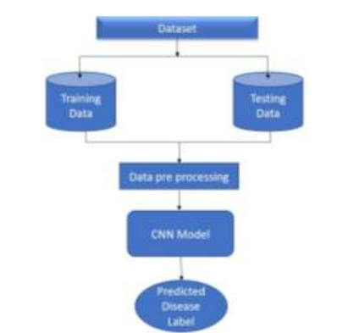

Figure: 1 (b)

Recently, a large collection of X-ray lung images, that contains the labeled lung disease info along with colored and greyscale images was made available on Kaggle, providing an excellent opportunity to carry out this approach. The dataset used for image classification in this study is divided into four categories. The new set of data ensures a balanced distribution of images across the sets that are divided under validation and testing categories. Each of the three main directories contains subdirectories labeled for each condition: Pneumonia, Tuberculosis, COVID-19, and Normal [7].

**Dataset Overview**

The authors will analyze and assess the dataset before applying both machine learning and deep learning techniques to examine and categorize whether the individual is having a lung issue, and if so, which specific condition they are suffering from Initially, the researcher tested our methods using a sample dataset collected from freely available datasets on Kaggle due to the large dataset size.

The datasets include

* Corona and Pneumonia Dataset
* Tuberculosis and Normal Dataset

1. **EXPERIMENT AND RESULT ANALYSIS**

**Defining Directories in the Dataset**

To facilitate model testing for four categories. The authors will upload the dataset onto the disk using Google Colab Notebook. After extracting the necessary data, the researchers will define directories to store and train images. For example, the training directories will be structured by class (e.g., COVID-19, normal, tuberculosis). Once the dataset is properly organized, the authors will build a Convolutional Neural Network (CNN) using TensorFlow.

TensorFlow will be used to create deep learning models by building instances of predefined classes and adding network layers. The CNN will be trained using 1,438 X-ray images across the four classes, and the goal of this model is to develop an image identification model for accurately detecting lung diseases.

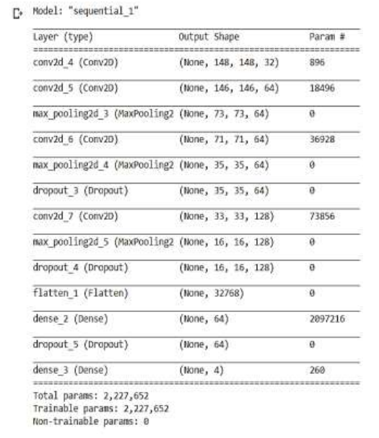

*Table 1: Performance of various layers in CNN*

Our focus is to predict multiple diseases as accurately as possible within a single model, as opposed to using separate models for each condition. Once the Kaggle dataset is fully collected, the authors will use the test results to train each class. The computational framework will be trained layer by layer using an ordered model summary approach, allowing us to progressively build the architecture.

For preprocessing, TensorFlow will be used to import images from the data generator. After completing the data preprocessing, the accuracy of the developed model is evaluated.

**Running the Model**

After testing each of the four classification models and extracting data from the database, the researchers will gradually train the module. First, we import the operating system and define a directory list for each of the four classes. Then, the authors create directories for our training images and run the model.

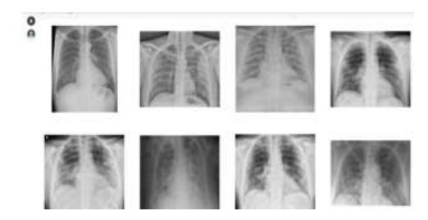

Figure 2: Covid-19 x-ray images

The CNN will process a total of 5,411 images. The researchers will import TensorFlow to analyze the visual data, followed by the addition of the sequential framework, which will be implemented in the following order: dropout layers, flattened layers, dense layers, max-pooling 2D layers, and more.

Once the framework is defined, the authors will use TensorFlow's ImageDataGenerator to rescale every image by 1./255. The model will then train on 5,364 images across the four categories and validate on 281 images. Finally, the test dataset will be used to evaluate 1,488 images across the four classes.

After storing and loading the processed data, the model will evaluate the test generator. The final output will include a graph that visualizes the training and validation accuracy.

Results of the COVID-19 illness photos that the researchers used to train and apply the model developed utilizing x-ray images that are downloaded from the Kaggle database.

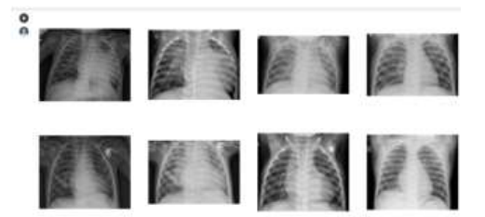

Figure 3: Pneumonia X-ray Images

Results of the x-rays the authors used to train and apply the model for pneumonia disease from the database Kaggle.

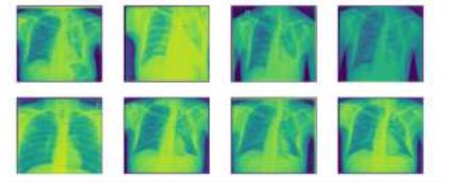

Figure 4: Tuberculosis Images

Results of X-rays downloaded from the Kaggle database that we used previously to train and apply the model with various X-ray and CT scan images of tuberculosis disease.

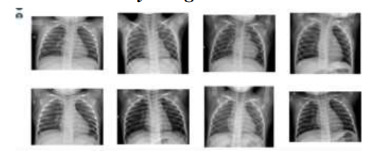

Figure 5: Normal X-Ray Images

The authors utilized a subset of typical illness images from the Kaggle database to train and test our model using X-rays. Specifically, the researchers trained the CNN with 5,411 images across four categories—COVID, NORMAL, PNEUMONIA, and TB—throughout ten epochs. To validate the model, the authors tested it on 283 images from the same four categories. The results showed an accuracy during the training phase of 84% and an accuracy during validation of 88%, indicating the model's rigid performance in recognizing and classifying these respiratory conditions based on the X-ray images.

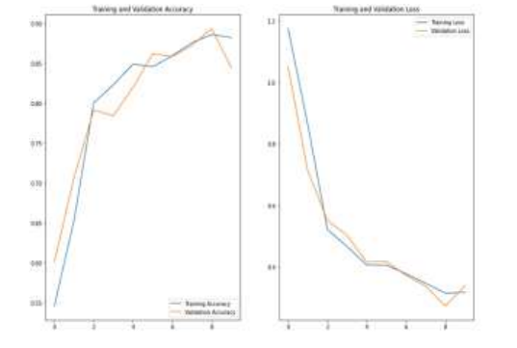

Figure 6: accuracy during the training phase

1. **CONCLUSION AND FUTURE SCOPE**

When the CNN was run, it gave an accuracy of close to 91% on the experimental dataset, consisting of 1,438 photos grouped into four. From this study, the researchers learned a lot about the importance and real-world applications of CNNs. The quality of pre-processing used on the data was a big factor that determined the model's success. The results of our research suggest that efficient medical picture categorization and analysis can significantly assist in the diagnosis and treatment of illness. CNNs are useful for more than just image processing; they may be used to predict a variety of ailments from MRI scans, such as lung cancer, respiratory infections, and other illnesses, in addition to medical image analysis.

**REFERENCES**

1. Tensor Flow's main website, https://www.tensorflow.org/.
2. Swetha, K. R., et al. "Prediction of Pneumonia Using Big Data, Deep Learning, and Machine Learning Techniques." 2021 6th International Conference on Communication and Electronics Systems (ICCES). IEEE, 2021.
3. Dey, Soumava, Gunther Correia Bacellar, Mallikarjuna Basappa Chandrappa, and Raj Kulkarni. "COVID-19 Chest X-Ray Image Classification Using Deep Learning." medRxiv (2021).
4. Tensor flow losses Module,
5. https://www.tensorflow.org/versions/r1.5/api_docs/python/tf/losses
6. CNN, <https://en.wikipedia.org/wiki/Convolutional_neural_network>.
7. Hyper Parameters,
8. https://en.wikipedia.org/wiki/Convolutional_ neural_network #Hyperparameters
9. Swetha, K. R., et al. "Prediction of Pneumonia Using Big Data, Deep Learning, and Machine Learning Techniques." 2021 6th International Conference on Communication and Electronics Systems (ICCES). IEEE, 2021.
10. Cruz A. A., Global Surveillance, Prevention and Control of Chronic Respiratory Diseases: A Comprehensive Approach, 2007, World Health Organization, Mexico, UK.
11. Elshennawy N. M. and Ibrahim D. M., Deep-pneumonia framework using deep learning models based on chest X-ray images, Diagnostics. (2020) 10, no. 9, <https://doi.org/10.3390/diagnostics10090649>.
12. Kanipriya M., Hemalatha C., Sridevi N., SriVidhya S., and Jany Shabu S., An improved capuchin search algorithm optimized hybrid CNN-LSTM architecture for malignant lung nodule detection, Biomedical Signal Processing and Control. (2022) 78, no. 2022, 103973, <https://doi.org/10.1016/j.bspc.2022.103973>.
13. Gunasinghe, A. C. Aponso and H. Thirimanna, “Early Prediction of Lung Diseases,” 2019
14. IEEE 5th International Conference for Convergence in Technology (I2CT), 2019, pp. 1–4,
15. S. Mukherjee, S.U. Bohra, Lung cancer disease diagnosis using machine learning approach, in*2020 3rd International Conference on Intelligent Sustainable Systems (ICISS)* (IEEE, 2020)
16. O.N. Oyelade, A.E. Ezugwu, H. Chiroma, CovFrameNet: an enhanced deep learning framework for COVID-19 detection, IEEE Access (2021)
17. B. Oltu et al., Automated tuberculosis detection using pre-trained CNN and SVM, in *2021 44th International Conference on Telecommunications and Signal Processing (TSP)* (IEEE, 2021)
18. B.A. Kitchenham, S. Charters, Guidelines for performing systematic literature reviews in software engineering **2** (2007).
19. R. Decorsière, P. L. Søndergaard, E. N. MacDonald and T. Dau, "Inversion of Auditory Spectrograms, Traditional Spectrograms, and Other Envelope Representations," in IEEE/ACM Transactions on Audio, Speech, and Language Processing, vol. 23, no. 1, pp. 46-56, Jan. 2015, doi: 10.1109/TASLP.2014.2367821.
20. M. S. Towhid and M. M. Rahman, "Spectrogram segmentation for bird species classification based on temporal continuity," 2017 20th International Conference of Computer and Information Technology (ICCIT), Dhaka, Bangladesh, 2017, pp. 1-4, doi: 10.1109/ICCITECHN.2017.8281775.
21. J. -G. Leu, L. -t. Geeng, C. E. Pu and J. -B. Shiau, "Speaker verification based on comparing normalized spectrograms," 2011 Carnahan Conference on Security Technology, Barcelona, Spain, 2011, pp. 1-5, doi: 10.1109/CCST.2011.6095878.
22. Tariq, Zeenat & Shah, Sayed & Lee, Yugyung. (2019). Speech Emotion Detection using IoT-based Deep Learning for Health Care. 10.1109/BigData47090.2019.9005638.
23. Zak M, Krzyżak A. Classification of Lung Diseases Using Deep Learning Models. Computational Science – ICCS 2020. 2020 May 22;12139:621–34. doi: 10.1007/978-3-030-50420-5_47. PMCID: PMC7304013.